Filtering muddy water:

Johnstone’s triangle

Learning objectives
- Name the equipment used to filter muddy water.
- Explain why the filtrate can pass through the filter paper but the residue cannot.
- Recognise the particle diagrams for different parts of the mixture.

Introduction

Filter paper contains a large number of tiny holes. Anything larger than these holes can be separated from a mixture. However, anything smaller than these holes will pass through. For this reason, only the mud can be separated from muddy spring water and not the dissolved minerals.

Johnstone’s triangle

In chemistry we make sense of the things that we can see by representing what we can’t see using formulas, equations, diagrams and models.

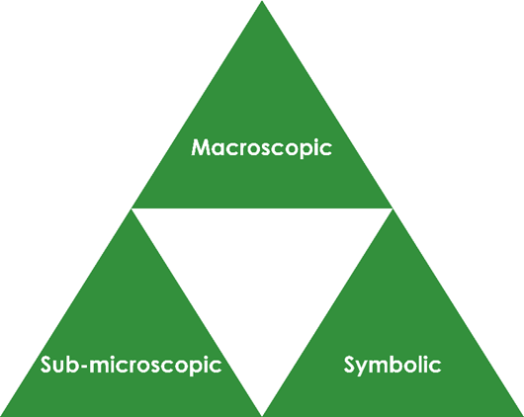
Johnstone’s triangle is a way of thinking about these different concepts as different corners of a triangle:
- Macroscopic – what we can see. Think about the properties we can observe, measure and record.
- Sub-microscopic – smaller than we can see. Think about the particle or atomic level.
- Symbolic – representations. Think about how we represent chemical ideas, including symbols and diagrams.

Being able to connect and move between these three different levels is important for scientific understanding.

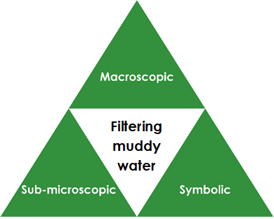
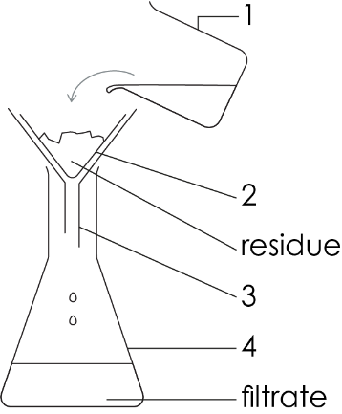

Macroscopic – what we can see

Some muddy spring water is a mixture of water, dissolved minerals and tiny solid fragments of mud. Name the filtering apparatus shown in the diagram.

1. ______________________ 2. ______________________

3. ______________________ 4. ______________________

Name the part of the mixture that will not pass through

the filter paper (the residue). _______________________

Sub-microscopic – smaller than we can see

The muddy water mixture is made up of water particles, particles of dissolved minerals and tiny solid fragments of mud.

The solid fragments of mud are made up of a large number of mud particles.

Can you see:

particles of water? ________ fragments of mud? ________

Which are larger, particles or mud fragments?

_____________________________________________________________

Explain why the tiny fragments of mud are not able to pass through the filter and form the residue left in the filter paper.

_____________________________________________________________

Explain why the water particles and particles minerals can pass through the filter paper to form the filtrate.

____________________________________________________________

Symbolic – representations

Give the letter of the particle diagram that represents the following:

solid fragment of mud ___

liquid water with dissolved minerals ___

pure liquid water ___

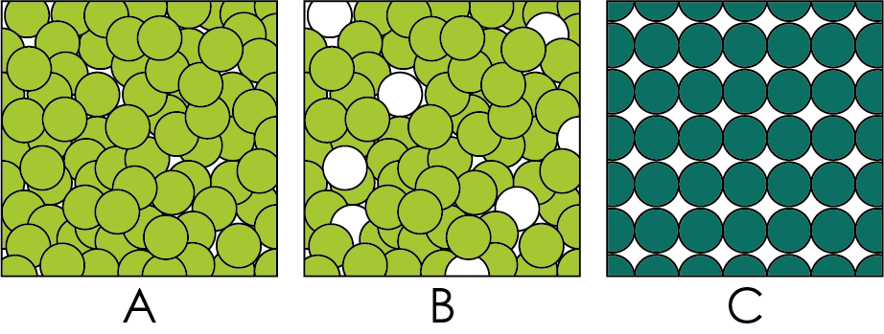

Draw what represents a single water particle and a single dissolved mineral particle.

Would a real fragment of mud contain more or fewer particles than the diagram? ________________________________

