Bioethanol: Johnstone’s triangle

Learning objectives
- Recognise a use and benefit of bioethanol.
- Explain why the properties of ethanol are different to the elements carbon, oxygen and hydrogen.
- Recognise what information is and is not provided by a particle diagram of an ethanol molecule.

Introduction

Bioethanol is a form of ethanol produced from biological sources such as sugar cane. Ethanol molecules are made of carbon, oxygen and hydrogen atoms. The compound ethanol has totally different properties to the elements carbon, oxygen and hydrogen.

Johnstone’s triangle

In chemistry we make sense of the things that we can see by representing what we can’t see using formulas, equations, diagrams and models.

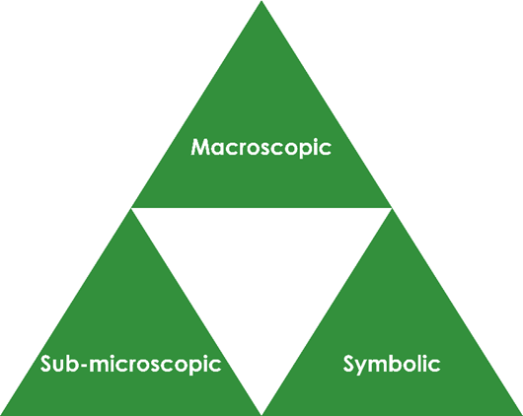
Johnstone’s triangle is a way of thinking about these different concepts as different corners of a triangle:

- Macroscopic – what we can see. Think about the properties we can observe, measure and record.
- Sub-microscopic – smaller than we can see. Think about the particle or atomic level.
- Symbolic – representations. Think about how we represent chemical ideas, including symbols and diagrams.

Being able to connect and move between these three different levels is important for scientific understanding.

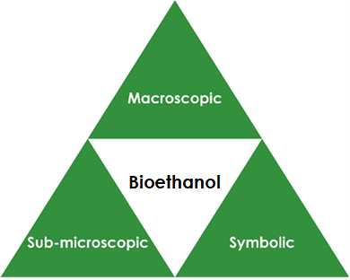
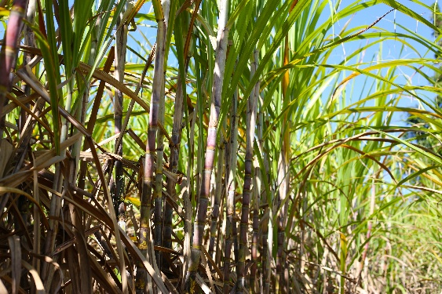

Symbolic – representations

Tick (✓) or cross (x) for each statement to show what information the particle diagram of an ethanol molecule does or does not provide.

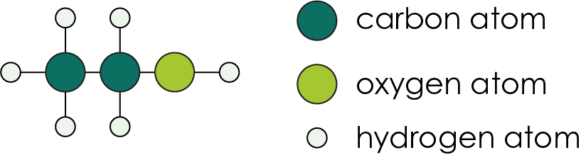

The diagram shows:

which atoms are connected to which.

the 3D arrangement of the atoms.

the number of each type of atom.

Diagrams often represent carbon atoms as black circles. Suggest why this could cause misunderstandings.

___________________________________________________

___________________________________________________

Sub-microscopic – smaller than we can see

Ethanol is made up of atoms of carbon, oxygen and hydrogen.

Complete the sentences to explain why the properties of ethanol are different to the properties of the elements carbon, oxygen and hydrogen. Use the words gases, solid, atoms and molecule.

The element carbon is often found as a black ________________. It is made up of lots of carbon ________________ joined together.

The elements oxygen and hydrogen are formed of molecules that are made of pairs oxygen or hydrogen ________________. Both elements are colourless ________________.

Atoms of an element do not have the same properties as the actual element, so ethanol does not share any of these properties. The properties of ethanol arise from the number and arrangement of carbon, oxygen and hydrogen ________________ that make up each ethanol ________________.

Macroscopic – what we can see

Bioethanol is a form of the compound ethanol that has been produced from biological sources such as sugar cane.

Bioethanol can be used as a fuel for vehicles. Suggest

the state of bioethanol at room temperature.

________________________________________________________

Give one advantage of using bioethanol instead of a fossil fuel. __________________________________________________
Image ©: Shutterstock/Bowonpat Sakaew

