Properties of elements and compounds

This resource is from the Johnstone’s triangle series which can be viewed at: rsc.li/4jI4bfW. In this series you will also find our Properties of elements and compounds: Johnstone’s triangle worksheet which introduces the triangle in the context of Bioethanol and can be viewed at: rsc.li/4fU7GB0.

Learning objectives
LO | Objective | Where assessed
1 | Recognise that a compound is made up of a combination of atoms of different elements. | Q1
2 | Recognise when elements combine to form a compound no small pieces of the element remain (and so an iron compound is not magnetic). | Q2
3 | Recognise that the colour of a compound is not a mixture of the colours of the elements with the types of atoms that make up the compound. | Q3
4 | Explain why a compound formed from two elements has different properties to the original elements which reacted. | Q4

How to use this resource
When to use? |   Introduce |   Develop |   Revise |   Assess
When to use? | Use after initial teaching or discussion of this topic to develop ideas further. You can also use as a revision activity.
Group size? |   Independent |   Small group |   Whole class |   Homework
Group size? | Suitable for independent work either in class or at home. Or use the questions for group or class discussions.
How long? |  |  | 15–30 mins

This resource aims to develop learners’ understanding of the combination of elements to form compounds. The questions encourage learners to think more deeply about why a compound does not have the same properties as its constituent elements. As a result, learners should develop more secure mental models to support their thinking about this topic.

Johnstone’s triangle

Johnstone’s triangle is a model of the three different conceptual levels in chemistry: macroscopic, sub-microscopic and symbolic. You can use Johnstone’s triangle to build a secure understanding of chemical ideas for your learners.

Find further reading about Johnstone’s triangle and how to use it in your teaching at rsc.li/4vQQOQs.

Johnstone’s triangle and this resource

The icons in the margin indicate which level of understanding each question is developing to help prompt learners in their thinking.

 | Macroscopic: what we can see. Think about the properties that we can observe, measure and record.
 | Sub-microscopic: smaller than we can see. Think about the particle or atomic level.
 | Symbolic: representations. Think about how we represent chemical ideas including symbols and diagrams.

The levels are interrelated, for example, learners need visual representation of the sub-microscopic to develop mental models of the particle or atomic level. Our approach has been to apply icons to questions based on what the learners should be thinking about.

Questions may be marked with two or all three icons, indicating that learners will be thinking at more than one level. However, individual parts of the question may require learners to think about only one or two specific levels at a time.

Support

This worksheet is ramped so that the earlier questions are more accessible. The activity becomes more challenging in the later questions. You can give extra explanations for the more challenging questions. If completing as an in-class activity, pause and check understanding at intervals, as often one question builds on the previous ones.

It is useful for learners to observe macroscopic properties first-hand. You could use a teacher demonstration to show a change in properties. Please note that full guidance on demonstrating the reaction between iron and sulfur may be found at rsc.li/3LVXGeC. Or, give learners physical models to use and manipulate, such as counters or marbles.


Answers
- Guidance note: This question develops learners’ understanding of the difference between elements and compounds in terms of their properties (macroscopic understanding) and their underlying structure of atoms or molecules (sub-microscopic understanding). Please note that the term ‘atoms’ is also used for copper oxide as learners are unlikely to have been introduced to the concept of ions at this stage. If this resource is being used as revision for older learners, then the term ions should be used.

Substance name | Element or compound | Appearance | Conducts electricity?
copper oxide | compound | black solid | no
copper | element | shiny/orange solid | yes
oxygen | element | colourless gas | no

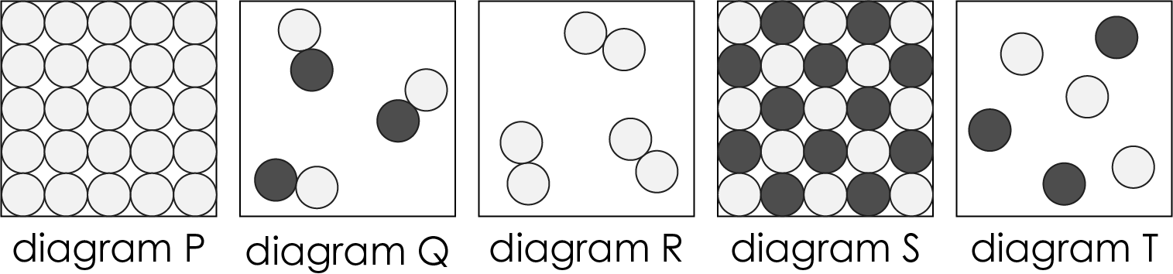 |  | 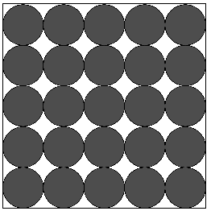
oxygen | copper oxide | copper

Substance | Type of atoms
copper | copper atoms
oxygen | oxygen atoms
copper oxide | copper and oxygen atoms

- Guidance note: This question develops learners’ understanding of the combining of elements to form a compound with different properties (macroscopic understanding). It also helps to clarify understanding about atoms to make sure learners are aware that an atom is not a ’small piece of’ an element (sub-microscopic understanding).
- C
- Iron sulfide is not magnetic because it does not contain the element iron.

- Guidance note: This question develops learners’ understanding of the independence of the colour of a compound from the colour of the elements made from its constituent atoms (macroscopic understanding). It is important that learners understand that an atom of an element does not have the colour of that element (sub-microscopic understanding). It is not possible to predict the colour of compound C because a substance does not get its colour from being made of individually coloured atoms from element A and B. This misconception may be inadvertently reinforced by the use of coloured particle diagrams.

- The atoms should not be coloured red.

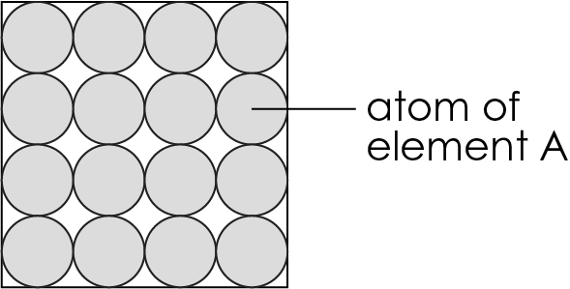
- The atoms should not be coloured yellow.

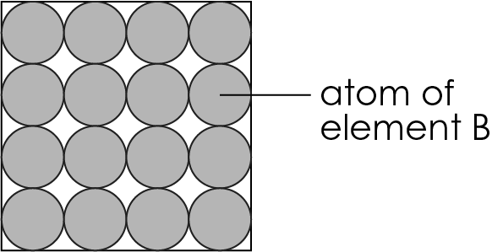
- The atoms should not be coloured red and yellow,

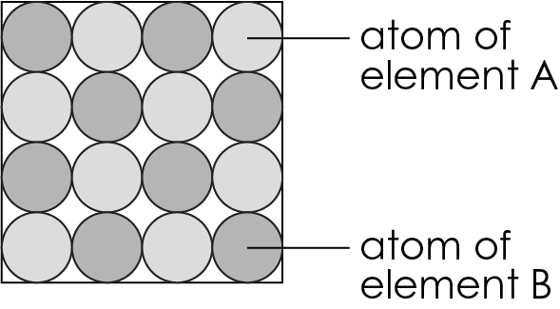

- It is not possible to predict the colour of compound C. The colour of compound C arises from the combination of atoms and not from the properties of element A and element B.

- Guidance note: This question develops learners’ understanding of the connection between real-life observation of the reaction of two elements to form a compound (macroscopic understanding), the symbolic representation of this using element symbols and chemical formulae (symbolic understanding) and how the arrangement of atoms and molecules changes (sub-microscopic understanding).

If learners are not yet confident in understanding chemical formulas, the element symbols and formula could be deleted from the question before sharing.

Please note that full guidance on demonstrating the reaction between sodium and chlorine may be found at: rsc.li/3uW6BQz
The pieces of sodium chloride formed are so small that they form a white smoke.

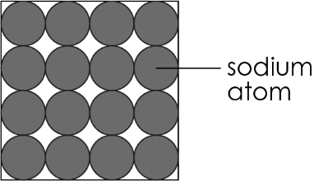

- Also accept correctly labelled chlorine molecule.

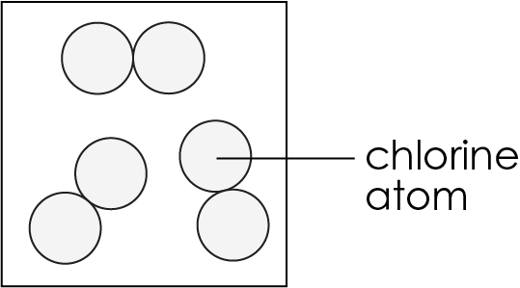

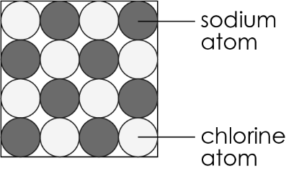

- Sodium chloride does not contain any sodium or chlorine in element form, so the properties of sodium chloride are not related to the two elements.

