Properties of elements and compounds

Introduction

These questions are designed to help you to develop your mental models (pictures in your head) of symbols and formulae. Use the icon in the margin to find out which level of understanding the question is developing.
 | Macroscopic: what we can see. Think about the properties that we can observe, measure and record.
 | Sub-microscopic: smaller than we can see. Think about the particle or atomic level.
 | Symbolic: representations. Think about how we represent chemical ideas including symbols and diagrams.


Questions
- Copper, oxygen and copper oxide look different and have different properties.
- Complete the table to show the correct substance on each row.
Substance name | Element or compound | Appearance | Conducts electricity?
copper oxide |  | black solid
copper
oxygen

- Label the diagram for copper, oxygen and copper oxide.

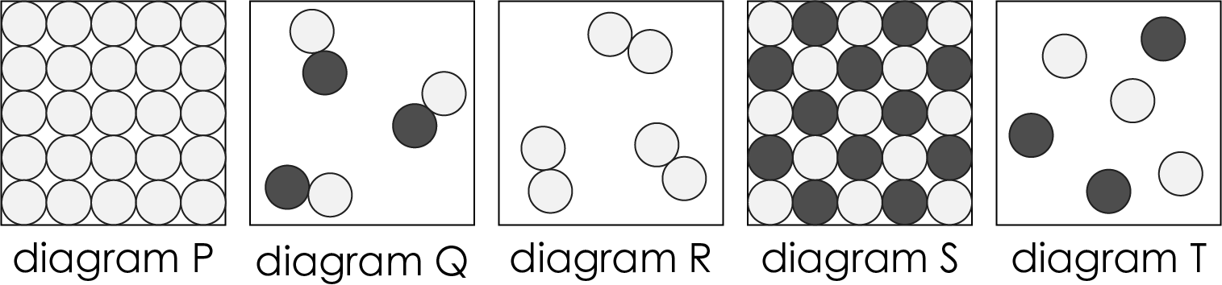 |  | 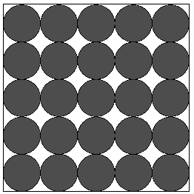
________________________ | ________________________ | ________________________

- Complete the table to show which type of atoms each substance is made from.
Substance | Type of atoms
copper
oxygen
copper oxide

- The element iron and the element sulfur combine to form a new compound called iron sulfide.
- Select the sentence that explains why the compound is called iron sulfide.

A | Iron sulfide is a mixture of small pieces of iron and sulfur.
B | Iron sulfide is made up of small pieces of iron and sulfur melted together.
C | Iron sulfide is made up of atoms of iron and sulfur that are combined.
D | Iron sulfide is made up of atoms of iron and sulfur that are mixed together.

- Iron is a shiny metal that is magnetic. Sulfur is a non-metal that is yellow.
Suggest whether iron sulfide is magnetic or not magnetic. Give one reason for your answer.

__________________________________________________________________________________

__________________________________________________________________________________
- This question relates to three made-up substances.
- Element A contains atoms of element A. Element A is red.
Draw a diagram to represent element A in the solid state.

- Element B contains atoms of element B. Element B is yellow.
Draw a diagram to represent element B in the solid state.

- Compound C is made when element A reacts with element B.
Draw a diagram to represent compound C in the solid state.

- Explain whether it is possible to predict the colour of compound C.

__________________________________________________________________________________

__________________________________________________________________________________

__________________________________________________________________________________

__________________________________________________________________________________

- A teacher demonstrates the reaction of sodium metal with chlorine gas. White sodium chloride is formed.
- Draw diagrams to show the arrangement of atoms (or molecules) for each substance.
- sodium ($Na$)

- chlorine (${Cl}_{2}$)

- sodium chloride ($NaCl$)

- Explain why it is possible for a shiny silver-coloured metal and a green gas to form a white solid.

__________________________________________________________________________________

__________________________________________________________________________________

__________________________________________________________________________________

__________________________________________________________________________________

