Algebra and equations
This set of activities forms part of the Maths skills for chemistry resources series which can be viewed at: rsc.li/4A41ezG. The series offers flexible, targeted support for maths skills which are fundamental to chemistry teaching:
- Graphs and data, divided into:
  - Creating graphs
  - Interpreting graphs
- Ratio and proportion
- Understanding number, divided into:
  - Unit conversion
  - Significant figures and rounding
- Algebra and equations

Resource series components
The resource series is divided into two stages. Stage 1 (✪) is most suitable for ages 11−14 and stage 2 (✪✪) for ages 14−16. However, older learners with gaps in their fundamental knowledge can use stage 1 as a stepping stone.
Stage 1 ✪ | 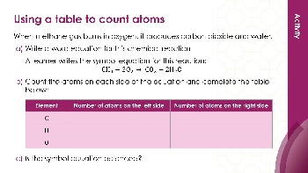  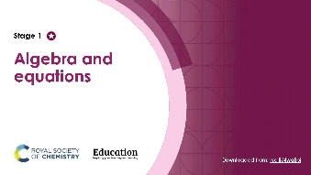 | 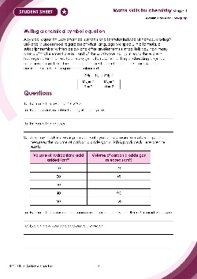
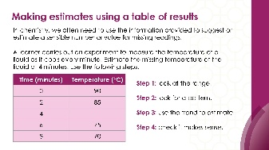
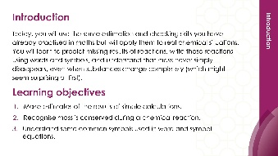
Teacher-led presentation (✪): a full lesson including learning objectives, learner-facing instructions and activities. | Short activities (✪): learner-facing activities, designed as lesson starters or quick activities to engage prior knowledge. | Learner worksheet sheet (✪): activities for learners to independently practice their maths skills. Suitable as classroom activity following the teacher presentation or as a home-learning task.

Stage 2 ✪✪ | 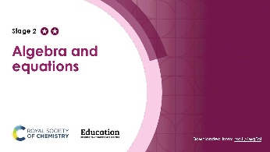  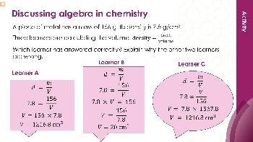 | 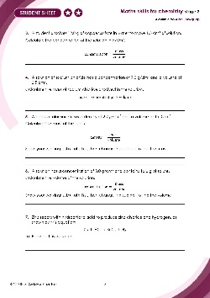
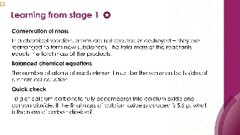
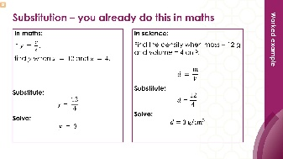

Teacher-led presentation (✪✪) | Short activities (✪✪) | Learner worksheet (✪✪)

Key terms support
Key mathematical vocabulary for each skill area is defined in the key terms support: rsc.li/4wypuqq. You will find the key terms listed by topic area and an accessible glossary slide for each term.

Using the short activities presentation
The aim of this resource is for learners to revisit and practise skills from the teacher-led presentation and to develop problem solving skills so they can apply these independently.

Learning objectives
- Make estimates of the results of simple calculations.
- Recognise that mass is conserved during a chemical reaction.
- Understand some of the common symbols used in word and symbol equations.
As you move through the activities, there is a clear progression in skill development. The first activity or activities engage learners’ prior knowledge. Following this, learners will complete activities using mathematical skills within a chemistry context.
Activities can be teacher-led, for learners requiring additional support or modelling, or can be set as independent work.
The presentation contains eight short activities that are designed to last 5–15 minutes and to be used as:
- a starter activity to engage prior knowledge or to practise a skill
- an assessment tool, used at the beginning of a lesson or sequence of work
- as follow-up independent practice during lessons or plenary
- for retrieval practice.

Metacognition
These short activities support learners to develop their metacognitive skills in three key areas.
- Planning − prompt learners to draw on their existing mathematical knowledge by asking themselves: ‘Have I seen a similar question before? Have I come across this mathematical skill before? Have I learned a different method for solving a similar problem?’
- Monitoring – prompt learners to ask themselves: ‘How confident am I feeling with these mathematical skills? Which questions am I finding difficult? Which type of questions do I feel I have mastered?’
- Evaluation – prompt learners to ask themselves: ‘What have I learned about myself when doing these questions? Which of the mathematical skills did I use to answer these questions?’

Slide notes

Slide 1: Title slide

Slide 2: Introduction
No notes.

Slide 3: Round to 1 significant figure and estimate
Check learners understand how to calculate relative formula mass before revealing the question. Use a different example such as water: H = 1 and O = 16, so the relative formula mass is 18. If we estimated this it would be 2 + 20 = 22.

Slide 4: Round to 1 significant figure and estimate (answers)
No notes.

Slide 5: Reactants and products
Give learners sufficient time to read and complete the question independently.

Slide 6: Reactants and products (answers)
(b) Ask learners if this is correct: $sodium hydroxide + hydrochloric acid → water + sodium chloride,$to check they understand that it is the reactants being on the left and the products being on the right that are important rather than the order. Ask learners why it is incorrect to use an equal sign rather than an arrow. They should know that the arrow represents the direction the reaction proceeds and that a transformation has occurred. The atoms are rearranged to make new products so things cannot be equal.

Slide 7: Where did the extra mass come from?
This question tests the less commonly taught direction of apparent mass increase. Learners who have only seen the gas-escaping scenario often assume an experimental error here. Some learners correctly identify that oxygen is involved, but still say mass is not conserved because they think gases have no mass.

Slide 8: Where did the extra mass come from? (answers)
(a) We would not normally write magnesium ribbon in the same way we do not write oxygen gas. Later in their studies, learners will learn about state symbols. This has not been included here because the focus is on being able to write a word equation. Introduce the state symbols if you feel learners are ready for this.

Slide 9: Using a table to count atoms
Remind learners what the subscript and the coefficient numbers mean before they independently complete the question.

Slide 10: Using a table to count atoms (answers)
No notes.

Slide 11: Estimating density
No notes.

Slide 12: Estimating density (answers)
No notes.

Slide 13: Symbols in chemistry 1
Give learners access to a periodic table to help them, if required: e.g. periodic-table.rsc.org.

Slide 14: Symbols in chemistry 1 (answers)
No notes.

Slide 15: Symbols in chemistry 2
No notes.

Slide 16: Symbols in chemistry 2 (answers)
No notes.

Slide 17: Discussing conservation of mass
This slide gives context, see the next slides for the learner question.

Slide 18: Discussing conservation of mass
No notes.

Slide 19: Discussing conservation of mass (answer)
No notes.

