Algebra and equations

This learner worksheet forms part of the Maths skills for chemistry resources series which can be viewed at: rsc.li/4A41ezG. The resource series covers maths skills which are fundamental to chemistry teaching:
- Algebra and equations
- Ratio and proportion
- Graphs and data, divided into:
  - Creating graphs
  - Interpreting graphs
- Understanding number, divided into:
  - Unit conversion
  - Significant figures and rounding

Resource series components
The resource series is divided into two stages. Stage 1 (✪) is most suitable for ages 11−14 and stage 2 (✪✪) for ages 14−16. However, older learners with gaps in their fundamental knowledge can use stage 1 as a stepping stone.
Stage 1 ✪ | 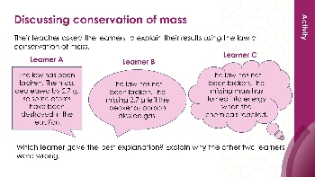  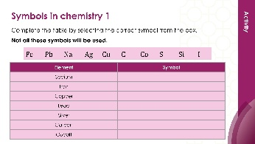 | 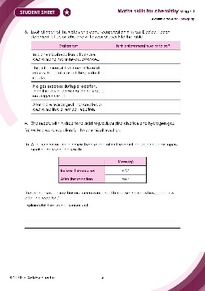
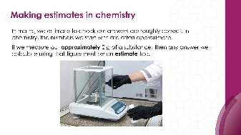
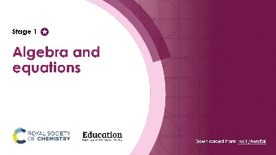
Teacher-led presentation (✪): a full lesson including learning objectives, learner-facing instructions and activities. | Short activities (✪): learner-facing activities, designed as lesson starters or quick activities to engage prior knowledge. | Learner worksheet (✪): activities for learners to independently practice their maths skills. Suitable as classroom activity following the teacher presentation or as a home-learning task.

Stage 2 ✪✪ | 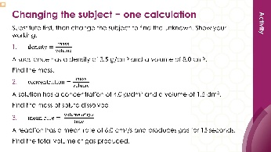  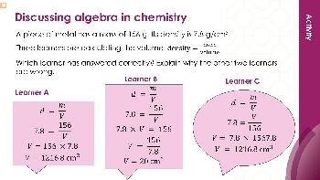 | 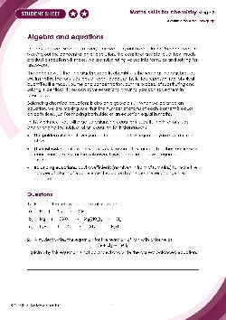
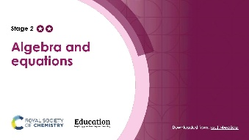
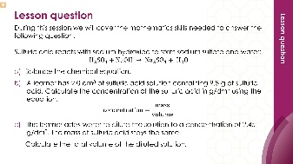

Teacher-led presentation (✪✪) | Short activities (✪✪) | Learner worksheet (✪✪)

Key terms support
Key mathematical vocabulary for each skill area is defined in the key terms support: rsc.li/4wypuqq. You will find the key terms listed by topic area and an accessible glossary slide for each term.

Using the learner worksheet
The focus of this learner worksheet is mastering maths skills in a chemistry context. The aim is for learners to develop and apply maths skills independently.

Learning objectives
- Make estimates of the results of simple calculations.
- Recognise mass is conserved during a chemical reaction.
- Understand the symbols used in word and symbol equations.
The learner worksheets complement the teacher-led presentations but can function independently, for example as a classroom activity or homework assignment.
Answers are provided at the end of this document. When relevant, common mathematical misconceptions are highlighted.

When to use
Use the learner worksheet for:
- Reviewing learning – if learners are confident with the mathematical skill, use the worksheet as a tool to review learning and assess learners’ skill level.
- Independent practice – provide learners with the worksheet to use as independent practice.
- Scaffolded practice – break the worksheet into sections and complete over a longer period, such as multiple lessons.
- Mathematical modelling – for those requiring additional support, talk through the initial questions pulling out the mathematical skills used to answer the question, highlighting and defining any key terms. If learners are still finding the task difficult, consider fading the initial questions and asking learners to complete the later questions independently.

Scaffolding
The worksheet presents a clear progression in skill development. It starts with a recap of key knowledge. The first question engages prior knowledge of the chosen maths skill. Following this, learners will do some maths–chemistry translation tasks, then complete activities in a chemistry context.
Have the key terms list or accessible glossary available for learners who require additional support with mathematical vocabulary.

Metacognition
The learner worksheet supports learners to develop their metacognitive skills in three key areas.
- Planning − prompt learners to draw on their existing mathematical knowledge by asking themselves: ‘Have I seen a similar question before? Have I come across this mathematical skill before? Have I learned a different method for solving a similar problem?’
- Monitoring – prompt learners to ask themselves: ‘How confident am I feeling with these mathematical skills? Which questions am I finding difficult? Which type of questions do I feel I have mastered?’
- Evaluation – prompt learners to ask themselves: ‘What have I learned about myself when doing these questions? Which of the mathematical skills did I use to answer these questions?’

Common misconceptions
Below is an outline of common misconceptions and common errors learners may make.

Rounding errors
Rounding errors are the most common source of wrong estimates. Watch for learners rounding 4.8 to 4 rather than 5 or rounding 9.3 to 10 rather than 9. In Q1, watch out for learners who do the calculation and then make an estimation by rounding.

Gases and mass
An often deeply held misconception is that gases have no mass. When a reaction produces a gas and the measured mass decreases, learners may conclude that matter has been destroyed. The reverse situation, where mass appears to increase, is less commonly taught but equally important. Learners who have only been taught the decreasing-mass scenario often find this deeply counter-intuitive and may assume an experimental error.
In Q3, statement 3 is the key diagnostic item. Learners who answer true here believe that the law breaks down when a gas escapes. Statement 1 may be answered incorrectly by learners who confuse the substance changing with the atoms being destroyed. Statements 2 and 4 are usually answered correctly but watch for learners who treat them as separate ideas rather than two expressions of the same principle.

Capitalisation errors
Capitalisation errors in chemical symbols are extremely common. In Q5(a) option ii. (Co) is the most diagnostic distractor because it looks plausible if learners do not know the capitalisation rule. Cobalt has the symbol Co; carbon monoxide is CO. Learners who select Co have confused element symbols with compound formulas or do not know that the case of each letter is significant. Option v. (2CO) is chosen by learners who understand that 2 oxygens are needed but place the number in the wrong position, interpreting it as a coefficient rather than a subscript.
For part (b), learners often describe ${\text{O}}_{2}$ as meaning 2 oxygen atoms without clarifying that they are bonded, which misses the distinction between ${\text{O}}_{2}$ (a molecule) and 2O (two separate atoms).

Signs
The arrow in a word or symbol equation is sometimes written with an equal sign. An equal sign implies the two sides are the same thing; the arrow communicates that a transformation has taken place.

Subscripts and coefficients
In Q6(c), option ii. is a very plausible distractor: doubling the product looks like it should work and many learners select it without re-counting. Option iv. is chosen by learners who know the equation needs adjusting but do not understand that formulas cannot be altered. The key teaching point is that only coefficients (large numbers in front) may be changed; subscripts within a formula are fixed because they define the substance.

Answers

- 4.8 rounds to 5
9.3 rounds to 9
- $5 × 9 = 45$

- 72 cm³
- Each additional 10 cm³ of acid that is added produces an extra 24 cm³ of carbon dioxide. The pattern increases by 24 cm³ each time so 30 cm³ of acid would produce$48+24=7{\text{2 cm}}^{\text{3}}$.

Statement | Is this statement true or false?
In a chemical reaction atoms are destroyed to make new substances | False
The total mass of the reactants used equals the total mass of the products made | True
If a gas escapes during a reaction, then the law of conservation of mass is no longer correct | False
Atoms are rearranged, not created or destroyed in a chemical reaction | True

- $\text{Zinc + hydrochloric acid → zinc chloride + hydrogen}$
- The learner is wrong because mass is always conserved. The mass decreased because hydrogen gas was produced and escaped into the air. Hydrogen gas is made of atoms and atoms have mass, so if the gas had been captured the total mass of the products would still be 63.4 g.

- C. ${CO}_{2}$
- The subscript$_{2}$ in $O_{2}$ means that there are 2 oxygen atoms bonded together in one molecule of oxygen gas.

Atoms on the left side of the equation | Atoms on the right side of the equation
H = 2 | H = 2
O = 2 | O = 1
- No, the equation is not balanced.
- Option C. is the correctly balanced equation: $2H_{2}+ O_{2}→2H_{2}O$

