Algebra and equations
This learner worksheet forms part of the Maths skills for chemistry resources series which can be viewed at: rsc.li/4A41ezG. The resource series covers maths skills which are fundamental to chemistry teaching:
- Ratio and proportion
- Graphs and data, divided into:
  - Creating graphs
  - Interpreting graphs
- Understanding number, divided into:
  - Unit conversion
  - Significant figure and rounding
- Algebra and equations

Resource series components
The resource series is divided into two stages. Stage 1 (✪) is most suitable for ages 11−14 and stage 2 (✪✪) for ages 14−16. However, older learners with gaps in their fundamental knowledge can use stage 1 as a stepping stone.
Stage 1 ✪ | 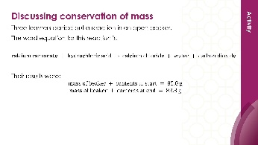 | 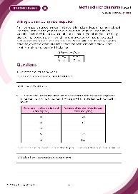
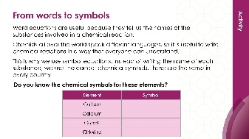
Teacher-led presentation (✪) | Short activities (✪) | Learner worksheet (✪)
Stage 2 ✪✪ | 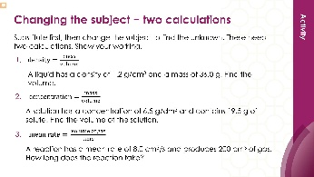  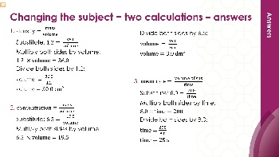 | 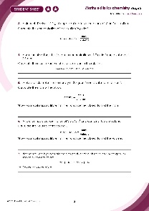
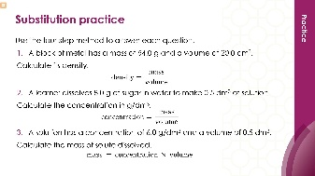
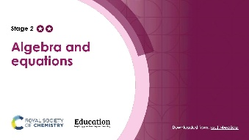

Teacher-led presentation (✪✪): a full lesson including learning objectives, learner-facing instructions and activities. | Short activities (✪✪): learner-facing activities, designed as lesson starters or quick activities to engage prior knowledge. | Learner worksheet (✪✪): activities for learners to independently practice their maths skills. Suitable as classroom activity following the teacher presentation or as a home-learning task.

Key terms support
Key vocabulary for each skill area is defined in the key terms support: rsc.li/4wypuqq. You will find the key terms listed by area and an accessible glossary slide for each term.

Using the learner worksheet
The focus of this learner worksheet is mastering maths skills in a chemistry context. The aim is for learners to develop and apply maths skills independently.

Learning objectives
- Make estimates of the results of simple calculations.
- Recognise mass is conserved during a chemical reaction.
- Understand the symbols used in word and symbol equations.
The learner worksheets complement the teacher-led presentations but can function independently, for example as a classroom activity or homework assignment.
Answers are provided at the end of this document. When relevant, common mathematical misconceptions are highlighted.

When to use
Use the learner worksheet for:
- Reviewing learning – if learners are confident with the mathematical skill, use the worksheet as a tool to review learning and assess learners’ skill level.
- Independent practice – provide learners with the worksheet to use as independent practice.
- Scaffolded practice – break the worksheet into sections and complete over a longer period, such as multiple lessons.
- Mathematical modelling – for those requiring additional support, talk through the initial questions pulling out the mathematical skills used to answer the question, highlighting and defining any key terms. If learners are still finding the task difficult, consider fading the initial questions and asking learners to complete the later questions independently.

Scaffolding
The worksheet presents a clear progression in skill development. It starts with a recap of key knowledge. The first question engages prior knowledge of the chosen maths skill. Following this, learners will do some maths–chemistry translation tasks, then complete questions in a chemistry context.
Have the key terms list or accessible glossary available for learners who require additional support with mathematical vocabulary.

Metacognition
The learner worksheet supports learners to develop their metacognitive skills in three key areas.
- Planning − prompt learners to draw on their existing mathematical knowledge by asking themselves: ‘Have I seen a similar question before? Have I come across this mathematical skill before? Have I learned a different method for solving a similar problem?’
- Monitoring – prompt learners to ask themselves: ‘How confident am I feeling with these mathematical skills? Which questions am I finding difficult? Which type of questions do I feel I have mastered?’
- Evaluation – prompt learners to ask themselves: ‘What have I learned about myself when doing these questions? Which of the mathematical skills did I use to answer these questions?’

Common misconceptions
Below is an outline of common misconceptions and common errors learners may make.

Subscripts and coefficients
Learners may change the subscripts instead of adding coefficients when balancing equations.

Substitution errors
A common error is substituting values the wrong way round (e.g. volume ÷ mass instead of mass ÷ volume).

Operational errors
A further misconception arises when learners do not recognise when the unknown should be on the bottom of a division. This requires a two-step process, and learners can make errors by missing one or both steps.
Learners can use the wrong inverse operation when changing the subject.

Mass
Learners may not realise that the mass of solute stays the same when a solution is diluted.

Units
A common error is completing the calculation, but forgetting to include units in the answer.

Answers

- $2\text{K + }{\text{Br}}_{\text{2}}\text{ →}\text{ 2KBr}$
Check: K: 2 = 2, Br: 2 = 2
- $\text{Mg + }{\text{2HNO}}_{3} \text{→}\text{ Mg(}{\text{NO}}_{\text{3}}{\text{)}}_{\text{2}}\text{ + }{\text{H}}_{\text{2}}$
Check: Mg: 1 = 1, H: 2 = 2, N: 2 = 2, O: 6 = 6
- ${\text{2C}}_{\text{4}}{\text{H}}_{\text{10}}\text{ + }{\text{13O}}_{\text{2}}\text{ →}\text{ 8}{\text{CO}}_{\text{2}}\text{ + }{\text{10H}}_{\text{2}}\text{O}$
Check: C: 8 = 8, H: 20 = 20, O: 26 = 26
- The equation is not balanced because chlorine does not balance. On the left: Cl = 2 (from ${\text{Cl}}_{\text{2}}$). On the right: Cl = 3 (from ${\text{FeCl}}_{\text{3}}$). Iron balances (1 = 1) but chlorine does not.
Balanced equation: $\text{2Fe + 3}{\text{Cl}}_{\text{2}} \text{→}\text{ 2}{\text{FeCl}}_{\text{3}}$
Check: Fe: 2 = 2, Cl: 6 = 6

$$\text{concentration= }\frac{\text{mass}}{\text{volume}}$$
$$c=\frac{12.0}{1.5}$$
$$c=8.0 {g/dm}^{3}$$

$$\text{mass = concentration × volume}$$
$$\text{m=9.0}× 0.5$$
$$\text{m=4.5}$$

$$\text{density = }\frac{\text{mass}}{\text{volume}}$$
Substitute: $2\text{.7 = }\frac{\text{m}}{\text{15.0}}$
Multiply on both sides by 15.0: $\text{m}\text{ = 2.7 × 15.0}$
m = 40.5 g
This is the one-step calculation: the unknown (mass) is on the top of the division.

$$\text{concentration= }\frac{\text{mass}}{\text{volume}}$$
Substitute:$3.0=\frac{18.0}{v}$
Multiply both sides by $v$: $\text{3.0 × }v$ $\text{= 18.0}$
Divide both sides by 3.0: $v=\frac{18.0}{3.0}$
$v$= 6.0 ${dm}^{3}$
This is the two-step calculation: the unknown (volume) is on the bottom of the division.

- $\text{Zn + 2HCl → }{\text{ZnCl}}_{\text{2}}\text{ + }{\text{H}}_{\text{2}}$
${\text{ZnCl}}_{\text{2}}$ has 2 $\text{Cl}$, so we need $2H\text{Cl}$. Check: Zn: 1 = 1, H: 2 = 2, Cl: 2 = 2.
- $c= \frac{m}{v}$
$$c= \frac{13.6}{2.0}$$
$$= {6.8 g/dm}^{3}$$

- $\text{concentration= }\frac{\text{mass}}{\text{volume}}$
Substitute: 4.9 $\text{=}\frac{\text{m}}{4.0}$
Multiply on both sides by 4.0: $\text{m}\text{ = 4.9 × 4.0}$
m = 19.6 g
- The mass stays the same (19.6 g). New volume = ${8.0 dm}^{3}$.
$$\text{concentration= }\frac{\text{mass}}{\text{volume}}$$
$$c= \frac{19.6}{8.0}$$
c = ${2.45 g/dm}^{3}$
- The concentration has halved (from 4.9 to 2.45 g/dm³). This is because the volume has doubled but the mass of sulfuric acid has stayed the same. The same amount of solute is now spread through twice the volume, so the concentration is half.

