Algebra and equations
These short activities form part of the Maths skills for chemistry resources series which can be viewed at: rsc.li/4A41ezG. The series offers flexible, targeted support for maths skills which are fundamental to chemistry teaching:
- Graphs and data, divided into:
  - Creating graphs
  - Interpreting graphs
- Ratio and proportion
- Understanding number, divided into:
  - Unit conversion
  - Significant figures and rounding
- Algebra and equations

Resource series components
The resource series is divided into two stages. Stage 1 (✪) is most suitable for ages 11−14 and stage 2 (✪✪) for ages 14−16. However, older learners with gaps in their fundamental knowledge can use stage 1 as a stepping stone.
Stage 1 ✪ | 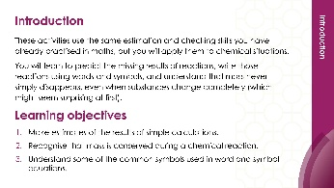 | 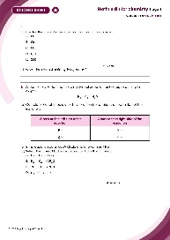
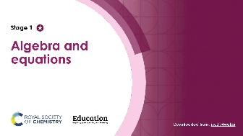
Teacher-led presentation (✪) | Short activities (✪) | Learner worksheet (✪)
Stage 2 ✪✪ | 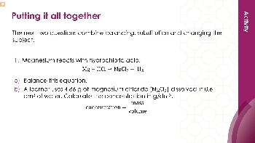  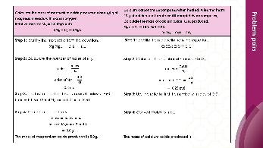 | 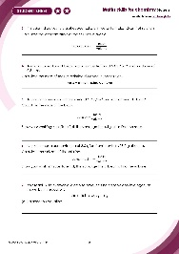
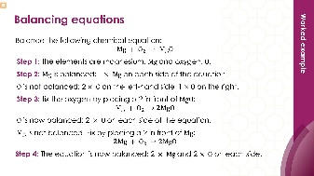
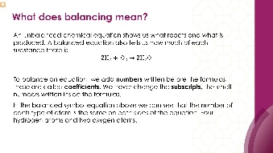

Teacher-led presentation (✪✪): a full lesson including learning objectives, learner-facing instructions and activities. | Short activities (✪✪): learner-facing activities, designed as lesson starters or quick activities to engage prior knowledge. | Learner worksheet (✪✪): activities for learners to independently practice their maths skills. Suitable as classroom activity following the teacher presentation or as a home-learning task.

Key terms support
Key mathematical vocabulary for each skill area is defined in the key terms support: rsc.li/4wypuqq. You will find the key terms listed by topic area and an accessible glossary slide for each term.

Using the short activities presentation
The aim of this resource is for learners to revisit and practise skills from the teacher-led presentation and to develop problem solving skills so they can apply these independently.

Learning objectives
- Understand the algebra needed for balancing chemical equations
- Substitute numerical values into formulas and expressions using appropriate units.
- Change the subject of an equation.
- Solve for unknowns in chemical equations and stoichiometry problems.
As you move through the activities, there is a clear progression in skill development. The first activity or activities engage learners’ prior knowledge. Following this, learners will complete activities using mathematical skills within a chemistry context.
Activities can be teacher-led, for learners requiring additional support or modelling, or can be set as independent work.
The presentation contains three short activities that are designed to last 5–15 minutes and to be used as:
- a starter activity to engage prior knowledge or to practise a skill
- an assessment tool, used at the beginning of a lesson or sequence of work
- as follow-up independent practice during lessons or plenary
- for retrieval practice.

Metacognition
The learner worksheet supports learners to develop their metacognitive skills in three key areas.
- Planning − prompt learners to draw on their existing mathematical knowledge by asking themselves: ‘Have I seen a similar question before? Have I come across this mathematical skill before? Have I learned a different method for solving a similar problem?’
- Monitoring – prompt learners to ask themselves: ‘How confident am I feeling with these mathematical skills? Which questions am I finding difficult? Which type of questions do I feel I have mastered?’
- Evaluation – prompt learners to ask themselves: ‘What have I learned about myself when doing these questions? Which of the mathematical skills did I use to answer these questions?’

Slide notes

Slide 1: Title slide

Slide 2: Introduction
No notes.

Slide 3: Balancing chemical equations
Allow learners time to attempt each equation. Encourage them to draw an atom count table for each one and to check that all elements balance at the end.

Slide 4: Balancing chemical equations (answers)
- ${Li}_{2}O$ has 2 $Li$, so we need ${2Li}_{2}O$ to use both oxygens from $O_{2}$ (giving 2 $O$on each side). Then ${2Li}_{2}O$ needs 4$Li$on the left. Check: $Li: 4 = 4, O: 2 = 2$
- Start with hydrogen: ${Ca(OH)}_{2}$has 2$H$ in the hydroxide groups, plus $H_{2}$ has 2 $H$on the right. Total $H$ on right $=$ 4. So, we need ${2H}_{2}O$on the left (4$H,$ 2 $O$). Check: $Ca: 1 = 1, H: 4 = 4, O: 2 = 2$
- Start with iron: ${2Fe}_{2}O_{3}$gives $4 Fe$, so $4Fe$on the right. Oxygen: ${2Fe}_{2}O_{3}$ has $6 O$, so need $3{CO}_{2} (6 O)$ on the right. Carbon: $3$ on each side. Check: $Fe: 4 = 4, O: 6 = 6, C: 3 = 3$
- Carbon: 1 on each side. Hydrogen: 4 in ${CH}_{4}$, so ${2H}_{2}O$ on the right. Oxygen on the right: 2 (from ${CO}_{2}$) $+$ 2 (from ${2H}_{2}O$) $= 4$, so ${2O}_{2}$ on the left. Check: $C: 1 = 1, H: 4 = 4, O: 4 = 4$. This is the combustion of methane (natural gas).
- Carbon: 3 in $C_{3}H_{8}$, so ${3CO}_{2}$. Hydrogen: 8 in $C_{3}H_{8}$, so ${4H}_{2}O$ Oxygen on the right: 6 (from ${3CO}_{2}$) + 4 (from ${4H}_{2}O$) $=$ 10, so ${5O}_{2}$ on the left. Check: $C: 3 = 3, H: 8 = 8, O: 10 = 10$. This is the combustion of propane. Remind learners to balance oxygen last in combustion equations as it appears in both products.

Slide 5: Substitution into formulas
Allow learners time to attempt each question using the four-step method: write the formula, substitute, solve, units.

Slide 6: Substitution into formulas (answers)
- This is close to the actual density of copper (8.96 g/cm³). Ask learners: what metal do you think this is?
- Ask: where do the units come from? Volume is in cm³ and time is in seconds (s), so the rate is cm³/s. The units follow from the formula.
- This question uses multiplication rather than division. Some learners may recognise that this is the same formula as Q2 rearranged. Discuss: these are not two different formulas; they are the same relationship written differently. This links to the ‘changing the subject’ slides.
Ask learners: which questions used division and which used multiplication? Q1, Q2 and Q3 use division. Q4 uses multiplication. The four-step method works the same way for both.

Slide 7: changing the subject – one calculation
These questions all have the unknown on the top of the division, so only one step is needed to change the subject. Allow learners time to attempt each one. Remind them to substitute first, then rearrange.

Slide 8: changing the subject – one calculation (answers)
Ask learners: how can you tell this is the one-step type? After substituting, the unknown is being divided by a number (e.g. m $÷$8.0). The unknown is on the top, so one multiplication gets it on its own.
Discuss: compare these with the substitution questions on slide 5. The algebra is slightly harder because the unknown is not already the subject of the formula. But the process is the same: substitute, then use an inverse operation.

Slide 9: changing the subject − two calculations
These questions all have the unknown on the bottom of the division, so two steps are needed. Allow learners time to attempt each one. Remind them to substitute first, then use two inverse operations to change the subject.

Slide 10: changing the subject − two calculations (answers)
Ask learners: how can you tell this is the two-step type? After substituting, the unknown is the letter that the number is being divided by (e.g. 36.0 $÷$ volume). The unknown is on the bottom, so you need to multiply both sides by the unknown first to bring it to the top, then divide to get it on its own.
Discuss: compare these with the one-step questions on slide 7. Ask learners: what is the key difference? In slide 7, the unknown was on the top (being divided by a number). Here the unknown is on the bottom (a number is being divided by it). Recognising which type a question is before starting helps learners plan their working.

Slide 11: putting it all together (question 1)
This question combines multiple skills. Allow learners time to attempt each one. Encourage them to identify which skills are needed before starting.

Slide 12: putting it all together (question 2)
This question combines multiple skills. Allow learners time to attempt each one. Encourage them to identify which skills are needed before starting.

Slide 13: putting it all together (answers)
Discuss: Question 2 is a multi-step problem. Part (b) uses conservation of mass from Stage 1. Part (c) uses the answer from part (b) as the mass in the density formula. Ask learners: what would happen if they got part (b) wrong? Their answer to part (c) would also be wrong, even if they used the formula correctly. This is why showing working is important, as examiners can award marks for correct method even if an earlier error carries through.

Slide 14: Discussing algebra in chemistry
Ask learners to work through each learner's answer, in pairs or on mini whiteboards, before revealing which is correct.

Slide 15: Discussing algebra in chemistry (answer)
Learner B is correct.
$V = \frac{156}{7.8}$
$${V=20 cm}^{3}$$
Learner A is incorrect because they used the wrong inverse operation. They correctly substituted ($7.8 = 156 ÷ V$) and correctly multiplied both sides by $V$ ($7.8 × V = 156$). But then they multiplied 156 by 7.8 instead of dividing. They confused the second step. Ask learners: after $7.8 × V = 156$, what do we need to do to get $V$ on its own? Divide both sides by 7.8, not multiply.
Learner C is incorrect because they substituted the values the wrong way round. They wrote $7.8 = V ÷ 156$instead of $7.8 = 156 ÷ V$. The formula says $density = mass ÷ volume$, so mass goes on the top and volume on the bottom. Learner C put volume on the top and mass on the bottom. Remind learners to look at the formula carefully before substituting.
Discuss: both Learner A and Learner C got the same wrong answer (1216.8 cm³) but for completely different reasons. Ask learners: how could they have spotted the error? A density of 7.8 g/cm³ is quite high, like the density of iron. A volume of 1216.8 cm³ for 156 g of a dense metal doesn't make sense. That would be over a litre. Checking whether an answer is reasonable is a good habit.
Ask: which type of rearrangement is this? The unknown ($V$) is on the bottom of the division, so it is the two-step type from slide 4. Learner B correctly used both steps.

