Significant figures and rounding
This set of short activities forms part of the Maths skills for chemistry resources series which can be viewed at: rsc.li/4A41ezG. The series offers flexible, targeted support for maths skills which are fundamental to chemistry teaching:
- Graphs and data, divided into:
  - Creating graphs
  - Interpreting graphs
- Ratio and proportion
- Understanding number, divided into:
  - Unit conversion
  - Significant figures and rounding
- Algebra and equations

Resource series components
The resource series is divided into two stages. Stage 1 (✪) is most suitable for ages 11−14 and stage 2 (✪✪) for ages 14−16. However, older learners with gaps in their fundamental knowledge can use stage 1 as a stepping stone. Understanding number is available at stage 1 only.
Stage 1 ✪ | 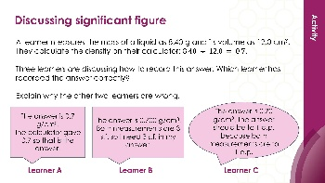  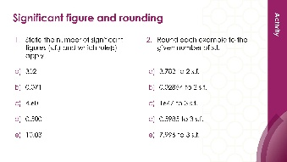 | 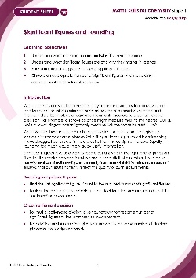
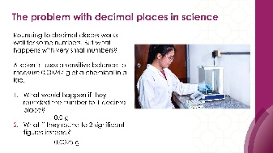
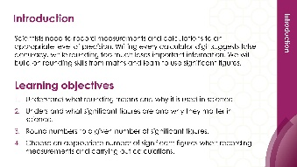
Teacher-led presentation (✪): a full lesson including learning objectives, learner-facing instructions and activities. | Short activities (✪): learner-facing activities, designed as lesson starters or quick activities to engage prior knowledge. | Learner worksheet (✪): activities for learners to independently practice their maths skills. Suitable as classroom activity following the teacher presentation or as a home-learning task.

Key terms support
Key mathematical vocabulary for each skill area is defined in the key terms support: rsc.li/4wypuqq. You will find the key terms listed by topic area and an accessible glossary slide for each term.

Using the short activities presentation
The aim of this resource is for learners to revisit and practise skills from the teacher-led presentation and to develop problem solving skills so they can apply these independently.

Learning objectives
- Understand what rounding means and why it is used in science.
- Understand what significant figures are and why they matter in science.
- Round numbers to a given number of significant figures.
- Choose an appropriate number of significant figures when recording measurements and carrying out calculations.
As you move through the activities, there is a clear progression in skill development. The first activity or activities engage learners’ prior knowledge of the chosen maths skill. Following this, learners will complete activities within a chemistry context.
Activities can be teacher-led, for learners requiring additional support or modelling, or can be set as independent work.
The presentation contains three short activities that are designed to last 5–15 minutes and to be used as:
- a starter activity to engage prior knowledge or to practise a skill
- an assessment tool, used at the beginning of a lesson or sequence of work
- as follow-up independent practice during lessons or plenary
- for retrieval practice.

Metacognition
The activities support learners to develop their metacognitive skills in three key areas.
- Planning − prompt learners to draw on their existing mathematical knowledge by asking themselves: ‘Have I seen a similar question before? Have I come across this mathematical skill before? Have I learned a different method for solving a similar problem?’
- Monitoring – prompt learners to ask themselves: ‘How confident am I feeling with these mathematical skills? Which questions am I finding difficult? Which type of questions do I feel I have mastered?’
- Evaluation – prompt learners to ask themselves: ‘What have I learned about myself when doing these questions? Which of the mathematical skills did I use to answer these questions?’

Slide notes

Slide 1: Title slide

Slide 2: Learning objectives

Slide 3: Significant figures and rounding
It may be useful to recap the rules presented in the teacher-led presentation (slide 7, full presentation from: rsc.li/4gbEt3p).
How do we work out which digits are significant?​
Rule 1: All non-zero digits are significant.​
Rule 2: Zeros between non-zero digits are significant. ​
Rule 3: Leading zeros are not significant digits.​
Rule 4: Trailing zeros after a decimal point are significant.​

Slide 4: Significant figures and rounding (answers)
- Identifying significant figures:
- 302 – 3 s.f. The 3 and 2 are non-zero (rule 1), and the zero is between non-zero digits so it is significant (rule 2).
- 0.071 – 2 s.f. The 7 and 1 are non-zero (rule 1), and the leading zeros are not significant (rule 3).
- 4.60 – 3 s.f. The 4 and 6 are non-zero (rule 1), and the trailing zero after the decimal point is significant (rule 4).
- 0.0500 – 3 s.f. The 5 is non-zero (rule 1), the leading zeros are not significant (rule 3), and the two trailing zeros after the decimal point are significant (rule 4). Learners may say 1 s.f. (only counting the 5) or 4 s.f. (counting every digit).
- 10.03 – 4 s.f. The 1 and 3 are non-zero (rule 1), and both zeros are between non-zero digits, so they are significant (rule 2).
- Rounding:
- 3.782 to 2 s.f. First s.f. is 3, second s.f. is 7. Decider is 8 (≥5), round up. Answer: 3.8
- 0.02854 to 2 s.f. Leading zeros are not significant. First s.f. is 2, second s.f. is 8. Decider is 5 (≥5), round up. Answer: 0.029
- 1647 to 3 s.f. First s.f. is 1, second s.f. is 6, third s.f. is 4. Decider is 7 (≥5), round up. Answer: 1650. Learners must fill in the placeholder zero. Without it the number would be 165, which is ten times too small.
- 0.5985 to 3 s.f. First s.f. is 5, second s.f. is 9, third s.f. is 8. Decider is 5 (≥5), round up. Answer: 0.599
- 7.996 to 3 s.f. First s.f. is 7, second s.f. is 9, third s.f. is 9. Decider is 6 (≥5), round up. The 9 becomes 10, which cascades: 7.996 becomes 8.00. Answer: 8.00
Discuss: why must the answer be written as 8.00 and not 8? Because 8 is 1 s.f. and 8.00 is 3 s.f. – dropping the trailing zeros changes what the number communicates about precision.

Extension task: Ask learners to round 0.009962 to 2 s.f. This combines the cascading rounding from question (e) with the leading zeros from question (b). Answer: 0.010 – learners must keep both the leading zeros and the trailing zero.

Slide 5: Recording answers to the right level of precision
No notes.

Slide 6: Recording answers to the right level of precision (answers)
Question 1: this is a division, so match significant figures.
Mass is 3 s.f., volume is 2 s.f.
The least precise is the volume (2 s.f.), so the answer should be to 2 s.f.
First s.f. is 2, second s.f. is 6. Decider is 6 (≥5), round up.
Answer: 2.7 g/cm³
Common errors and misconceptions:
- writing 2.67 (3 s.f., matching the mass instead of the volume)
- writing 2.669230769 (copying the calculator)
- writing 3 (over-rounding to 1 s.f.)
Question 2: the mean is 19.5°C, which is to 1 d.p. The thermometer reads to 1 d.p., so 19.5°C is correct.
The purpose is to check that learners can explain why it is correct: the answer matches the precision of the thermometer, not just because the calculator said so.
Ask: what if the mean had been 19.5333...? Then they would round to 19.5°C (1 d.p., matching the thermometer).
Question 3: this is a division, so match significant figures.
Both values are 2 s.f., so the answer should be to 2 s.f.
Leading zeros are not significant. First s.f. is 3, second s.f. is 3. Decider is 3 (<5), round down.
Answer: 0.033 g/cm³
Discuss: some learners may want to write $0.3\dot{3 }$using recurring dot notation from maths. Explain that this is not acceptable in science – measurements have limited precision, so our answer cannot be infinitely precise. We always round instead.

Slide 7: Significant figures
No notes.

Slide 8: Significant figures (answers)
Learner B is correct.
This is a division, so match significant figures.
Mass = 8.40 g (3 s.f. – the trailing zero after the decimal point is significant, rule 4)
Volume = 12.0 cm³ (3 s.f. – the trailing zero after the decimal point is significant, rule 4)
Both are 3 s.f., so the answer should be to 3 s.f.
0.7 written to 3 s.f. is 0.700 g/cm³
Learner A is incorrect because they have just accepted the calculator display. The calculator shows 0.7, which is only 1 s.f. The measurements justify 3 s.f., so trailing zeros must be added to show the answer is precise to 3 s.f. This is the reverse of the usual problem – normally learners write too many digits, but here the calculator has given too few.
Learner C is incorrect because they have used the decimal places rule instead of the significant figures rule. This is a division, so significant figures apply, not decimal places. The d.p. rule is for addition and subtraction. Even though both measurements are to 1 d.p., that is not the relevant consideration here.
Learner C's reasoning sounds plausible, which makes it a valuable misconception to explore. Ask learners to explain what is wrong with the logic in Learner C's own words.
Ask: how would the answer change if the measurements were 8.4 g (2 s.f.) and 12 cm³ (2 s.f.)? Then the answer would be 0.70 g/cm³ (2 s.f.). Learner C's answer would then be numerically correct but still for the wrong reason.

