Significant figures and rounding
This learner worksheet forms part of the Maths skills for chemistry resources series which can be viewed at: rsc.li/4A41ezG. The resource series covers maths skills which are fundamental to chemistry teaching:
- Algebra and equations
- Ratio and proportion
- Graphs and data, divided into:
  - Creating graphs
  - Interpreting graphs
- Understanding number, divided into:
  - Unit conversion
  - Significant figures and rounding

Resource series components
The resource series is divided into two stages. Stage 1 (✪) is most suitable for ages 11−14 and stage 2 (✪✪) for ages 14−16. However, older learners with gaps in their fundamental knowledge can use stage 1 as a stepping stone. Understanding number is available at stage 1 only.
Stage 1 ✪ | 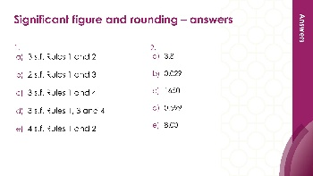  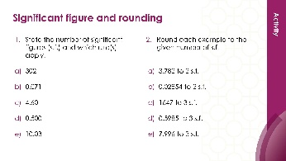 | 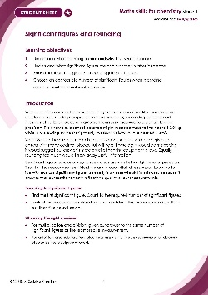
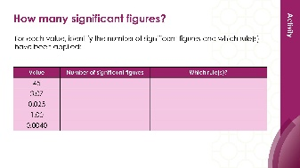
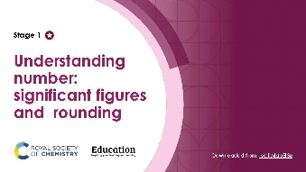
Teacher-led presentation (✪): a full lesson including learning objectives, learner-facing instructions and activities. | Short activities (✪): learner-facing activities, designed as lesson starters or quick activities to engage prior knowledge. | Learner worksheet (✪): activities for learners to independently practice their maths skills. Suitable as classroom activity following the teacher presentation or as a home-learning task.

Key terms support
Key mathematical vocabulary for each skill area is defined in the key terms support: rsc.li/4wypuqq. You will find the key terms listed by topic area and an accessible glossary slide for each term.

Using the learner worksheet
The focus of this learner worksheet is mastering maths skills in a chemistry context. The aim is for learners to develop and apply maths skills independently.

Learning objectives
- Understand what rounding means and why it is used in science.
- Understand what significant figures are and why they matter in science.
- Round numbers to a given number of significant figures.
- Choose an appropriate number of significant figures when recording measurements and carrying out calculations.
The learner worksheets complement the teacher-led presentations but can function independently, for example as a classroom activity or homework assignment.
Teacher notes and answers are provided at the end of this document. When relevant, common mathematical misconceptions are highlighted.

When to use
Use the learner worksheet for:
- Reviewing learning – if learners are confident with the mathematical skill, use the worksheet as a tool to review learning and assess learners’ skill level.
- Independent practice – provide learners with the worksheet to use as independent practice.
- Scaffolded practice – break the worksheet into sections and complete over a longer period, such as multiple lessons.
- Mathematical modelling – for those requiring additional support, talk through the initial questions pulling out the mathematical skills used to answer the question, highlighting and defining any key terms. If learners are still finding the task difficult, consider fading the initial questions and asking learners to complete the later questions independently.

Scaffolding
The worksheet presents a clear progression in skill development. It starts with a recap of key knowledge and worked examples. The first question engages prior knowledge of the chosen maths skill. Following this, learners will do some maths–chemistry translation tasks, then complete activities in a chemistry context.
Have the key terms list or accessible glossary available for learners who require additional support with mathematical vocabulary.

Metacognition
The learner worksheet supports learners to develop their metacognitive skills in three key areas.
- Planning − prompt learners to draw on their existing mathematical knowledge by asking themselves: ‘Have I seen a similar question before? Have I come across this mathematical skill before? Have I learned a different method for solving a similar problem?’
- Monitoring – prompt learners to ask themselves: ‘How confident am I feeling with these mathematical skills? Which questions am I finding difficult? Which type of questions do I feel I have mastered?’
- Evaluation – prompt learners to ask themselves: ‘What have I learned about myself when doing these questions? Which of the mathematical skills did I use to answer these questions?’

Answers:

- 56 – 2 s.f. (both digits non-zero)
- 3.04 – 3 s.f. (zero between non-zero digits is significant)
- 0.072 – 2 s.f. (leading zeros are not significant)
- 8.0 – 2 s.f. (trailing zero after decimal point is significant)
- 0.00310 – 3 s.f. (leading zeros not significant, trailing zero is significant)

- 4.83 → 4.8 (decider is 3, round down)
- 0.0672 → 0.067 (leading zeros not significant; decider is 2, round down)
- 345 → 350 (decider is 5, round up; fill placeholder zero)
- 12.95 → 13 (decider is 5, round up)

- This is a division, so match significant figures. Mass = 47.2 g (3 s.f.), volume = 18 cm³ (2 s.f.). The least precise is the volume (2 s.f.), so the answer should be to 2 s.f.
- 2.622 rounded to 2 s.f.: first s.f. is 2, second s.f. is 6. Decider is 2 (<5), round down. Answer: 2.6 g/ cm³

- The balance reads to 1 d.p. A mean of repeated measurements from the same instrument should match the precision of that instrument. Answer: 12.6 g (1 d.p.)
- Writing 12.333 g implies the measurement is precise to 3 d.p., but the balance only reads to 1 d.p. The answer cannot be more precise than the equipment used.
Note for question 4: most exam boards accept an arithmetic mean quoted to one more significant figure than the raw data if it is the exact result of the calculation. This nuance is not addressed at Level 1 but may be relevant at post-16.

- This is a division, so match significant figures. Mass = 4.0 g (2 s.f.), volume = 150 cm³ (2 s.f.). Both are 2 s.f., so the answer should be to 2 s.f.
- 0.026666 rounded to 2 s.f.: leading zeros are not significant. First s.f. is 2, second s.f. is 6. Decider is 6 (≥5), round up. Answer: 0.027 g/ cm³
- In maths, dot notation is an exact way to represent a recurring number because mathematically the number is infinitely precise. In science, this is not acceptable because measurements have limited precision. The balance and measuring cylinder can only measure to a certain level of precision, so our answer cannot be infinitely precise. In chemistry we always round instead.

