Unit conversion
This set of short activities forms part of the Maths skills for chemistry resources series which can be viewed at: rsc.li/4A41ezG. The resource series covers mathematical skills which are fundamental to chemistry teaching:
- Graphs and data, divided into:
  - Creating graphs
  - Interpreting graphs
- Ratio and proportion
- Understanding number, divided into:
  - Unit conversion
  - Significant figures and rounding
- Algebra and equations

Resource series components
The resource series is divided into two stages. Stage 1 (✪) is most suitable for ages 11−14 and stage 2 (✪✪) for ages 14−16. However, older learners with gaps in their fundamental knowledge can use stage 1 as a stepping stone. Understanding number is available at stage 1 only.
Stage 1 ✪ | 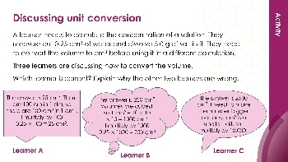  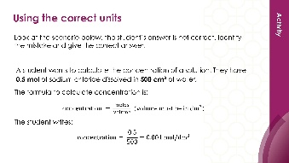 | 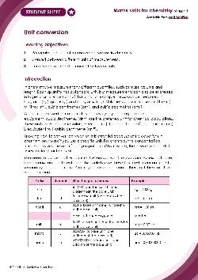
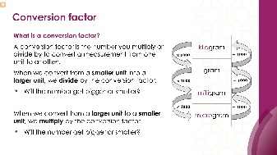
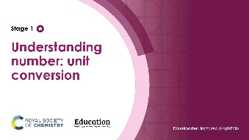
Teacher-led presentation (✪): a full lesson including learning objectives, learner-facing instructions and activities. | Short activities (✪): learner-facing activities, designed as lesson starters or quick activities to engage prior knowledge. | Learner worksheet (✪): activities for learners to independently practice their maths skills. Suitable as classroom activity following the teacher presentation or as a home-learning task.

Key terms support
Key mathematical vocabulary for each skill area is defined in the key terms support: rsc.li/4wypuqq. You will find the key terms listed by topic area and an accessible glossary slide for each term.

Using the short activities
The aim of this resource is for learners to revisit and practise skills from the teacher-led presentation and to develop problem solving skills so they can apply these independently.

Learning objectives
- Recognise the units of measurements we use in chemistry.
- Convert between different units of measurement.
- Know when we need to convert between units.
As you move through the activities, there is a clear progression in skill development. The first activity or activities engage learners’ prior knowledge of the chosen maths skill. Following this, learners will complete activities within a chemistry context.
Activities can be teacher-led, for learners requiring additional support or modelling, or can be set as independent work.
The presentation contains four short activities that are designed to last 5–15 minutes and to be used as:
- a starter activity to engage prior knowledge or to practise a skill
- an assessment tool, used at the beginning of a lesson or sequence of work
- as follow-up independent practice during lessons or plenary
- for retrieval practice.

Metacognition
The activities support learners to develop their metacognitive skills in three key areas.
- Planning − prompt learners to draw on their existing mathematical knowledge by asking themselves: ‘Have I seen a similar question before? Have I come across this mathematical skill before? Have I learned a different method for solving a similar problem?’
- Monitoring – prompt learners to ask themselves: ‘How confident am I feeling with these mathematical skills? Which questions am I finding difficult? Which type of questions do I feel I have mastered?’
- Evaluation – prompt learners to ask themselves: ‘What have I learned about myself when doing these questions? Which of the mathematical skills did I use to answer these questions?’

Slide notes

Slide 1: Title slide

Slide 2: Introduction
Ask students to think of an example of when using the wrong unit could cause a problem.

Slide 3: Identify the conversion factor
No notes.

Slide 4: Identify the conversion factor (answers)
Answers:

- kg to g. Conversion factor: 1 kg = 1000 g
- Is the unit getting bigger or smaller? g is smaller than kg
- Is the answer getting bigger or smaller? The answer gets bigger (more grams than kilograms)
- Do we multiply or divide? Multiply by 1000
- mm to m. Conversion factor: 1 m = 1000 mm
- Is the unit getting bigger or smaller? m is bigger than mm
- Is the answer getting bigger or smaller? The answer gets smaller (fewer metres than millimetres)
- Do we multiply or divide? Divide by 1000
- μm to nm. This may prove challenging to learners as nanometres are often not introduced until post-16. However, learners are practising unit conversions for this example, so the process is the same. Conversion factor: 1 μm = 1000 nm
- Is the unit getting bigger or smaller? nm is smaller than μm
- Is the answer getting bigger or smaller? The answer gets bigger (more nanometres than micrometres)
- Do we multiply or divide? Multiply by 1000
- cm³ to dm³. Conversion factor: 1 dm³ = 1000 cm³ (because volumes are cubed: 10 $×$ 10 $×$ 10 = 1000)
- Is the unit getting bigger or smaller? dm³ is bigger than cm³
- Is the answer getting bigger or smaller? The answer gets smaller (fewer dm³ than cm³)
- Do we multiply or divide? Divide by 1000

Slide 5: Using the correct units
No notes.

Slide 6: Using the correct units (answer)
No notes.

Slide 7: Using the correct units
No notes.

Slide 8: Using the correct units (answer)
No notes.

Slide 9: Discussing unit conversion
No notes.

Slide 10: Discussing (answer)
Learner B is correct.
- Conversion factor: 1 dm³ = 1000 cm³ (because volumes are cubed: 10 $×$ 10 $×$ 10 = 1000)
- Is the unit getting bigger or smaller? cm³ is smaller than dm³
- Is the answer getting bigger or smaller? Bigger – more cm³ than dm³
- Do we multiply or divide? Multiply by 1000
0.25 $×$ 1000 = 250 cm³

