Unit conversion
This learner worksheet forms part of the Maths skills for chemistry resources series which can be viewed at: rsc.li/4A41ezG. The resource series covers maths skills which are fundamental to chemistry teaching:
- Algebra and equations
- Ratio and proportion
- Graphs and data, divided into:
  - Creating graphs
  - Interpreting graphs
- Understanding number, divided into:
  - Unit conversion
  - Significant figures and rounding

Resource series components
The resource series is divided into two stages. Stage 1 (✪) is most suitable for ages 11−14 and stage 2 (✪✪) for ages 14−16. However, older learners with gaps in their fundamental knowledge can use stage 1 as a stepping stone. Understanding number is available at stage 1 only.
Stage 1 ✪ | 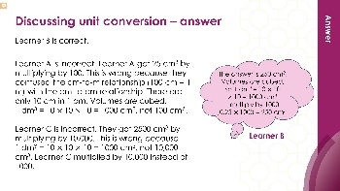  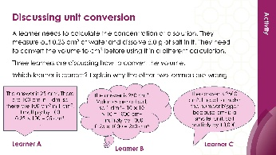 | 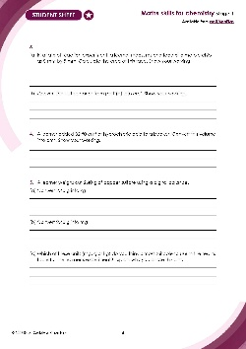
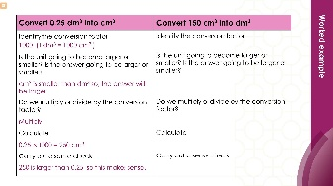
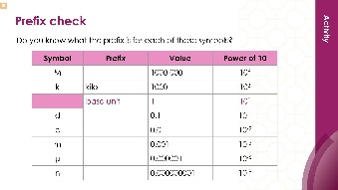
Teacher-led presentation (✪): a full lesson including learning objectives, learner-facing instructions and activities. | Short activities (✪): learner-facing activities, designed as lesson starters or quick activities to engage prior knowledge. | Learner worksheet (✪): activities for learners to independently practice their maths skills. Suitable as classroom activity following the teacher presentation or as a home-learning task.

Key terms support
Key maths vocabulary for each skill area is defined in the key terms support: rsc.li/4wypuqq. You will find the key terms listed by topic area and an accessible glossary slide for each term.

Using the learner worksheet
The focus of this learner worksheet is mastering maths skills in a chemistry context. The aim is for learners to develop and apply maths skills independently.

Learning objectives
- Recognise the units of measurement we use in chemistry.
- Convert between different units of measurement.
- Know when we need to convert between units.
The learner worksheets complement the teacher-led presentations but can function independently, for example as a classroom activity or homework assignment.
Answers are provided at the end of this document. When relevant, common mathematical misconceptions are highlighted.

When to use
Use the learner worksheet for:
- Reviewing learning – if learners are confident with the mathematical skill, use the worksheet as a tool to review learning and assess learners’ skill level.
- Independent practice – provide learners with the worksheet to use as independent practice.
- Scaffolded practice – break the worksheet into sections and complete over a longer period, such as multiple lessons.
- Mathematical modelling – for those requiring additional support, talk through the initial questions pulling out the mathematical skills used to answer the question, highlighting and defining any key terms. If learners are still finding the task difficult, consider fading the initial questions and asking learners to complete the later questions independently.

Scaffolding
The worksheet presents a clear progression in skill development. It starts with a recap of key knowledge and worked examples. The first question engages prior knowledge of the chosen maths skill. Following this, learners will do some maths–chemistry translation tasks, then complete activities in a chemistry context.
Have the key terms list or accessible glossary available for learners who require additional support with mathematical vocabulary.

Metacognition
This resource type supports learners to develop their metacognitive skills in three key areas.
- Planning − prompt learners to draw on their existing mathematical knowledge by asking themselves: ‘Have I seen a similar question before? Have I come across this mathematical skill before? Have I learned a different method for solving a similar problem?’
- Monitoring – prompt learners to ask themselves: ‘How confident am I feeling with these mathematical skills? Which questions am I finding difficult? Which type of questions do I feel I have mastered?’
- Evaluation – prompt learners to ask themselves: ‘What have I learned about myself when doing these questions? Which of the mathematical skills did I use to answer these questions?’

Common misconceptions
In question 1(a), dividing instead of multiplying is the most frequent error. Learners sometimes confuse the direction of the conversion. Some may write 3.5000 g, misplacing decimal points. Encourage them to write out the conversion factor before calculating. If this is a frequent mistake among learners, introduce place value tables to support them to correctly place the decimal point.
In question 1(b), the most common error is multiplying instead of dividing. Decimal place errors are common; learners may write 2.5 g or 0.025 g. Reassure them that the small answer makes sense because a milligram is a much smaller unit than a gram.
In question 1(c), learners may not have encountered dm³ very often. Learners often think the conversion factor is 10 (confusing dm with dm³). Spend a moment explaining why: 1 dm = 10 cm. But 1 dm³ is a cube, so 10 cm $×$ 10 cm $×$ 10 cm = 1000 cm³. Multiplying instead of dividing is also common.
Question 1(d) is the reverse of question 1(c). A key question to ask learners is whether they think their answer is sensible or reasonable. A number in cm³ should be larger than when it is in dm³.
For question 1(e), learners may incorrectly assume a conversion calculation is needed and invent a factor. Some may confuse this with ml and cm³ (also equivalent: 1 ml = 1 cm³). This is an excellent question to pause on – ask learners how many cm³ are in 1 litre (1000 cm³) to reinforce the bigger picture. Remind learners that in maths and everyday life, litres are used, but in chemical calculations units of cubic decimetres or cubic centimetres are used.
Question 2 requires learners to carry out a unit conversion and an area calculation. The most common error is forgetting to convert mm to cm before calculating, giving 900 $×$6 = 5400 (with incorrect units). Some learners calculate only the area of one face (9 cm²) rather than all six, and others confuse surface area with volume (3³ = 27). Prompt learners to ask themselves what units their final answer should be in and why.
For question 3, learners may forget to write the unit correctly as mm². Part b is demanding, so you can opt to remove it or use it as an extension. The most frequent error is dividing by 10 instead of 100, giving 4 cm². Learners know that 1 cm = 10 mm but do not square the conversion factor for area. This is a persistent misconception so check this as often as possible. The same logic applies to volume: 1 cm³ = 1000 mm³ (the conversion factor is cubed).
A visual approach can help, draw a 1 cm $×$1 cm square on the board, divide it into millimetre grid squares, and count the 100 squares. Speak to your maths department as they may have physical aids such as base-10 blocks in 1’s, 10’s, 100’s, and 1000’s for you to borrow and demonstrate with. Equally, treat this question as an extension if necessary.
For question 4, the answer is a small decimal which learners can find counterintuitive. The most common misconception is to multiply by 1000 (giving 32,500). Rounding errors are also common, learners may write 0.03 and lose the significant figures. Reassure learners that 32.5 cm³ is a small volume (roughly two tablespoons), so a small dm³ value makes sense.
For question 5, the pairing of (a) and (b) can provide an illustration of equivalence across three units. 0.00240 kg = 2.40 g = 2400 mg. Part (c) asks for a reasonable justification of why g is the best unit to use here, but if learners give a good reason for using mg this could be accepted. However, it is important to make sure this is not due to a misconception about precision. Learners may incorrectly think if there are more numbers then the measurement is more precise.
In question 6, part (d) is challenging and involves a two-step calculation. Make a judgement about whether this question is suitable at this point in the curriculum for your class. Again, you can use it as an extension.

Answers

- 3.5 $×$ 1000 = 3500 g
- 250 $÷$ 1000 = 0.25 g
- 4200 $÷$ 1000 = 4.2 dm³
- 0.6 $×$ 1000 = 600 cm³
- 2.12 L = 2.12 dm³ (no calculation needed)
- 85 $÷$100 = 0.85 m
- Convert 30 mm to cm (1 cm = 10 mm, so 30 $÷$ 10 = 3 cm)
Area of one face = 3 $×$3 = 9 cm²
A cube has 6 faces, so surface area = 6 $×$9 = 54 cm²

- Area of a face measuring 8 mm by 5 mm: 8 $×$5 = 40 mm²
- Key fact: 1 cm = 10 mm, therefore 1 cm² = 10 $×$10 = 100 mm²
40 $÷$100 = 0.4 cm²
- Conversion factor: 1 dm³ = 1000 cm³
32.50 $÷$1000 = 0.03250 dm³

- 2.40 $÷$1000 = 0.0240 kg
- 2.40 $×$1000 = 2400 mg
- The best units to use would be grams (g) because this is the unit used by the balance and it is easy to read and to write down. The other two values are trickier to write into the table and give either a large number or a very small number.

- Kilojoules
- Joules
- Yes, they match 8.4 kJ = 8.4 $×$ 1000 = 8400 J. The two values are the same quantity expressed in different related units.
- Convert kJ to J. 8.4 $×$ 1000 = 8400
Convert J to MJ. 1 MJ = 1 000 000 J
8400 $÷$ 1 000 000 = 0.0000084 MJ

