Creating graphs
This set of short activities forms part of the Maths skills for chemistry resources series which can be viewed at: rsc.li/4A41ezG. The resource series covers mathematical skills which are fundamental to chemistry teaching:
- Graphs and data, divided into:
  - Creating graphs
  - Interpreting graphs
- Ratio and proportion
- Understanding number, divided into:
  - Unit conversion
  - Significant figures and rounding
- Algebra and equations

Resource series components
The resource series is divided into two stages. Stage 1 (✪) is most suitable for ages 11−14 and stage 2 (✪✪) for ages 14−16. However, older learners with gaps in their fundamental knowledge can use stage 1 as a stepping stone.
Stage 1 ✪ | 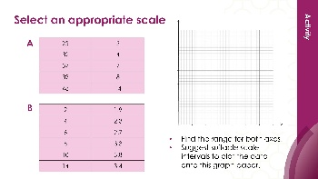  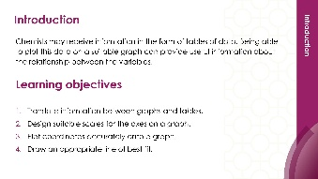 | 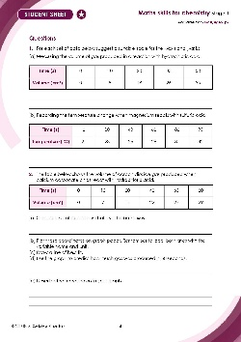
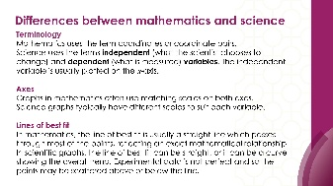
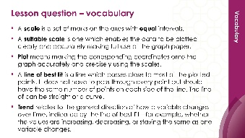
Teacher-led presentation (✪): a full lesson including learning objectives, learner-facing instructions and activities. | Short activities (✪): learner-facing activities, designed as lesson starters or quick activities to engage prior knowledge. | Learner worksheet (✪): activities for learners to independently practice their maths skills. Suitable as classroom activity following the teacher presentation or as a home-learning task.

Stage 2 ✪✪ | 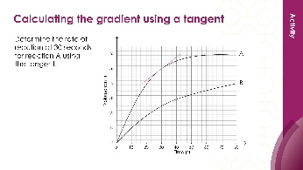  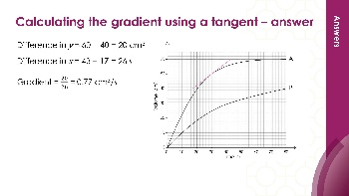 | 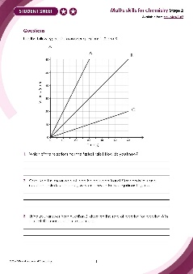

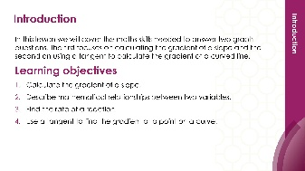

Teacher-led presentation (✪✪) | Short activities (✪✪) | Learner worksheet (✪✪)

Key terms support
Key maths vocabulary for each skill area is defined in the key terms support: rsc.li/4wypuqq. You will find the key terms listed by topic area and an accessible glossary slide for each term.

Using the short activities
The focus of short activities is embedding maths skills and engaging prior learning. The aim of this resource is for learners to revisit and practise skills from the teacher-led presentation and to develop problem solving skills so they can apply these independently.

Learning objectives
- Translate information between graphs and tables.
- Design suitable scales for the axes on a graph.
- Plot coordinates accurately onto a graph.
- Draw an appropriate line of best fit.
As you move through the activities, there is a clear progression in skill development. The first activity or activities engage learners’ prior knowledge of the chosen maths skill. Following this, learners will complete activities within a chemistry context.
Activities can be teacher-led, for learners requiring additional support or modelling, or can be set as independent work.
The presentation contains five short activities that are designed to last 5–15 minutes and to be used as:
- a starter activity to engage prior knowledge or to practise a skill
- an assessment tool, used at the beginning of a lesson or sequence of work
- as follow-up independent practice during lessons or plenary
- for retrieval practice.

Metacognition
The activities support learners to develop their metacognitive skills in three key areas.
- Planning – prompt learners to draw on their existing mathematical knowledge by asking themselves: ‘Have I seen a similar question before? Have I come across this mathematical skill before? Have I learned a different method for solving a similar problem?’
- Monitoring – prompt learners to ask themselves: ‘How confident am I feeling with these mathematical skills? Which questions am I finding difficult? Which type of questions do I feel I have mastered?’
- Evaluation – prompt learners to ask themselves: ‘What have I learned during the presentation? Which of the mathematical skills did I use to answer these questions?’

Slide notes

Slide 1: Title slide

Slide 2: Introduction
No notes.

Slide 3: Which axis to plot?
In mathematics, learners plot the coordinate which comes first in the pair on the $x$-axis. In science, we need to make decisions as it is not always apparent which is the $x$-coordinate or $y$-coordinate.
Check learners understand the terms independent and dependent variable and the relationship between the $x$ and $y$ axes.
More guidance on mathematical terminology for graphs is available in our key terms support, which contains an accessible glossary and key term list: rsc.li/4wypuqq.

Slide 4: Which axis to plot? (answers)
No notes.

Slide 5: Select an appropriate scale
Talk to learners about how to choose suitable scales.
Discuss the fact that scales do not have to start at zero, but they must increase in equal intervals.
Learners may mistakenly think that the $x$-axis and $y$-axis need to have the same scale.
It may be necessary to discuss B further because it has decimal values. The same guidance applies and suitable intervals might be 0.1, 0.2, 0.5, for example.
Table B has a higher value in the penultimate row.

Slide 6: Select an appropriate scale (answers)
There are several options for both tables, but the critical factor is the graph paper and making the best use of it so the graph is plotted over as large an area as possible.
For the graph paper on the slide here is a suggestion.

Slide 7: Suitable scales
The scales on learner B’s graph are better because they make full use of the graph paper so that the pattern is easier to see and values are easier to plot.
If possible, it would be preferable to use one more square on the $x$-axis to make sure that the coordinates do not fall off the edge.

Slide 8: Suitable scales (answers)
No notes

Slide 9: Plotting the points
Check that the axes are correctly labelled. The $x$-axis is time (s) and $y$-axis temperature (℃). Insist on correct labelling in words and the unit.
The coordinate pair at 40 seconds are (40, 46). They must be in this order.
The next slide provides a plotted graph.
A sharp pencil makes a thin precise point so you can plot the data points in exactly the right place. If the pencil is blunt the marks are much thicker and this makes it more difficult to see exactly where the points are. A sharp pencil creates a point less than 0.5 mm wide. A blunt pencil might create marks of 1−2 mm wide. The graph paper we use is 1 mm $×$ 1 mm usually, so this can significantly affect the accuracy.

Slide 10: Plotting the points (answer)
This slide shows the points plotted in the correct position. The coordinate pairs are (0, 20), (20, 33), (40, 46) and (60, 58).
The plots are in a straight line. Learners could be asked to draw the line of best fit too.

Slide 11: Line of best fit
No notes.

Slide 12: Line of best fit (answer)
No notes.

