Creating graphs

Learning objectives
- Translate information between graphs and tables.
- Understand how to design suitable scales for the axes on a graph.
- Know how to plot coordinates onto a graph.
- Be able to draw a suitable line of best fit.

Why are graphs important in chemistry?
We use graphs in chemistry to help:

Spot patterns and trends
It can be hard to see the pattern or trend when there are lots of numbers in a table. A graph makes the data visual, so it is easier to see if a reaction is speeding up, slowing down or progressing at a constant rate.

Making predictions
Once we have plotted points and drawn a line of best fit, we can predict what might happen at the values we didn't test.

Compare different conditions
We can plot multiple lines on the same graph axes to compare how different conditions (e.g. temperature or concentrations) affect a reaction. The steeper the line, the faster the reaction.

Identify anomalies
We can spot any odd or anomalous results more easily on a graph as they don’t fit the pattern.
In this worksheet you will focus on the key skills to plot accurate graphs to help you spot the trends in chemical reactions.

Plotting and drawing lines of best fit
When we plot a graph, we must choose a scale that:
- allows all the data to fit onto one page of graph paper
- uses sensible intervals which are easy to plot
- makes good use of as much of the graph area as possible

Worked example
Here are some data a learner has recorded from an experiment. The learner took the temperature of the water at 20 second intervals as it was heated.
Time (s) | 0 | 20 | 40 | 60 | 80
Temperature (°C) | 20 | 28 | 35 | 44 | 60

Axes and scales
- Decide which is the independent and dependent variable.
- The independent variable is the one which the learner chose to change.
- The dependent variable is the one that the learner measured.
In this example the independent variable is time. The dependent variable is temperature.
- Find the range for each variable.
- The range is from the smallest to the highest value.
In this example the range for time is 0−100 seconds. The range for temperature is 20−60°C.
- Decide on a suitable scale and interval for each axis.
- Avoid scales with intervals of 3, 7, 9 or 13. These are harder to read, to plot and to do analysis from.
- Scales usually extend beyond the highest point by one interval.
- The independent variable is usually plotted on the x-axis.
- The dependent variable is usually plotted on the y-axis.
A suitable scale for the independent variable on the x-axis would be from 0 to 110 with intervals of 10 s.
A suitable scale for the dependent variable on the y-axis would be from 0 to 70°C with intervals of 5 or 10°C.
An alternative would be to start at 20°C and go up to 70°C with intervals of 5 or 10 °C.
- Label the axes.
- The headings from the table will usually help here. The x-axis should be labelled Time (s) and the y-axis labels should be Temperature (°C). Units are important.

Plotting the points
Each point on a graph has a coordinate (x, y) which comes from the data table.
- The x-coordinate explains how far along the horizontal axis we travel away from the origin (0, 0).
- The y-coordinate instructs us how far up the y-axis we travel to move up vertically. We then mark the spot with an x or other symbol.
- If we had to plot the point (40, 35) then we would find 40 on the x-axis and find 35 on the y-axis and mark where these values meet.

Lines of best fit
A line of best fit shows the general trend in the data. It doesn't have to go through every point. Sometimes it might not go through any of the points. In chemistry, a line of best fit can be straight or curved.
- Hold the graph paper up to your eye horizontally and look down the points to see if the pattern looks straight or curved.
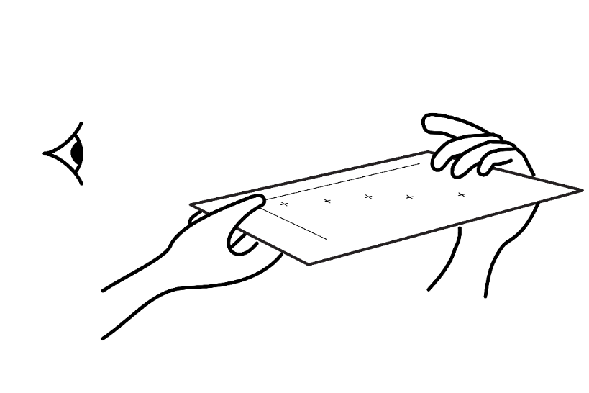
- Use a ruler for straight lines but draw a smooth curve freehand in a single line.
- It can help to draw a smooth curve by holding the pencil further away from the tip.
- The line should pass through or near as many points as possible.
- Points should be balanced on both sides of the line.
- Ignore any anomalies (results that don't fit the pattern).

Questions
- For each set of data below suggest a suitable scale for the x-axis and y-axis:
- Measuring the volume of gas produced in a reaction with hydrochloric acid.

Time (s) | 0 | 10 | 20 | 30 | 50
Volume (cm³) | 0 | 8 | 18 | 26 | 35

__________________________________________________________________________________
__________________________________________________________________________________
- Recording the temperature change when magnesium reacts with sulfuric acid.

Time (s) | 0 | 20 | 40 | 60 | 80 | 90
Temperature (°C) | 21 | 23 | 26 | 28 | 31 | 32

__________________________________________________________________________________
__________________________________________________________________________________
- The table below shows the volume of carbon dioxide gas produced when calcium carbonate chips react with hydrochloric acid.
Time (s) | 0 | 10 | 20 | 40 | 60 | 80
Volume (cm³) | 0 | 7 | 14 | 22 | 27 | 29

- Choose a suitable scale and interval for both axes.

__________________________________________________________________________________
- Plot these coordinates on graph paper. Remember to label both axes with the variable name and unit.
- Draw a line of best fit.
- Use the graph to predict how much gas was produced in 50 seconds.

__________________________________________________________________________________
- Describe the trend shown in your graph.

__________________________________________________________________________________
__________________________________________________________________________________
