Creating and representing graphs
This presentation forms part of the Maths skills for chemistry resources series which can be viewed at: rsc.li/4A41ezG. The resource series covers maths skills which are fundamental to chemistry teaching:
- Graphs and data, divided into:
  - Creating graphs
  - Interpreting graphs
- Ratio and proportion
- Understanding number, divided into:
  - Unit conversion
  - Significant figures and rounding
- Algebra and equations

Resource series components
The resource series is divided into two stages. Stage 1 (✪) is most suitable for ages 11−14 and stage 2 (✪✪) for ages 14−16. However, older learners with gaps in their fundamental knowledge can use stage 1 as a stepping stone.
Stage 1 ✪ | 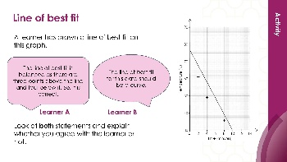  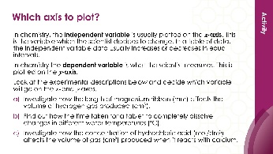 | 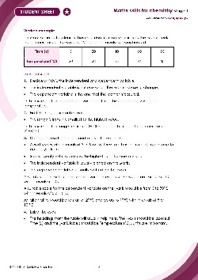
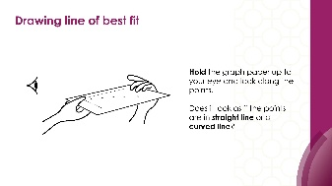

Teacher-led presentation (✪): a full lesson including learning objectives, learner-facing instructions and activities. | Short activities (✪): learner-facing activities, designed as lesson starters or quick activities to engage prior knowledge. | Learner worksheet (✪): activities for learners to independently practice their maths skills. Suitable as a classroom activity following the teacher presentation or as a home-learning task.

Stage 2 ✪✪ | 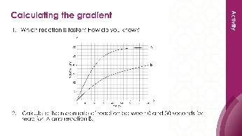  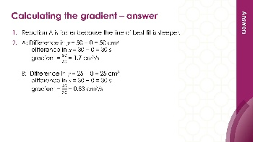 | 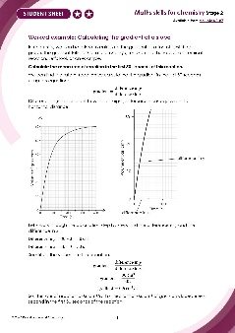
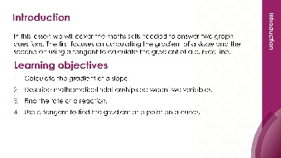
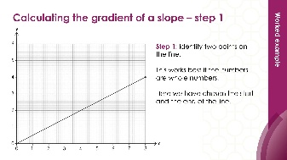

Teacher-led presentation (✪✪) | Short activities (✪✪) | Learner worksheet (✪✪)

Key terms support
Key maths vocabulary for each skill area is defined in the key terms support: rsc.li/4wypuqq. You will find the key terms listed by topic area and an accessible glossary slide for each term.

Using the teacher-led presentation
This is a full lesson focused on mastering maths skills in a chemistry context. The aim is for learners to develop key skills and then begin to apply these independently.

Learning objectives
- Translate information between graph and table.
- Design suitable scales for the axes on a graph.
- Plot coordinates accurately onto a graph.
- Draw an appropriate line of best fit.
As you move through the presentation, there is a clear progression in skills development. The first slides engage learners’ prior knowledge of the chosen maths skill. These slides link back to their learning from maths lessons and prior chemistry knowledge, where applicable.
Following this, the slides move onto some maths−chemistry translation tasks, then learners complete activities within a chemistry context.
The teacher-led presentation is designed to be used:
- prior to teaching a topic which makes explicit use of the maths skill, such as plotting results from an experiment, plotting coordinates or drawing a line of best fit for a data set
- after summative assessment as an intervention.

Scaffolding
The presentation is scaffolded, moving from worked examples (‘I do’) to faded examples (‘we do’), before learners go on to answer questions themselves (‘you do’).

Metacognition
This resource type supports learners to develop their metacognitive skills in three key areas.
- Planning – prompt learners to draw on their existing mathematical knowledge by asking themselves: ‘Have I seen a similar question before? Have I come across this mathematical skill before? Have I learned a different method for solving a similar problem?’
- Monitoring – prompt learners to ask themselves: ‘How confident am I feeling with these maths skills? Which parts of the presentation were most helpful to me?’
- Evaluation – prompt learners to ask themselves: ‘What have I learned during the presentation? How will I apply this new knowledge in my learning?’

Teaching sequence
Each teacher-led presentation begins with an introduction, learning objectives, and a chemistry question which uses the target maths skills. During the presentation, learners acquire the maths skills relevant to the question. At the end of the presentation, learners answer the question posed at the start, using the maths skills they have developed.
Avoid giving learners access to this presentation independently. It is designed to be teacher-led.
- Outline the learning objectives (slide 2)
- Review the lesson question (slide 3–4) without answering it, following the teacher notes (provided in the presentation and below).
- Work through the mathematical modelling slides, making explicit links between maths and science (slides 5–19).
- Learners complete the ‘checking for understanding’ questions. Ask learners to independently complete the lesson question using the knowledge covered during the lesson, the steps are broken down through this section (slides 20–27).

Review learning
You can use the linked learner worksheet and short activities as a follow-up to this lesson or later as a review.

Slide notes

Introduction (slides 1–4)

Slide 1: Title slide

Slide 2: Introduction
Explain that we will cover these key maths skills in a chemistry context using data from practicals learners are likely to recognise.
Learners at secondary level need to be confident in both reading and plotting coordinates in all four quadrants of a graph from mathematics in the primary phase. However, only two quadrants (the typical L-shaped graph) are usually required in chemistry for this age range. Only two quadrants will be used throughout this resource.

Slide 3: Lesson question
This slide introduces the challenge question that learners will return to at the end of the lesson. Learners are not expected to attempt it at this point. We will return to complete the question at the end of the session. Discuss the question and the key words which are in bold, these terms are explained on the next slide.

Slide 4: Lesson question (vocabulary)
More key terms are available for learners in the key terms support: rsc.li/4wypuqq.

Mathematical modelling (slides 5–19)

Slide 5: Choosing a suitable scale for each axis
Discuss the meaning of the terms: range and interval.
Talk to learners about how to choose suitable scales.
Discuss the fact that scales do not have to start at zero, but they must increase in equal intervals.
Learners may think that the $x$-axis and $y$-axis need to have the same scale. This is often the case in the primary phase but not in science at secondary phase.
Range is the smallest value to the highest value. In maths this can involve a calculation, but this is not necessary when we are looking to decide on a suitable scale.
Interval is the space or gap between the values on the axis.

Slide 6: Choosing a suitable scale for each axis (answers)
No notes.

Slide 7: Coordinate pairs 1
Discuss how we transfer information from the table onto a graph. The first column contains the x-coordinate values which are plotted on the x-axis. Make sure learners recognise the term origin.

Slide 8: Coordinate pairs 2
Discuss the x, y coordinates and model how to plot the coordinate (1, 5) using a ruler and a sharp pencil. Draw arrows using your interactive smartboard to show the relationship between the table heading and the x and y axes.
A sharp pencil makes a thin precise point so you can plot the data points in exactly the right place. If the pencil is blunt the marks are much thicker and this makes it more difficult to see exactly where the points are. A sharp pencil creates a point less than 0.5 mm wide. A blunt pencil might create marks of 1−2 mm wide. The graph paper we usually use is 1 mm x 1 mm, so this can significantly affect the accuracy.

Slide 9: Coordinate pairs (activity)
No notes.

Slide 10: Coordinate pairs (answers)
Ask learners to describe what they did to work out the coordinate pair for A and B. Some may say they looked at the table and some may say they read the coordinates from the graph. It is important that learners know how to do both as there is not always a table of data provided. The next slide provides the graph and table side by side for learners to practice these skills.

Slide 11: Coordinate pairs (practice)
Draw arrows using your interactive smartboard to show the relationship between the table heading and the x and y axes.
Discuss with learners if all axes need to start at (0, 0). This one does but this is not always necessary.

Slide 12: Drawing a line of best fit
Show learners how to hold up the graph paper with plotted points close to your eye and look down the points to see if it looks like a straight or curved line. It is clear that these points form a straight line of best fit.

Slide 13: Drawing a straight line of best fit
Model how to draw a line of best fit.
What does a straight line mean? A straight line of best fit means there's a linear relationship between the two variables – as one variable changes, the other changes at a constant rate.
In maths, the points tend to follow a perfect mathematical relationship and so most, if not all, points will be on the line of best fit. In science, the line of best fit may not pass through any points directly but will be as close to as many as possible and the number of points above the line will be as balanced as possible with the number below the line.

Slide 14: Drawing a curved line of best fit
Look at this data set. Discuss with learners why a line might be curved. It is curved because the relationship between variables isn't linear, i.e. when one variable doesn't change at a constant rate relative to the other.
Return to the graph and table on slide 11 if needed to demonstrate a linear relationship.

Slide 15: Drawing a curved line of best fit (worked example)
Discuss which value goes on the x-axis and which on the y-axis. Time on the x-axis and temperature on the y-axis.
Check the scales are suitable before learners start to plot.
A suitable scale to fit this graph paper and which makes the best use of the size could be:
x-axis − start at 0 and go up in intervals of 2 (every 5 small squares) up to 14. Each small square represents 0.4 units
y-axis − start at 30 and go up in intervals of 10 (every 10 small squares) up to 90. Each small square represents 1 unit.
This graph paper is available to print from page 2 of the interpreting graphs stage 1 learner worksheet: rsc.li/3S9bXHV.

Slide 16: Drawing a curved line of best fit (worked example 2)
This slide shows the points plotted. Model how to draw the curved line in one go without sketching. It can help to hold the pencil further away from the tip.

Slide 17: Drawing a curved line of best fit (option 1)
Here is one interpretation of the line of best fit. Another line (on the next slide) may miss some of the points such as (12, 30) for example. There is no perfect line of best fit.
Line of best fit: option 1.

Slide 18: Drawing a curved line of best fit (option 2)
Line of best fit option 2: misses (12, 30).

Slide 19: Differences between mathematics and science
Talk to your colleagues in the mathematics team about whether learners are using graph paper or block paper in lessons.
If learners tend to use block paper in mathematics, then spend time discussing how to use the graph paper provided in science. Exam boards tend to use the 1 mm x 1 mm paper. Make sure learners are comfortable in using this. For example, what does each small square represent, what do the larger squares represent? Can learners see the markings on the graph paper? Sometimes when graph paper is copied the integrity of the lines can be lost.

Checking for understanding (slides 20–27)

Slide 20: Returning to the lesson question
Explain that we are going to use the mathematical methods mentioned earlier to answer this question.

Slide 21: Apply your learning – design suitable scales
Qualitative: the focus is on the discussion about a suitable scale for this set of data.
Before plotting we need to consider what information we can find out from the table.
Look at the headings and the question.
- What is the scientist choosing to change during the experiment? Time is being monitored at regular points, so this is what the scientist is choosing to change.
- The independent variable is usually plotted on the $x$-axis. The label would be Time (s) or Time/s. The solidus (/) is recommended at post-16 and brackets are suggested pre-16. Throughout these resources, Time (s) has been used. Both are correct, however.
- Where should both axes start? The table of data has the first set of coordinates as (0,0), this can be explained because before the experiment begins no gas has been produced so it should be zero.
- The range of data for the independent variable is 0−120 and 0−54 for the dependent variable. This helps us design the best scales.
- The graph itself should occupy most of the graph paper (not just the axes) so it is easier to read, and the pattern can be seen more clearly. This could be demonstrated by using different sized scales.
- A suitable scale for the graph paper in the original question might be:
  - $x$-axis – 0 to 140 in intervals of 20 per 5 small squares (each small square = 4 units)
  - $y$-axis – 0 to 60 in intervals of 10 per 5 small squares (each small square is worth 2 units)
- Make sure the labels and units are correctly added: $x$-axis label is Time (s) and $y$-axis label is Volume (cm³).

Slide 22: Apply your learning – plot the results
Quantitative: here we develop from the qualitative discussion about scales to placing the coordinates on the scales precisely and accurately.

Slide 23: Apply your learning – draw the line of best fit
Here we move to a conceptual stage.

Slide 24: Apply your learning – line of best fit (answers a–b)
- A good answer will use terms like steep, increase and slows. If learners simply say ‘it goes up’ then more discussion is needed to model a more suitable response.
- A good answer will mention errors, but a weaker answer may talk about mistakes. Emphasise that these are random errors and not mistakes usually.

Slide 25: Apply your learning – line of best fit (answers c–d)
No notes.

Slide 26: Apply your learning – describe the trend
This slide shows a line of best fit but there are other possible lines of best fit which might be slightly different.
There is no perfect line as it is a generalisation.
The trend shows the general change over time.

Slide 27: Apply your learning – describe the trend (answers)
No notes.

