Creating graphs
This learner worksheet forms part of the Maths skills for chemistry resources series which can be viewed at: rsc.li/4A41ezG. The resource series covers maths skills which are fundamental to chemistry teaching:
- Algebra and equations
- Ratio and proportion
- Graphs and data, divided into:
  - Creating graphs
  - Interpreting graphs
- Understanding number, divided into:
  - Unit conversion
  - Significant figures and rounding

Resource series components
The resource series is divided into two stages. Stage 1 (✪) is most suitable for ages 11−14 and stage 2 (✪✪) for ages 14−16. However, older learners with gaps in their fundamental knowledge can use stage 1 as a stepping stone.
Stage 1 ✪ | 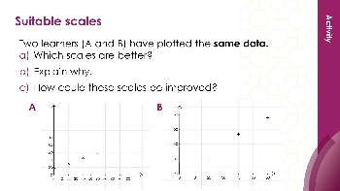   | 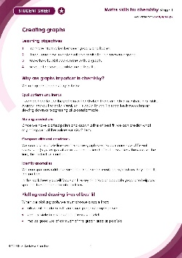
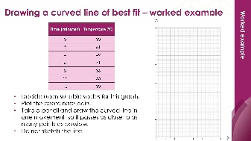
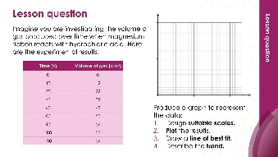
Teacher-led presentation (✪): a full lesson including learning objectives, learner-facing instructions and activities. | Short activities (✪): learner-facing activities, designed as lesson starters or quick activities to engage prior knowledge. | Learner worksheet (✪): activities for learners to independently practice their maths skills. Suitable as classroom activity following the teacher presentation or as a home-learning task.

Stage 2 ✪✪ | 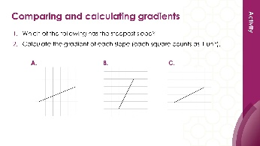  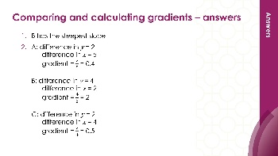 | 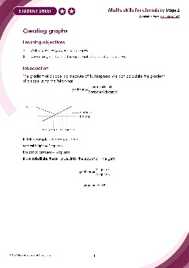
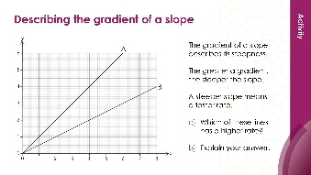
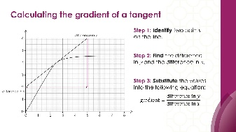

Teacher-led presentation (✪✪) | Short activities (✪✪) | Learner worksheet (✪✪)

Key terms support
Key maths vocabulary for each skill area is defined in the key terms support: rsc.li/4wypuqq. You will find the key terms listed by topic area and an accessible glossary slide for each term.

Using the learner worksheet
The focus of this learner worksheet is mastering maths skills in a chemistry context. The aim is for learners to develop and apply maths skills independently.
Learners will require graph paper to complete this worksheet. Page 5 of the learner worksheet is a blank sheet of graph paper for you to print.

Learning objectives
- Translate information between graphs and tables.
- Design suitable scales for the axes on a graph.
- Plot coordinates accurately onto a graph.
- Draw an appropriate line of best fit.
The learner worksheets complement the teacher-led presentations but can function independently, for example as a classroom activity or homework assignment.
Teacher notes and answers are provided at the end of this document. When relevant, common mathematical misconceptions are highlighted.

When to use
Use the learner worksheet for:
- Reviewing learning – if learners are confident with the mathematical skill, use the worksheet as a tool to review learning and assess learners’ skill level.
- Independent practice – provide learners with the worksheet to use as independent practice.
- Scaffolded practice – break the worksheet into sections and complete over a longer period, such as multiple lessons.
- Mathematical modelling – for those requiring additional support, talk through the initial questions pulling out the mathematical skills used to answer the question, highlighting and defining any key terms. If learners are still finding the task difficult, consider fading the initial questions and asking learners to complete the later questions independently.

Scaffolding
The worksheets present a clear progression in skill development. It starts with a recap of key knowledge and worked examples. The first question engages prior knowledge of the chosen maths skill. Following this, learners will do some maths–chemistry translation tasks, then complete activities in a chemistry context.
Have the key terms list or accessible glossary available for learners who require additional support with mathematical vocabulary.

Metacognition
This resource type supports learners to develop their metacognitive skills in three key areas.
- Planning − prompt learners to draw on their existing mathematical knowledge by asking themselves: ‘Have I seen a similar question before? Have I come across this mathematical skill before? Have I learned a different method for solving a similar problem?’
- Monitoring – prompt learners to ask themselves: ‘How confident am I feeling with these mathematical skills? Which questions am I finding difficult? Which type of questions do I feel I have mastered?’
- Evaluation – prompt learners to ask themselves: ‘What have I learned about myself when doing these questions? Which of the mathematical skills did I use to answer these questions?’

Answers

- $x$-axis: 0 to 60 s in intervals of 10 s
$y$-axis: 0 to 40 cm³ in intervals of 5 or 10 cm³

- $x$-axis: 0 to 110 s in intervals of 20 s
$y$-axis: 20 to 34℃ in intervals of 1 or 2°C or 0 to 35°C in intervals of 5°C

- $x$-axis: 0 to 90 s with intervals of 10 s
$y$-axis: 0 to 40 cm³ with intervals of 5 or 10 cm³
- Check that learners have:
- chosen sensible scales
- labelled axes correctly with variable and unit
- plotted points accurately with a sharp pencil
- Line of best fit has been drawn appropriately.
- The volume of gas produced at 50 s is predicted to be 25 cm³. Learners may get a different reading depending on their line of best fit.
- The trend shows that the volume of gas is produced at a constant rate until 20 seconds when it begins to be released more slowly as the line becomes less steep.

