Creating graphs

Learning objectives
- Calculate the gradient of a slope.
- Use a tangent to find the gradient at a point on a curve.

Introduction

The gradient of a slope is a measure of its steepness. We can calculate the gradient of a slope using the following:
$$gradient=\frac{vertical height}{horizontal distance}$$

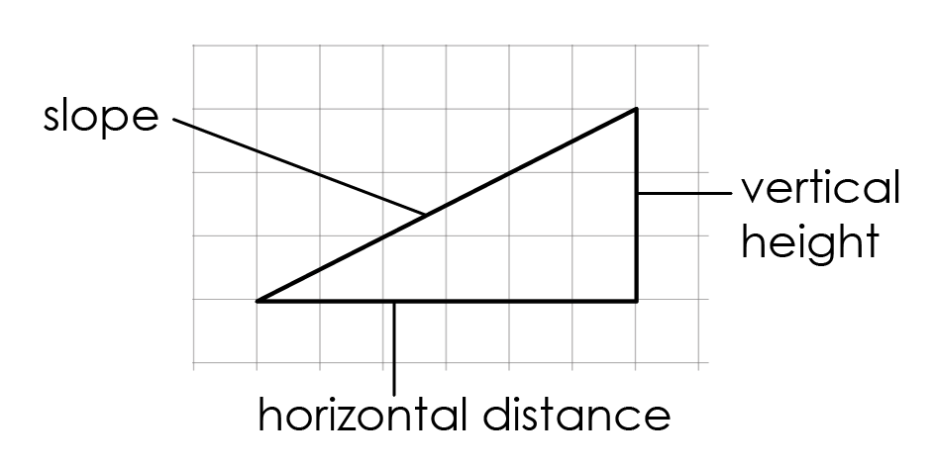

In this example we can see that:

vertical height = 3 squares

horizontal distance = 6 squares

If we substitute these values into the equation, we get:

$$gradient=\frac{3 squares}{6 squares}$$

$$gradient=0.5$$

Questions: maths
- Which of the following is the steepest slope?

__________________________________________________________________________________
- Calculate the gradient of the following slopes.
- 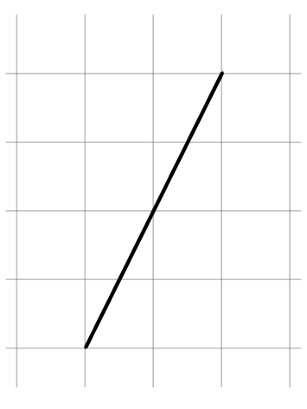 (b) 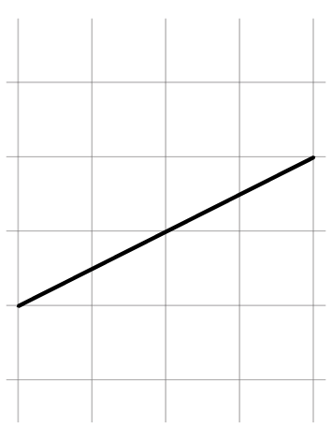 (c) 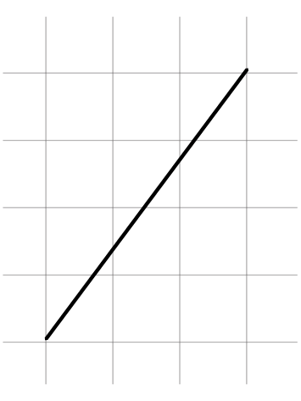 (d) 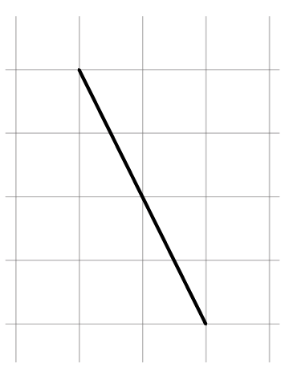

__________________________________________________________________________________

__________________________________________________________________________________

__________________________________________________________________________________

__________________________________________________________________________________

__________________________________________________________________________________

__________________________________________________________________________________

__________________________________________________________________________________

Worked example: Calculating the gradient of a slope

In chemistry, we can be asked to calculate the gradient of a line of best fit on a graph. The gradient tells us the rate of change, for example the rate of a chemical reaction. Let’s look at an example.

Calculate the mean rate of reaction in the first 50 seconds of this reaction.

We can find the rate of reaction by calculating the gradient in the first 50 seconds using this equation:
$$gradient=\frac{difference in y}{difference in x}$$

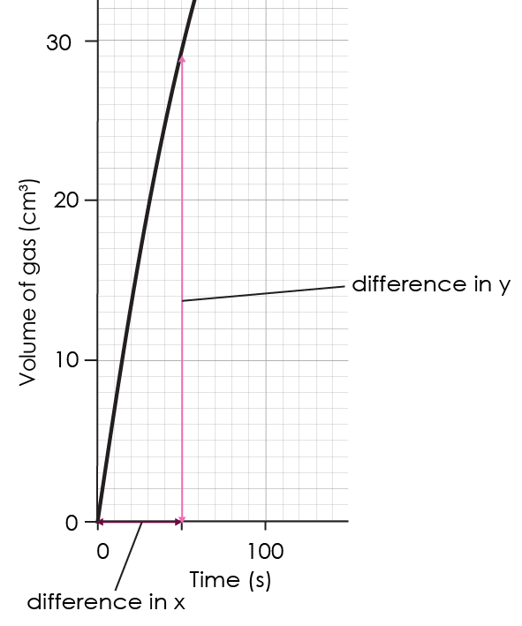
Difference in y is equivalent to vertical height, difference in x is equivalent to horizontal distance.

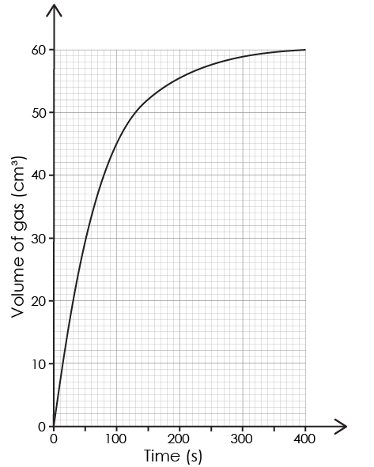

Let’s work through the calculation step by step. Find the difference in y and the difference in x.

Difference in y = 30 – 0 = 30 cm³

Difference in x = 50 – 0 = 50 s

Substitute the values into the equation:
$$gradient=\frac{difference in y}{difference in x}$$
$$gradient=\frac{30 {cm}^{3}}{50 s}$$
$$gradient=0.6 {cm}^{3}/s$$

So, the rate of reaction is 0.6 cm³/s. This means that 0.6 cm³ of gas is produced every second in the first 50 seconds of the reaction.

Worked example: calculating the gradient of a tangent

In chemistry, we may need to find the rate of reaction at a particular point on a curved graph. To do this we need to draw a tangent to the line at that point. A tangent is a straight line that follows the general direction of the curve at that point.

Calculate the rate of reaction at 100 seconds for this reaction.

We can find the rate of reaction by calculating the gradient of the tangent to the line at 100 seconds using this equation:
$$gradient=\frac{difference in y}{difference in x}$$

Let’s work through the calculation step by step.

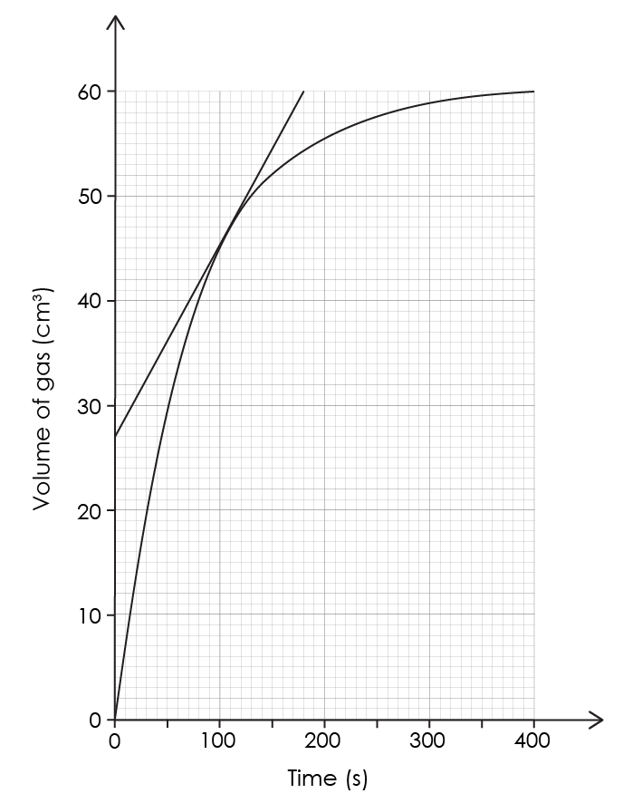

Difference in y = 60 – 27 = 33 cm³

Difference in x = 170 – 0 = 170 s

Substitute the values into the equation:
$$gradient=\frac{difference in y}{difference in x}$$
$$gradient=\frac{33 {cm}^{3}}{170 s}$$
$gradient=0.19 {cm}^{3}/s$

So, the rate of reaction is 0.19 cm³/s.

Questions

Use the following graph to answer questions 1, 2 and 3.

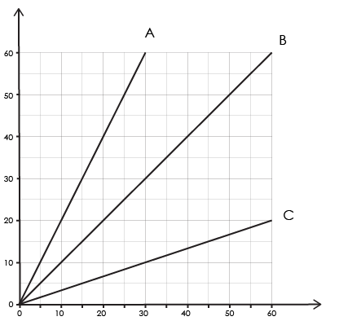
Time (s)
Volume (cm³)

- Which of the reactions has the fastest rate? How do you know?

__________________________________________________________________________________

__________________________________________________________________________________

__________________________________________________________________________________
- Calculate the mean rate of reaction between 0 and 30 seconds for each reaction. Include units and give your answers to two significant figures.

__________________________________________________________________________________

__________________________________________________________________________________

__________________________________________________________________________________

- Using your answer from question 2, describe the rate of reaction for reaction A in the first 30 seconds of the experiment.

__________________________________________________________________________________

__________________________________________________________________________________

__________________________________________________________________________________

Use the following graph to answer question 4.

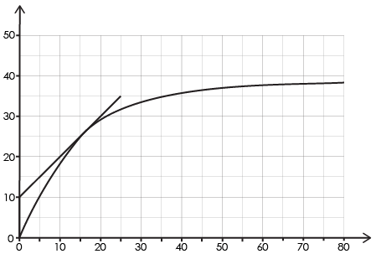
Time (s)
Volume (cm³)

- Find the rate of reaction at 15 seconds using the tangent to the line of best fit.

__________________________________________________________________________________

__________________________________________________________________________________

__________________________________________________________________________________

