Creating graphs
This presentation forms part of the Maths skills for chemistry resources series, rsc.li/4A41ezG. The series offers flexible, targeted support for maths skills which are fundamental to chemistry teaching:
- Graphs and data, divided into:
  - Creating graphs
  - Interpreting graphs
- Ratio and proportion
- Understanding number, divided into:
  - Unit conversion
  - Significant figures and rounding
- Algebra and equations

Resource series components
The resource series is divided into two stages. Stage 1 (✪) is most suitable for ages 11−14 and stage 2 (✪✪) for ages 14−16. However, older learners with gaps in their fundamental knowledge can use stage 1 as a stepping stone.
Stage 1 ✪ | 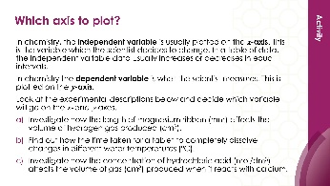 | 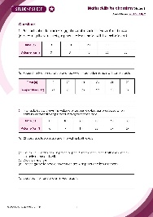
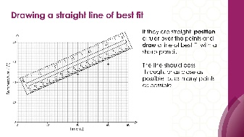
Teacher-led presentation (✪) | Short activities (✪) | Learner worksheet (✪)
Stage 2 ✪✪ | 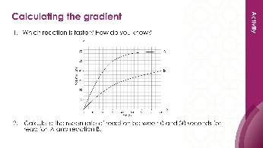  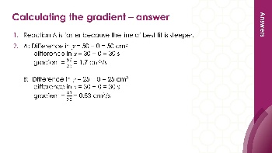 | 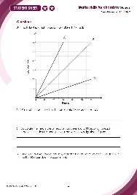
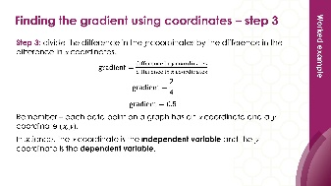


Teacher-led presentation (✪✪): a full lesson including learning objectives, learner-facing instructions and activities. | Short activities (✪✪): learner-facing activities, designed as lesson starters or quick activities to engage prior knowledge. | Learner worksheet (✪✪): activities for learners to independently practice their maths skills. Suitable as classroom activity following the teacher presentation or as a home-learning task.

Key terms support
Key maths vocabulary for each skill area is defined in the key terms support: rsc.li/4wypuqq. You will find the key terms listed by topic area and an accessible glossary slide for each term.

Using the teacher-led presentation
This is a full lesson focused on mastering maths skills in a chemistry context. The aim is for learners to develop key skills and then begin to apply these independently.

Learning objectives
- Calculate the gradient of a slope.
- Describe mathematical relationships between two variables.
- Find the rate of a reaction.
- Use a tangent to find the gradient at a point on a curve.
As you move through the presentation, there is a clear progression in skills development. The first slides engage learners’ prior knowledge of the chosen maths skill. These slides link back to their learning from maths lessons and prior chemistry knowledge, where applicable. Following this, the slides move onto some maths−chemistry translation tasks, then learners complete activities within a chemistry context.
This presentation follows this progression sequence twice, first looking at the gradient of a slope and then at using a tangent.
The teacher-led presentation is designed to be used:
- prior to teaching a topic which makes explicit use of the maths skill, such as calculating the gradient or tangent to find the mean rate of reaction
- after summative assessment as an intervention.

Scaffolding
The presentation is scaffolded, moving from worked examples (‘I do’) to faded examples (‘we do’), before learners go on to answer questions themselves (‘you do’).

Metacognition
This resource supports learners to develop their metacognitive skills in three key areas.
- Planning – prompt learners to draw on their existing mathematical knowledge by asking themselves: ‘Have I seen a similar question before? Have I come across this maths skill before? Have I learned a different method for solving a similar problem?’
- Monitoring – prompt learners to ask themselves: ‘How confident am I feeling with these maths skills? Which parts of the presentation were most helpful to me?’
- Evaluation – prompt learners to ask themselves: ‘What have I learned during the presentation? How will I apply this new knowledge in my learning?’

Teaching sequence
This teacher-led presentation begins with an introduction, learning objectives and two chemistry questions which use the targeted maths skills. During the lesson, learners acquire the maths skills relevant to the questions. At appropriate points in the presentation, learners answer the questions posed at the start, using the skills they have just developed.
Avoid giving learners access to this presentation independently. It is designed to be teacher-led.
- Outline the learning objectives (slide 2)
- Review the lesson questions (slides 3-4) without answering them, following the teacher notes (provided in the presentation and copied below).
- Work through the mathematics modelling slides, making explicit links between maths and science. Slides 5–20 focus on modelling calculating the gradient of a slope and 25–27 on using a tangent.
- Learners complete the ‘checking for understanding’ questions. Ask learners to independently complete the lesson questions using the knowledge covered during the lesson. Slides 21–24 check understanding of a gradient of a slope and 28–29 check understanding of using a tangent.

Review learning
You can use the linked learner worksheet and short activities as a follow-up to this lesson or later as a review.

Slide notes

Introduction (slides 1–4)

Slide 1: Title slide

Slide 2: Introduction and learning objectives
Explain that we will be covering these key maths skills in a chemistry context.

Slide 3: Lesson question 1
This slide introduces the first challenge question that learners will return to at the end of the lesson. Learners are not expected to attempt it at this point. Discuss the question and the key words that are in bold.
- What do the terms ‘mean’ and ‘rate’ mean? The mean is the most commonly used measure of average. The rate is how quickly something happens.
- What do they think ‘mean rate’ means? The mean rate (of reaction) is the average speed of a reaction over time.
Emphasise that we are only interested in the gradient between 0 and 40 seconds.

Slide 4: Lesson question 2
This slide introduces the second challenge question that learners will return to at the end of the lesson. Learners are not expected to attempt it at this point. We will return to complete the question at the end of the session. Discuss the question and the key words that are in bold.
What do we mean by rate of reaction? The rate (of reaction) is how quickly something happens. In this example, the faster the rate, the higher the volume of gas produced per second.
Emphasise that we are only interested in the rate at 25 seconds.

Mathematical modelling: gradient of a slope (slide 5–14)

Slide 5: Describing the gradient of a slope
Discuss the link between gradient and steepness. Ask learners to answer the two questions on the slide.
What is the mathematical relationship between the two variables on this graph for line A? Learners should talk in terms of $x$ and $y$.

Slide 6: Describing the gradient of a slope (answer)
No notes.

Slide 7: Calculating the gradient of a slope
This method helps learners calculate the gradient of a slope. Each step is modelled on the following slides.

Slide 8: Calculating the gradient of a slope (step 1)
Discuss step 1. Explain that we are going to draw a triangle under the line to help. Emphasise that it is best if the numbers involved are whole numbers.
Explain that it doesn’t matter which points they are as the line is straight, but some questions ask for the gradient to be taken at specific points along the line.

Slide 9: Calculating the gradient of a slope (step 2)
Discuss step 2. Explain the arrows which create under the graph, including how this relates to finding the difference in y and the difference in x.

Slide 10: Calculating the gradient of a slope (step 3)
Discuss step 3: how to substitute values into an equation. Explain how this process also links to units i.e. units = y/x
You can return to the graph (slide 6) and ask learners to use different values from the line to show that the gradient is the same no matter which values they use on the line. This is because the line is straight.

Slide 11: Differences between mathematics and science
No notes.

Slide 12: Finding the gradient using coordinates (step 1)
No notes.

Slide 13: Finding the gradient using coordinates (step 2)
No notes.

Slide 14: Finding the gradient using coordinates (step 3)
Independent variable – the variable changed by the investigator during the experiment.
Dependent variable – the variable being tested or measured during the experiment.

Checking for understanding: gradient of a slope (slides 15–24)

Slide 15: Returning to lesson question 1
Now we are going to translate our learning back into a chemistry context. Explain that we are going to use the mathematical methods mentioned earlier to compare the two mean rates of reaction.

Slide 16: Describing the gradient of a slope (activity)
Qualitative: here the focus is on describing the relationship between the variables and describing the difference in the gradients in words.
Emphasise the use of comparative terms e.g. more, less, steeper, less steep etc.

Slide 17: Describing the gradient of a slope (activity answer)
No notes.

Slide 18: Calculating the gradient of a slope (activity)
Quantitative: here we are developing the relationship from qualitative to quantitative.
Explain that we are going to calculate the mean rate of reaction for reaction A together (modelling) and then learners will individually calculate the rate of reaction B using the same method. They will then compare the rates of reaction.
The next slides model how to complete the calculation for reaction A. Complete reaction B together (slide 20).

Slide 19: Calculating the gradient of a slope (answer a)
Quantitative: here we are developing the relationship from qualitative to quantitative.
Explain that we are going to calculate the mean rate of reaction for reaction A together (we do) and then they will individually (you do) calculate the rate of reaction B using the same method. They will then compare the rates of reaction.
Explain why the arrows are drawn between 0 and 40 seconds.

Slide 20: Deriving the units (answer a continued)
Quantitative: here we are developing the relationship from qualitative to quantitative.
Discuss where the units have come from.

Slide 21: Calculating the gradient of a slope (part b)
Quantitative: here we are developing the relationship from qualitative to quantitative.
Putting the calculations from slide 18 and slide 19 together, the answer for reaction A is therefore 1 cm³/s.
Ask learners to individually calculate the rate of reaction B using the same method.

Slide 22: Calculating the gradient of a slope (answer b)
No notes.

Slide 23: Comparing the mean rates of reaction
Conceptual: here we link the mathematical operations to the underlying chemistry that explains the relationship.
Ask learners to compare the two rates of reaction using the information they have so far (reaction A has a rate of reaction of 1 cm³/s in the first 40 seconds, reaction B has a reaction rate of 0.75 cm³/s in that same time). Explain what this means, i.e. reaction A produces 1 cm³ of gas every second for the first 40 seconds, whereas reaction B only produces 0.75 cm³ of gas every second for 40 seconds.
Give learners the opportunity to discuss which line they think represents the reaction with large lumps of calcium carbonate and which with small lumps. Can they explain why they think this is the case? Use this opportunity to elicit any misconceptions or misunderstandings learners have.
Ask learners to sketch the line of best fit they think powdered calcium carbonate would give. Emphasise that the temperature, concentration of HCl, volume of HCl and the mass of calcium carbonate are the same for each of these experiments.

Slide 24: Comparing the mean rates of reaction (answers)
(c) The line for powdered calcium carbonate would be steeper than the other two lines and would level off earlier at 50 cm³. This is because the reaction will be faster as powder has a larger surface area, so the line is steeper. The maximum volume of gas would be 50 cm³ because the mass of calcium carbonate and concentration and volume of HCl is the same. The reaction stops when one of the reactants – normally this would be the HCl – is used up. The reactant that is not used up is said to be in excess, the reactant that is used up is the limiting factor.

Mathematical modelling: using a tangent (slides 25–27)

Slide 25: Drawing a tangent to a curve
Discuss the link between gradient and steepness. Explain what a tangent is and how to draw one. Remind learners to look for where the tangent will give whole numbers, to make it easier to read off the scale and carry out calculations.

Slide 26: Calculating the gradient of a tangent
No notes.

Slide 27: Calculating the gradient of tangent
Explain the arrows under the tangent, including how this relates to finding the difference in $y$ and the difference in $x$.

Checking for understanding: using a tangent (slides 28–29)

Slide 28: Returning to lesson question 2
Now we are going to translate our learning back into a chemistry context. Explain that we are going to use the mathematical methods mentioned earlier to find the rate of reaction at 25 seconds.
Explain that we need to find the gradient of the slope at 25 seconds. To do this, we need to draw a tangent to the line at 25 seconds. Explain that the tangent line should just touch the curve at the point at 25 seconds and should match the slope of the curve at that point. Place a ruler on the point being studied and adjust its position so the space on either side of the point between the ruler and curve are approximately equal. The line should be extended as far as is convenient to take readings for the calculations.

Slide 29: Calculating the gradient using a tangent (answer)
No notes.

