Creating graphs
This learner worksheet forms part of the Maths skills for chemistry resources series which can be viewed at: rsc.li/4A41ezG. The resource series covers maths skills which are fundamental to chemistry teaching:
- Algebra and equations
- Ratio and proportion
- Graphs and data, divided into:
  - Creating graphs
  - Interpreting graphs
- Understanding number, divided into:
  - Unit conversion
  - Significant figures and rounding

Resource series components
The resource series is divided into two stages. Stage 1 (✪) is most suitable for ages 11−14 and stage 2 (✪✪) for ages 14−16. However, older learners with gaps in their fundamental knowledge can use stage 1 as a stepping stone.
Stage 1 ✪ | 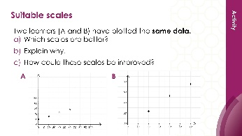 | 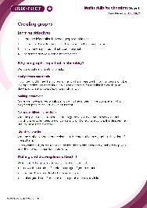
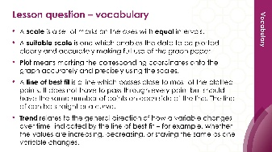
Teacher-led presentation (✪) | Short activities (✪) | Learner worksheet (✪)
Stage 2 ✪✪ | 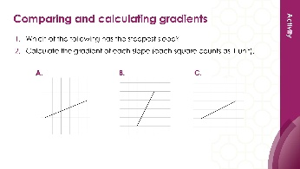  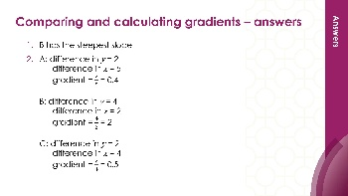 | 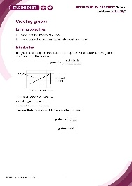
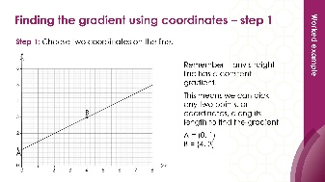


Teacher-led presentation (✪✪): a full lesson including learning objectives, learner-facing instructions and activities. | Short activities (✪✪): learner-facing activities, designed as lesson starters or quick activities to engage prior knowledge. | Learner worksheet (✪✪): activities for learners to independently practice their maths skills. Suitable as classroom activity following the teacher presentation or as a home-learning task.

Key terms support
Key maths vocabulary for each skill area is defined in the key terms support: rsc.li/4wypuqq. You will find the key terms listed by topic area and an accessible glossary slide for each term.

Using the learner worksheet
The focus of this learner worksheet is mastering maths skills in a chemistry context. The aim is for learners to develop and apply maths skills independently.

Learning objectives
- Compare the gradient of a slope.
- Use a tangent to find the gradient at a point on a curve.
The learner worksheets complement the teacher-led presentations but can function independently, for example as a classroom activity or homework assignment.
Answers are provided at the end of this document. When relevant, common mathematical misconceptions are highlighted.

When to use
Use the learner worksheet for:
- Reviewing learning – if learners are confident with the mathematical skill, use the worksheet as a tool to review learning and assess learners’ skill level.
- Independent practice – provide learners with the worksheet to use as independent practice.
- Scaffolded practice – break the worksheet into sections and complete over a longer period, such as multiple lessons.
- Mathematical modelling – for those requiring additional support, talk through the initial questions pulling out the mathematical skills used to answer the question, highlighting and defining any key terms. If learners are still finding the task difficult, consider fading the initial questions and asking learners to complete the later questions independently.

Scaffolding
The worksheet presents a clear progression in skill development. Each section starts with a recap of key knowledge and/or worked examples. The first questions engage prior knowledge of the chosen maths skill. Following this, learners complete activities in a chemistry context.
Have the key terms list or accessible glossary available for learners who require additional support with mathematical vocabulary.

Metacognition
This resource type supports learners to develop their metacognitive skills in three key areas.
- Planning − prompt learners to draw on their existing mathematical knowledge by asking themselves: ‘Have I seen a similar question before? Have I come across this mathematical skill before? Have I learned a different method for solving a similar problem?’
- Monitoring – prompt learners to ask themselves: ‘How confident am I feeling with these mathematical skills? Which questions am I finding difficult? Which type of questions do I feel I have mastered?’
- Evaluation – prompt learners to ask themselves: ‘What have I learned about myself when doing these questions? Which of the mathematical skills did I use to answer these questions?’

Answers

Questions: maths (page 2)
- Slope (a) is the steepest.
- The gradient in this activity has no unit. This is because we are dividing squares by squares. Consequently, the units cancel out.
The last slope is the hardest to calculate as it is a negative slope, as $x$ is increasing, $y$ is decreasing. Errors with this question should lead to a class discussion around why the horizontal distance is negative rather than positive. Use a number line to help illustrate this point.
Questions 2(c) and (d) are good opportunities to discuss the importance of rounding numbers in science. In mathematics, learners place a dot above the three to show that it is recurring. In science, learners are expected to round the number.
- $gradient=\frac{4 squares}{2 squares}$ $gradient=2$

- $gradient=\frac{2 squares}{4 squares}$ $gradient=0.5$

- $gradient=\frac{4 squares}{3 squares}$ $gradient=1.3$

- $gradient=\frac{4 squares}{-3 squares}$ $gradient= -1.3$

Questions (pages 5-6)
- Reaction (a) has the fastest rate of reaction. It has the steepest line of best fit.
- Learners can draw triangles underneath each of the lines to aid the calculations.
- Difference in $y$ = 60 – 0 = 60
Difference in $x$ = 30 – 0 = 30
$$gradient=\frac{60 {cm}^{3}}{30 s}$$
$$gradient=2.0 {cm}^{3}/s$$
- Difference in $y$ = 30 – 0 = 30
Difference in $x$ = 30 – 0 = 30
$$gradient=\frac{30 {cm}^{3}}{30 s}$$
$$gradient=1.0 {cm}^{3}/s$$
- Difference in $y$ = 10 – 0 = 10
Difference in $x$ = 30 – 0 = 30
$$gradient=\frac{10 {cm}^{3}}{30 s}$$
$$gradient=0.33 {cm}^{3}/s$$

- The rate of reaction for reaction (a) is 2.0 cm³/s. This means that 2.0 cm³ of gas is produced every second for the first 30 seconds.
- Difference in $y$ = 35 – 10 = 25 cm³
Difference in $x$ = 25 – 0 = 25 s
$$gradient= \frac{25 {cm}^{3}}{25 s}$$
$$gradient=1 {cm}^{3}/s$$

