Creating and representing graphs
This set of short activities forms part of the Maths skills for chemistry resources series which can be viewed at: rsc.li/4A41ezG. The resource series covers mathematical skills which are fundamental to chemistry teaching:
- Graphs and data, divided into:
  - Creating graphs
  - Interpreting graphs
- Ratio and proportion
- Understanding number, divided into:
  - Unit conversion
  - Significant figures and rounding
- Algebra and equations

Resource series components
The resource series is divided into two stages. Stage 1 (✪) is most suitable for ages 11−14 and stage 2 (✪✪) for ages 14−16. However, older learners with gaps in their fundamental knowledge can use stage 1 as a stepping stone.
Stage 1 ✪ | 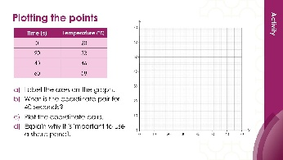 | 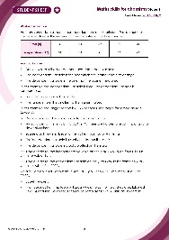
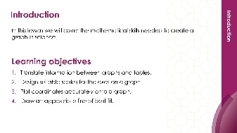
Teacher-led presentation (✪) | Short activities (✪) | Learner worksheet (✪)
Stage 2 ✪✪ | 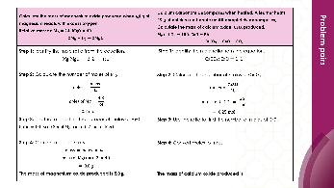  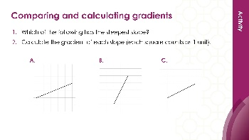 | 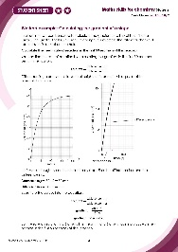
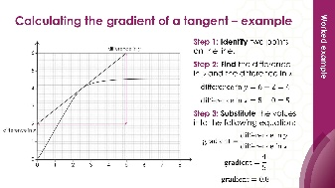
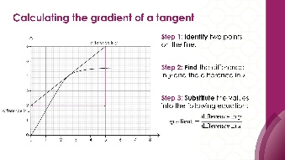

Teacher-led presentation (✪✪): a full lesson including learning objectives, learner-facing instructions and activities. | Short activities (✪✪): learner-facing activities, designed as lesson starters or quick activities to engage prior knowledge. | Learner worksheet (✪✪): activities for learners to independently practice their maths skills. Suitable as classroom activity following the teacher presentation or as a home-learning task.

Key terms support
Key maths vocabulary for each skill area is defined in the key terms support: rsc.li/4wypuqq. You will find the key terms listed by topic area and an accessible glossary slide for each term.

Using the short activities
The aim of this resource is for learners to revisit and practise skills from the teacher-led presentation and to develop problem solving skills so they can apply these independently.

Learning objectives
- Compare the gradient of a slope.
- Calculate the gradient of a slope.
- Use a tangent to find the gradient at a point on a curve.
As you move through the activities, there is a clear progression in skill development. The first activity or activities engage learners’ prior knowledge of the chosen maths skill. Following this, learners will complete activities within a chemistry context.
Activities can be teacher-led, for learners requiring additional support or modelling, or can be set as independent work.
The presentation contains three short activities that are designed to last 5–15 minutes and to be used as:
- a starter activity to engage prior knowledge or to practise a skill
- an assessment tool, used at the beginning of a lesson or sequence of work
- as follow-up independent practice during lessons or plenary
- for retrieval practice.

Metacognition
The activities support learners to develop their metacognitive skills in three key areas.
- Planning − prompt learners to draw on their existing mathematical knowledge by asking themselves: ‘Have I seen a similar question before? Have I come across this mathematical skill before? Have I learned a different method for solving a similar problem?’
- Monitoring – prompt learners to ask themselves: ‘How confident am I feeling with these mathematical skills? Which questions am I finding difficult? Which type of questions do I feel I have mastered?’
- Evaluation – prompt learners to ask themselves: ‘What have I learned about myself when doing these questions? Which of the mathematical skills did I use to answer these questions?’

Slide notes

Slide 1: Title slide

Slide 2: Introduction
No notes.

Slide 3: Comparing and calculating gradients
No notes.

Slide 4: Comparing and calculating gradients (answers)
No notes.

Slide 5: Calculating the gradient
No notes.

Slide 6: Calculating the gradient (answers)
Alterative answers for question 1:
- Reaction A is faster because the gradient is higher.
- Reaction A is faster because less time is needed to collect the same volume of gas.
- Reaction A is faster because more gas is collected in the same time.

Slide 7: Calculating the gradient using a tangent
No notes.

Slide 8: Calculating the gradient using a tangent (answers)
Accept 0.8 cm³/s if learners have rounded.

