Interpreting graphs
This set of short activities forms part of the Maths skills for chemistry resources series which can be viewed at: rsc.li/4A41ezG. The resource series covers mathematical skills which are fundamental to chemistry teaching:
- Graphs and data, divided into:
  - Creating graphs
  - Interpreting graphs
- Ratio and proportion
- Understanding number, divided into:
  - Unit conversion
  - Significant figures and rounding
- Algebra and equations

Resource series components
The resource series is divided into two stages. Stage 1 (✪) is most suitable for ages 11−14 and stage 2 (✪✪) for ages 14−16. However, older learners with gaps in their fundamental knowledge can use stage 1 as a stepping stone.
Stage 1 ✪ | 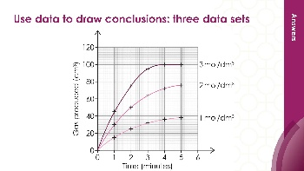  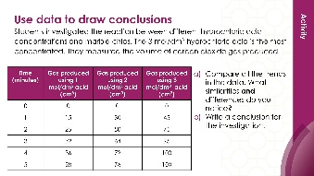 | 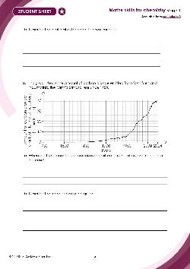
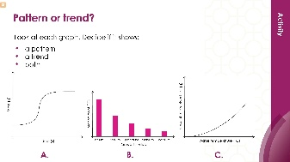
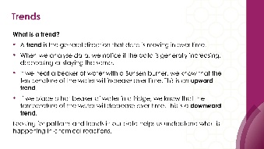
Teacher-led presentation (✪): a full lesson including learning objectives, learner-facing instructions and activities. | Short activities (✪): learner-facing activities, designed as lesson starters or quick activities to engage prior knowledge. | Learner worksheet (✪): activities for learners to independently practice their maths skills. Suitable as classroom activity following the teacher presentation or as a home-learning task.

Stage 2 ✪✪ | 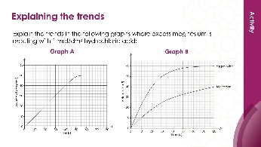  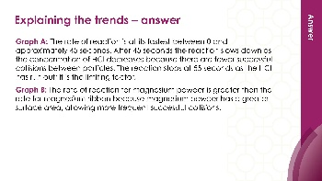 | 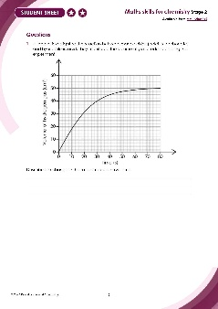

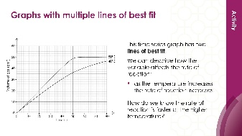

Teacher-led presentation (✪✪) | Short activities (✪✪) | Learner worksheet (✪✪)

Key terms support
Key maths vocabulary for each skill area is defined in the key terms support: rsc.li/4wypuqq. You will find the key terms listed by topic area and an accessible glossary slide for each term.

Using the short activities
The focus of short activities is embedding maths skills and engaging prior learning. The aim of this resource is for learners to revisit and practise skills from the teacher-led presentation and to develop problem solving skills so they can apply these independently.

Learning objectives
- Describe and compare patterns and trends in data.
- Understand how the variables are related to each other.
- Use data to draw conclusions about chemical reactions.
As you move through the activities, there is a clear progression in skill development, as learners practise specific graph interpretation skills within a chemistry context.
Activities can be teacher-led, for learners requiring additional support or modelling, or can be set as independent work.
The presentation contains four short activities that are designed to last 5–15 minutes and to be used as:
- a starter activity to engage prior knowledge or to practise a skill
- an assessment tool, used at the beginning of a lesson or sequence of work
- as follow-up independent practice during lessons or plenary
- for retrieval practice.

Metacognition
The activities support learners to develop their metacognitive skills in three key areas.
- Planning – prompt learners to draw on their existing mathematical knowledge by asking themselves: ‘Have I seen a similar question before? Have I come across this mathematical skill before? Have I learned a different method for solving a similar problem?’
- Monitoring – prompt learners to ask themselves: ‘How confident am I feeling with these mathematical skills? Which questions am I finding difficult? Which type of questions do I feel I have mastered?’
- Evaluation – prompt learners to ask themselves: ‘What have I learned during the presentation? Which of the mathematical skills did I use to answer these questions?’

Slide notes

Slide 1: Title slide

Slide 2: Introduction
No notes.

Slide 3: Patterns and trends in data
No notes.

Slide 4: Patterns and trends in data – example graph (answer)
- Provide scales if learners are not confident in this area. The $x$-axis is labelled concentration of hydrochloric acid (mol/dm³) and the scale should increase in intervals of 0.1 or 0.2 units. The $y$-axis is labelled final volume of hydrogen collected (cm³) and the scale should increase with suitable intervals of 10 or 20 units. Learners should plot the points correctly and draw a straight line of best fit. Remind learners to look at their plotted points by holding the paper to their eye to see if it looks as if it is a straight line or a curve.
A possible answer graph is on slide 6 (this will depend on the intervals chosen by learners).

Slide 5: Patterns and trends in data – describing the trend (answer)
- As concentration increases the final volume of hydrogen gas also increases. This is a positive linear relationship because it goes upwards towards the right and is a straight line.

Slide 6: Identifying a pattern using the periodic table
Show learners a periodic table and check they understand what a period is. Highlight period 3 to them.
For additional scaffolding ask:
- Look at the number of protons − what pattern do you see?
- Look at the atomic masses − what pattern do you notice?

Slide 7: Identifying a pattern using the periodic table (answer a)
No notes.

Slide 8: Identifying a pattern using the periodic table (answers b–c)
- Some learners may also notice that the relationship is positive but not consistent each time.

Slide 9: Using data
Explain to learners that calcium carbonate chips are like small stones. You can opt to demonstrate the reaction, and learners can record data from the demonstration.

Slide 10: Using data – example graph (answer)
- Time (s) is plotted on the $x$-axis and mass (g) on the $y$-axis. The line of best fit should be a straight line showing a negative linear relationship.
Here is an answer graph for the question on slide 9: using data. Display this to learners if time is not available for plotting the graph.

Slide 11: Using data (answers b–c)
- The mass at 55 seconds is 49.10 g (accept 49.05 to 49.15 g) Demonstrate, using the answer graph, how to interpolate to find this figure. Draw a line upwards from 55 seconds until it hits the line of best fit and then draw a horizontal line to the $y$-axis and read off the figure.

Slide 12: Use data to draw conclusions
You can decide whether this data is too complex for your learners. Remove a set of data to make this simpler. Learners can plot this graph, or you can give them two of the three concentration data sets pre-plotted to save time. Slide 13 has a copy of the full graph. Slide 14 provides an example with just two of the three data sets plotted. Similarities and difference are available on slide 15. An example conclusion is available on slide 16.
Encourage learners to discuss what they see in the table and/or in the graph before answering the question independently.
Some learners may need sentence starters to help them unpack this data.
Ask learners – how would we know that the reaction had finished?
Answer: the volume of gas produced levels off and does not increase much as time continues. Using 3 mol/dm³ acid we can see the reaction finished at 4 minutes because the volume is the same at 5 minutes.
Remind students that a conclusion should:
- describe any pattern or trend clearly
- state the relationship between the variables
- include actual data
- explain what has happened (this is not the focus for the session however).

Slide 13: Use data to draw conclusions: three data sets
Here is a model graph for the question on slide 12: using data to draw conclusions. Display this to learners if time is not available for plotting the graph.

Slide 14: Use data to draw conclusions: two data sets
Here is a scaffolded model graph for the question on slide 12 for you to with learners. They can plot the final set: 3 mol/dm³.

Slide 15: Use data to draw conclusions (answer a)
Above are a selection of possible responses. Learners may have recorded some but not all.
Differences expanded:
- Different total volumes of gas are produced: 3 mol/dm³ produces most (100 cm³), 2 mol/dm³ produces 76 cm³, 1 mol/dm³ produces least (38 cm³).
- The reactions finish at different times: 3 mol/dm³ finishes first, 1 mol/dm³ finishes last. 1 mol/dm³ and 2mol/dm³ may not actually have finished reacting yet but are very close to it.

Slide 16: Use data to draw conclusions (answer b–c)
Further detail learners may include:
As the concentration of acid increased from 1 mol/dm³ to 3 mol/dm³, the volume of gas produced also increased. The 1 mol/dm³ acid produced 38 cm³ of gas, the 2 mol/dm³ acid produced 76 cm³, and the 3 mol/dm³ acid produced 100 cm³.
The 3 mol/dm³ acid produced gas the fastest and finished at 4 minutes, while the 1 mol/dm³ acid was slowest and had nearly finished at 5 minutes.

