Interpreting graphs
There are many advantages to using graphs in chemistry.

Spot patterns and trends
It can be hard to see the pattern or trend when there are lots of numbers in a table. A graph makes the data visual, so it is easier to see if a reaction is speeding up, slowing down or progressing at a constant rate.

Make predictions
Once we have plotted points and drawn a line of best fit, we can predict what might happen at values we didn't test.

Compare different conditions
We can plot multiple lines on the same graph axes to compare how different conditions (e.g. temperature or concentrations) affect a reaction. The steeper the line, the faster the reaction.

Identify anomalies
We can spot any odd or anomalous results more easily on a graph as they don’t fit the pattern.
In this worksheet you will focus on the key skills needed to effectively interpret data in graphs and tables.

Questions
- A learner investigated how much potassium nitrate dissolves in 100 g of water at different temperatures.
Temperature (°C) | Mass of potassium nitrate dissolved (g)
20 | 32
30 | 46
40 | 64
50 | 86
60 | 110
- Plot the graph on the graph paper provided. Follow this approach:

- Decide which is the independent variable and plot this on the x-axis.
- Identify the range of each variable and choose a suitable interval for both axes.
- Label the axes with a title and unit.
- Plot the points with a sharp pencil.
- Draw a line of best fit.
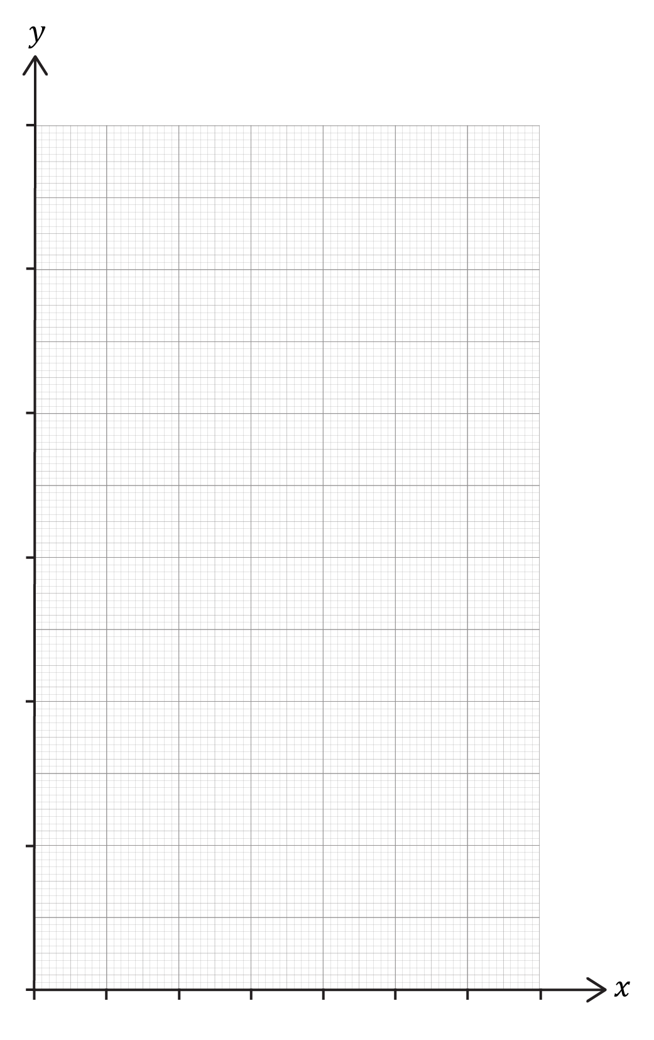
- Describe the relationship between the two variables.

______________________________________________________________________________
______________________________________________________________________________
______________________________________________________________________________
______________________________________________________________________________
______________________________________________________________________________
______________________________________________________________________________

- This graph shows the amount of carbon dioxide emitted from fossil fuels and industry into the Earth’s atmosphere since 1750.
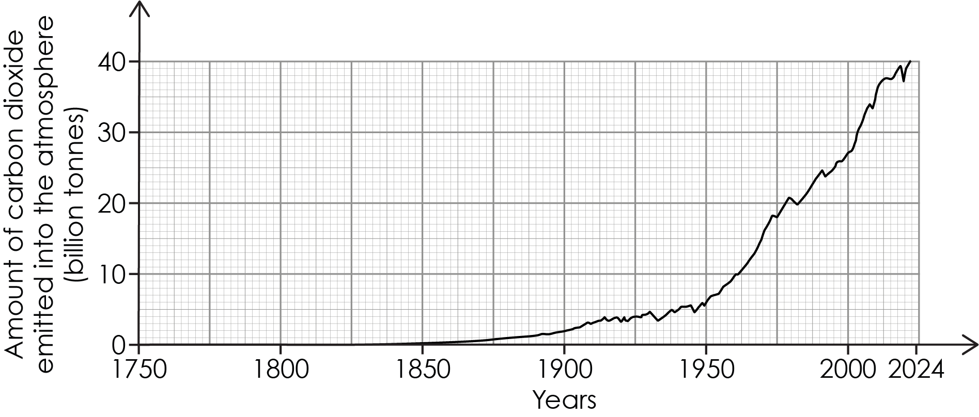
- When did the amount of carbon dioxide emitted into the atmosphere begin to increase?

__________________________________________________________________________________
__________________________________________________________________________________
__________________________________________________________________________________

- Describe the trend shown in the graph.

__________________________________________________________________________________
__________________________________________________________________________________
__________________________________________________________________________________
__________________________________________________________________________________
__________________________________________________________________________________
__________________________________________________________________________________
- A learner reacted calcium carbonate (marble chips) with hydrochloric acid. They used the same mass of marble chips but changed the surface area by using different sized pieces.
Size of pieces of marble chip | Surface area of marble chip | Time to collect 50 cm³ of carbon dioxide (s)
1 large chip | small | 240
4 medium chips | medium | 122
8 small chips | large | 58
powder | very large | 15

- Identify the variables:
independent variable _____________________________________________________
dependent variable _____________________________________________________
control variables _____________________________________________________

- Describe what happens as the surface area increases.

__________________________________________________________________________________
__________________________________________________________________________________
__________________________________________________________________________________
- What type of relationship can be seen between the variables?

__________________________________________________________________________________
__________________________________________________________________________________
__________________________________________________________________________________

- A learner investigated how adding salt to water affects the freezing point.

Mass of salt added (g) | Freezing point (°C)
0 | 0.0
1 | -0.6
2 | -1.1
3 | -1.7
4 | -2.2
5 | -2.8

Describe the pattern in the data.
__________________________________________________________________________________
__________________________________________________________________________________
__________________________________________________________________________________
__________________________________________________________________________________
__________________________________________________________________________________
__________________________________________________________________________________

Acknowledgements
Graph on page 3 reproduced from: Global Carbon Budget (2025) – with major processing by Our World in Data. ‘Annual CO₂ emissions’ [dataset]. Global Carbon Project, ‘Global Carbon Budget v15’ [original data].

