Interpreting graphs
This presentation forms part of the Maths skills for chemistry resources series, rsc.li/4A41ezG. The series offers flexible, targeted support for maths skills which are fundamental to chemistry teaching:
- Graphs and data, divided into:
  - Creating graphs
  - Interpreting graphs
- Ratio and proportion
- Understanding number, divided into:
  - Unit conversion
  - Significant figures and rounding
- Algebra and equations

Resource series components
The resource series is divided into two stages. Stage 1 (✪) is most suitable for ages 11−14 and stage 2 (✪✪) for ages 14−16. However, older learners with gaps in their fundamental knowledge can use stage 1 as a stepping stone.
Stage 1 ✪ | 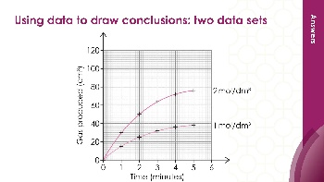  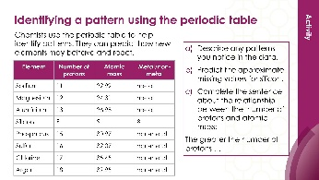 | 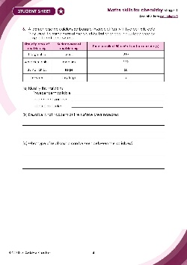
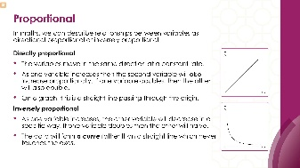
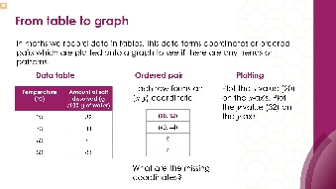
Teacher-led presentation (✪): a full lesson including learning objectives, learner-facing instructions and activities. | Short activities (✪): learner–facing activities, designed as lesson starters or quick activities to engage prior knowledge. | Learner worksheet (✪): activities for learners to independently practise their maths skills. Suitable as a classroom activity following the teacher presentation or as a home-learning task.

Stage 2 ✪✪ |   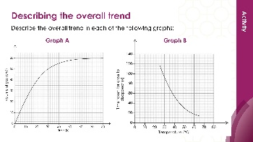 | 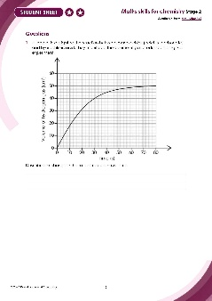

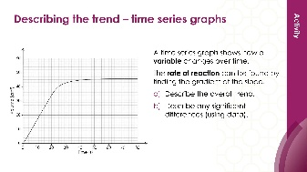

Teacher-led presentation (✪✪) | Short activities (✪✪) | Learner worksheet (✪✪)

Key terms support
Key maths vocabulary for each skill area is defined in the key terms support: rsc.li/4wypuqq. You will find the key terms listed by topic area and an accessible glossary slide for each term.

Using the teacher-led presentation
This is a full lesson focused on mastering maths skills in a chemistry context. The aim is for learners to develop key skills and then begin to apply these independently.

Learning objectives
- Describe and compare patterns and trends in data.
- Understand how the variables are related to each other.
- Use data to draw conclusions about chemical reactions.
As you move through the presentation, there is a clear progression in skill development. The first slides engage learners’ prior knowledge of the chosen maths skills. These slides link back to their learning from maths lessons as well as prior chemistry knowledge, where applicable.
Following this, the slides move onto some maths−chemistry translation tasks, then learners complete activities within a chemistry context.
The teacher-led presentation is designed to be used:
- prior to teaching a topic which makes explicit use of the maths skill, such as describing relationships between variables or writing conclusions from data presented in graphs
- after summative assessment as an intervention.

Scaffolding
The presentation is scaffolded, moving from worked examples (‘I do’) to faded examples (‘we do’), before learners go on to answer questions themselves (‘you do’).

Metacognition
This resource type supports learners to develop their metacognitive skills in three key areas.
- Planning – prompt learners to draw on their existing mathematical knowledge by asking themselves: ‘Have I seen a similar question before? Have I come across this maths skill before? Have I learned a different method for solving a similar problem?’
- Monitoring – prompt learners to ask themselves: ‘How confident am I feeling with these maths skills? Which parts of the presentation were most helpful to me?’
- Evaluation – prompt learners to ask themselves: ‘What have I learned during the presentation? How will I apply this new knowledge in my learning?’

Teaching sequence
Each teacher-led presentation begins with an introduction, learning objectives and a chemistry question which uses the maths skills. During the presentation, the learners acquire the skills relevant to the question. At the end of the presentation, learners answer the question posed at the start, using the maths skills they have developed.
Avoid giving learners access to this presentation independently. It is designed to be teacher-led.
- Outline the learning objectives (slide 2)
- Review the lesson question (slide 4) without answering it.
- Work through the maths modelling slides, making explicit links between maths and science (slides 5–25).
- Learners complete the ‘checking for understanding’ questions. Ask learners to independently complete the lesson question using the knowledge covered in the presentation (slides 26–28).

Review learning
Use the learner worksheet and short activities presentation as a follow-up or later as a review.

Slide notes
Below is the teacher guidance by slide, giving detailed information to support your teaching of the maths skill. Answers are provided for all questions. When relevant, common mathematical misconceptions are highlighted. These notes are also provided in the notes section of the PowerPoint presentation.

Introduction (slides 1–4)

Slide 1: Title slide

Slide 2: Introduction
Discuss with learners where they might have done something like the learning objectives before.
In science at the primary phase, learners will have:
- carried out experiments and recorded data in a table.
- drawn bar charts, scatter graphs and line graphs from experiments and made decisions about which category was the highest or lowest.
- used results to make simple conclusions, make predictions and suggest improvements.
In maths at primary phase, learners will have:
- presented data and interpreted it in tables and bar charts.
- used these visuals to make decisions on how many more of x there is than y for example.
In maths at secondary phase, learners:
- construct and interpret tables, bar charts, pie charts and pictograms for categorical data and vertical line charts for grouped or ungrouped data.
- are used to describing simple mathematical relationships between two variables using scatter graphs.

Slide 3: Why does data analysis matter?
Data is collected via measurements or through observations. Discuss what the difference between these two are to remind learners that in chemistry we may use qualitative methods, such as colour changes, too.
Discuss with learners what data not being perfect means.
- Why might the data not be perfect?
- What is meant by the true value?
- What can you do to improve the quality of data collected?
How likely is it that learners will achieve the true value in a school laboratory?
- Perfect data would be completely accurate measurements with no errors at all. No data is ever perfect – there are always small differences between what you measure and the actual true value. If we measure the temperature of boiling water, you might get 99.2°C, 100.1°C, or 99.8°C in different attempts, even though pure water boils at exactly 100°C under controlled conditions such as environmental temperature and pressure.
Possible reasons for data not being perfect:
- zero error
- random errors
- equipment limitations – e.g. lack of precision in measuring instruments or not calibrated correctly
- environmental limitations – room temperature fluctuations, heat loss to the surroundings, impurities in the chemicals used
- method limitations – reactions happen too fast to measure accurately, variables not controlled well.
Learners can improve the quality of data by:
- repeating measurements and calculating the mean.
- spotting and removing any anomalies.
- using equipment with more precision e.g. digital balance or digital thermometer rather than analogue versions.
- using as large a sample size as possible.
- using larger quantities where it is safe and possible to do so.
Are we likely to achieve true value data? No, because:
- school equipment is less precise than research laboratory equipment.
- chemicals used in school experiments likely to be less pure.
But we can achieve results close to the true value by getting results which are consistent and repeatable.

Slide 4: Lesson question
This slide introduces the challenge question that learners will return to at the end of the lesson. Learners are not expected to attempt it at this point. We will return to complete the question at the end of the session.
Discuss the question and the words in bold, which are in bold. Learners should recognise the terms but, if not, help them problem-solve the meaning: bi means two such as bicycle, bilingual, bilateral, bisect, bifold, binoculars. What does the term variate sound a bit like? Variable – a variable is something which changes or varies. Link back to independent and dependent variables.
Bivariate data is data which involves two variables.
A pattern is seen when data repeats in a predictable way.
Variables are anything in an experiment which can be measured and changed. Make sure learners understand the different types.
A conclusion summarises what has been found out during the investigation.

Mathematical modelling (slides 5–25)

Slide 5: Bivariate data
What does a positive correlation mean? As one variable increases, so does the other.
What does a negative correlation mean? As one variable increases, the other decreases.
What if there is no correlation? Then variables are not related.
Correlation specifically describes how closely data points follow a straight line.
Use the key terms list available from: rsc.li/4wypuqq thttps://rsc.li/4wypuqqo further support pupils with mathematical vocabulary.

Slide 6: Relationship between variables?
Discuss what the terms mean before linking to the correct example.
A linear relationship is one which forms a straight line.
Positive linear relationship means as one variable increases, so does the other variable. We look for an upward trend in the data.
If the relationship between the variables produces a straight line or is very close to being a straight line, then we can say it is a positive linear relationship (if it slopes upwards to the right) or a negative linear relationship (if it slopes downwards towards the right).
Negative linear relationship means as one variable increases, the other decreases and so we look for a downward trend in the data.

Slide 7: Relationship between variables? (answers)
Ask learners how they could describe a curved line. This would be a non-linear relationship (not a straight line but there is a relationship between the variables).

Slide 8: Patterns in data
Discuss the term pattern and its definition. What patterns have learners noticed in chemistry?

Slide 9: Patterns in data 2
Show learners a periodic table and remind them where group 1 is and how lithium, potassium and sodium react with water. You can even demonstrate this or show learners a short video clip.
Ask, what do we predict would happen if francium was added to water? We know what would happen because we have identified a pattern.
If we measured the air temperature in the morning at 8am for five days and then again at 2 pm, we might notice that the air temperature is always warmer in the afternoons. It is a predictable pattern which repeats itself. As scientists we can then seek to understand why this pattern may occur. Ask learners for their ideas.
You can also ask a more challenging question, such as: if we add alkaline sodium hydroxide solution drop by drop to hydrochloric acid what will happen to the pH over time? The pH will increase as more sodium hydroxide is added.

Slide 10: Trends
No notes.

Slide 11: Pattern or trend?
These are qualitative graphs, which means they show the relationship between the variables without numbers.

Slide 12: Pattern or trend? (answers)
B. Melting point decreases down group 1. This is predictable behaviour. Ask learners why this is not a trend. It is not a trend because there is no change over time. The data is categorical data and not a sequence changing over time.
C. The graph shows that as water temperature increases, more sucrose can be dissolved. This is predictable behaviour. Ask learners what they think might happen to the line as water temperature increases further.
Learners may find this distinction tricky as these words are often used interchangeably in everyday language. If learners find the terminology tricky, use our key terms list and accessible glossary to support their understanding: rsc.li/4wypuqq.

Slide 13: Variables and tables
Discuss the definitions of the different types of variable.
- An independent variable is the thing that the learner decides to change. This is the temperature of the water.
- The dependent variable is the thing that the learner will measure and record. This is the amount of salt which dissolves at each different temperature.
- Control variables can affect the results so they should be kept the same throughout. These could be the volume of water and the type of salt used.
Answer: a suitable table would have ‘temperature’ and the correct units in the first column header and ‘amount of salt dissolved (g)’ in the second column. Best practice would have additional columns for repeats and calculating a mean.

Slide 14: From table to graph
In science, we don’t often talk about (x, y) coordinates or ordered pairs. This might be something learners are familiar with from maths. Discuss these with learners and ask them how we would describe these numbers in science. We describe them as variables. In the ordered pair (20, 32) the 20 would be the independent variable and the 32 is the dependent variable.In science, we also often have more than two columns because of repeats, so it is not always as easy to see the ordered pair.
Answer: the missing coordinates are (60, 61) and (80, 83).

Slide 15: Proportional
Inversely proportional graphs may be challenging for most learners in this phase. You can choose not to include this section. You can also use our accessible glossary: rsc.li/4wypuqq to further support learner understanding of these terms.
Ask learners what will happen in an inverse relationship if one variable triples? The other variable will be divided by three.

Slide 16: Relationships between the variables 1
Ask learners to talk to each other and describe what they see.
For those who are struggling to get started use sentence starters such as:
- As A increases, B ____________
- The line is ___________________
- The line passes through the _____________
Possible responses may be:
- The line goes up.
- The line is straight.
Encourage learners to use the variables A and B in their answer to highlight the relationship between the variables in words. They might need to unpack what the variables are: A and B.

Slide 17: Relationships between the variables 1 (answers)
No notes.

Slide 18: Relationships between the variables 2
Ask learners to talk to each other and describe what they see.
Possible responses which need more description may be:
- The line goes up.
- The line is straight.
For those who are struggling to get started use sentence starters such as:
- As A increases, B ____________
- The line is ___________________
- The line passes through the _____________
Encourage learners to use the variables A and B in their answer. They might need to unpack what the variables are: A and B.

Slide 19: Relationships between the variables 2 (answers)
The relationship is not proportional or directly proportional, as it does not pass through the origin (0,0). In maths, sometimes we say ‘proportional’, but it means the same as ‘directly proportional’. It is good practice to say ‘directly proportional’ to avoid confusion when we talk about ‘inversely proportional’.

Slide 20: Relationships between variables 3
This is potentially challenging as there is a lot to consider. Break it down more slowly by looking at each question on its own. The slide is animated so you can look at each question in turn.
If learners need to be able to visualise the pattern more easily, they can plot this as a line graph. You can also do this as a modelling exercise on the whiteboard or under a visualiser while thinking aloud.
Use ‘think aloud’ strategies to model the strategy you would use to answer the question. Discuss how learners can tell that this is not a linear relationship if they have not plotted the graph.
Look at the differences in variable B as variable A increases by 4 units each time. If this was a linear relationship, B would decrease by the same amount each time.
When A increases from 4 to 8, B drops by 30.
When A increases from 8 to 12, B decreases by 10.
When A increases from 12 to 16, B decreases by 5.

Slide 21: Relationships between the variables 3 (answers)
(f) For example: A = 4, B = 60 → A = 8, B = 30
A = 20, B = 12 → A = 40, B = 6

Slide 22: Writing a conclusion
This session is not about substantive knowledge, so the explanation of the results is not a focus.

Slide 23: Writing a conclusion (example graph)
No notes.

Slide 24: Writing a conclusion (writing frame)
If learners require additional scaffolding, use a writing frame (example on the slide).

Slide 25: Conclusion
The pattern: as temperature increases, the amount of salt dissolved also increases.
The relationship: the points form a curved line, so the relationship is not linear. The increase in amount which can be dissolved is not happening at a constant rate.
Extension
You can ask learners to include an explanation of the results. For example, at 20°C, about 32 g of salt dissolves, while at 80°C, about 83 g dissolves. This happens because warmer water has more energy, which helps it dissolve more salt. As the temperature gets higher, the water becomes better at dissolving salt, so more salt can dissolve.

Checking for understanding (slides 26–28)

Slide 26: Returning to the lesson question
This is the original question from the beginning of the lesson.

Slide 27: Returning to the lesson question (answer a)
No notes.

Slide 28: Returning to the lesson question (answers b–d)
No notes.

