Interpreting graphs
This learner worksheet forms part of the Maths skills for chemistry resources series which can be viewed at: rsc.li/4A41ezG. The resource series covers maths skills which are fundamental to chemistry teaching:
- Algebra and equations
- Ratio and proportion
- Graphs and data, divided into:
  - Creating graphs
  - Interpreting graphs
- Understanding number, divided into:
  - Unit conversion
  - Significant figures and rounding

Resource series components
The resource series is divided into two stages. Stage 1 (✪) is most suitable for ages 11−14 and stage 2 (✪✪) for ages 14−16. However, older learners with gaps in their fundamental knowledge can use stage 1 as a stepping stone.
Stage 1 ✪ | 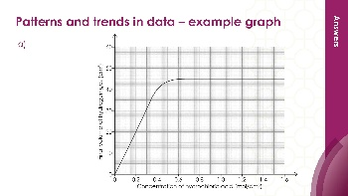  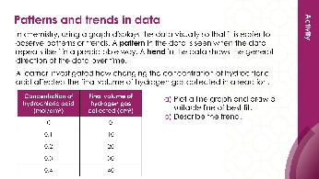 | 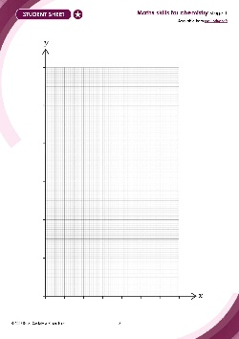
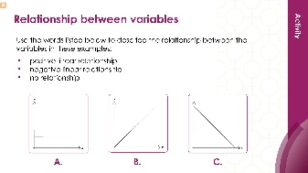

Teacher-led presentation (✪): a full lesson including learning objectives, learner-facing instructions and activities. | Short activities (✪): learner-facing activities, designed as lesson starters or quick activities to engage prior knowledge. | Learner worksheet (✪): activities for learners to independently practice their maths skills. Suitable as classroom activity following the teacher presentation or as a home-learning task.

Stage 2 ✪✪ | 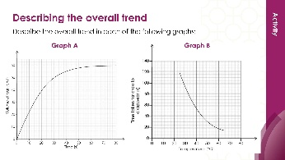  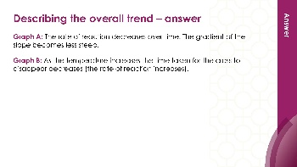 | 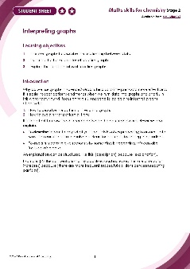
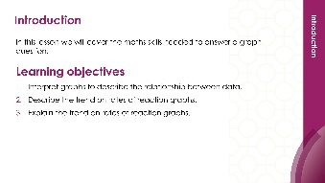
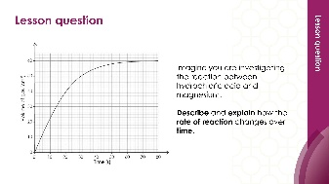

Teacher-led presentation (✪✪) | Short activities (✪✪) | Learner worksheet (✪✪)

Key terms support
Key maths vocabulary for each skill area is defined in the key terms support: rsc.li/4wypuqq. You will find the key terms listed by topic area and an accessible glossary slide for each term.

Using the learner worksheet
The focus of this learner worksheet is mastering maths skills in a chemistry context. The aim is for learners to develop and apply maths skills independently.

Learning objectives
- Translate information between graphs and tables.
- Design suitable scales for the axes on a graph.
- Plot coordinates accurately onto a graph.
- Draw an appropriate line of best fit.
The learner worksheets complement the teacher-led presentations but can function independently, for example as a classroom activity or homework assignment.
Teacher notes and answers are provided at the end of this document. When relevant, common mathematical misconceptions are highlighted.

When to use
Use the learner worksheet for:
- Reviewing learning – if learners are confident with the mathematical skill, use the worksheet as a tool to review learning and assess learners’ skill level.
- Independent practice – provide learners with the worksheet to use as independent practice.
- Scaffolded practice – break the worksheet into sections and complete over a longer period, such as multiple lessons.
- Mathematical modelling – for those requiring additional support, talk through the initial questions pulling out the mathematical skills used to answer the question, highlighting and defining any key terms. If learners are still finding the task difficult, consider fading the initial questions and asking learners to complete the later questions independently.

Scaffolding
The worksheets present a clear progression in skill development. It starts with a recap of key knowledge. Learners then work through activities that ask them to interpret graphs and data in a chemistry context.
Have the key terms list or accessible glossary available for learners who require additional support with mathematical vocabulary.
For question 1(a), if learners are struggling to plot the graph, then provide a suggested scale, such as:
- Place temperature (°C) on the $x$-axis with a scale from 0 to 70°C using 10°C intervals.
- Place mass (g) on the $y$-axis with a scale from 0–120 g using 20 g intervals.
If necessary, supply learners with partially drawn axes (a blank grid is included in the worksheet on page 4) or drawn and labelled axes and a plotted point.
For question 1(b), provide sentence starters if needed:
- As temperature increases __________________________________.
- The relationship is [linear/nonlinear/curved/ directly proportional].
Provide a similar approach for questions 2–4 if required. Alternatively, give support for question 1 and then gradually remove it in questions 2–4, following a structured scaffold approach.

Metacognition
This resource type supports learners to develop their metacognitive skills in three key areas.
- Planning – prompt learners to draw on their existing mathematical knowledge by asking themselves: ‘Have I seen a similar question before? Have I come across this mathematical skill before? Have I learned a different method for solving a similar problem?’
- Monitoring – prompt learners to ask themselves: ‘How confident am I feeling with these mathematical skills? Which questions am I finding difficult? Which type of questions do I feel I have mastered?’
- Evaluation – prompt learners to ask themselves: ‘What have I learned about myself when doing these questions? Which of the mathematical skills did I use to answer these questions?’

Answers

- Check learners have drawn a suitable graph.
- The data shows a positive linear relationship – as temperature increases, the amount of potassium nitrate that dissolves also increases.

- 1850 as the line starts to show an upward trend.
- The amount of carbon dioxide being released into the Earth's atmosphere stayed constant between 1750 and 1850 when the amount released rose quickly as the line becomes steeper up to 2024.

- Surface area (accept size)
Time
Mass of marble used, concentration of the acid, volume of the acid.
- As surface area increases from small to very large, the time taken decreases from 240 seconds to 15 seconds.
- The data shows a negative correlation between surface area and time taken to produce 50 cm³ of gas. As surface area increases, the time taken to release 50 cm³ of gas decreases.
- As the mass of the salt increases, the freezing point decreases. The data shows a negative linear relationship between the mass of salt added and the freezing point of water.

