Interpreting graphs
This learner worksheet forms part of the Maths skills for chemistry resources series which can be viewed at: rsc.li/4A41ezG. The resource series covers maths skills which are fundamental to chemistry teaching:
- Algebra and equations
- Ratio and proportion
- Graphs and data, divided into:
  - Creating graphs
  - Interpreting graphs
- Understanding number, divided into:
  - Unit conversion
  - Significant figures and rounding

Resource series components
The resource series is divided into two stages. Stage 1 (✪) is most suitable for ages 11−14 and stage 2 (✪✪) for ages 14−16. However, older learners with gaps in their fundamental knowledge can use stage 1 as a stepping stone.
Stage 1 ✪ | 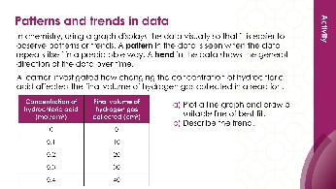 | 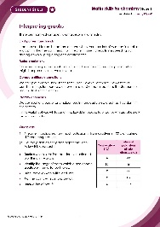
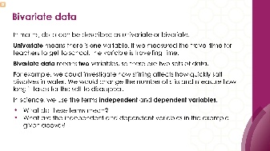
Teacher-led presentation (✪) | Short activities (✪) | Learner worksheet (✪)
Stage 2 ✪✪ |   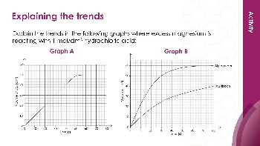 | 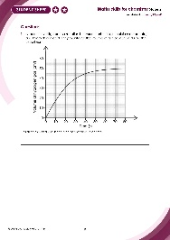
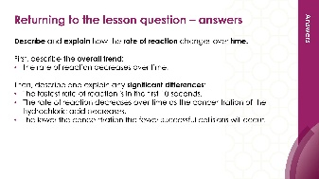
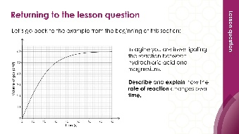

Teacher-led presentation (✪✪): a full lesson including learning objectives, learner-facing instructions and activities. | Short activities (✪✪): learner-facing activities, designed as lesson starters or quick activities to engage prior knowledge. | Learner worksheet (✪✪): activities for learners to independently practice their maths skills. Suitable as classroom activity following the teacher presentation or as a home-learning task.

Key terms support
Key maths vocabulary for each skill area is defined in the key terms support: rsc.li/4wypuqq. You will find the key terms listed by topic area and an accessible glossary slide for each term.

Using the learner worksheet
The focus of this learner worksheet is mastering maths skills in a chemistry context. The aim is for learners to develop and apply maths skills independently.

Learning objectives
- Interpret graphs to describe the relationship between data.
- Describe the trend on rates of reaction graphs.
- Explain the trend on rates of reaction graphs.
The learner worksheets complement the teacher-led presentations but can function independently, for example as a classroom activity or homework assignment.
Answers are provided at the end of this document. When relevant, common mathematical misconceptions are highlighted.

When to use
Use the learner worksheet for:
- Reviewing learning – if learners are confident with the mathematical skill, use the worksheet as a tool to review learning and assess learners’ skill level.
- Independent practice – provide learners with the worksheet to use as independent practice.
- Scaffolded practice – break the worksheet into sections and complete over a longer period, such as multiple lessons.
- Mathematical modelling – for those requiring additional support, talk through the initial questions pulling out the mathematical skills used to answer the question, highlighting and defining any key terms. If learners are still finding the task difficult, consider fading the initial questions and asking learners to complete the later questions independently.

Scaffolding
The worksheets present a clear progression in skill development. It starts with a recap of key knowledge. Learners then work through activities that ask them to interpret graphs and data in a chemistry context.
Have the key terms list or accessible glossary available for learners who require additional support with mathematical vocabulary.

Metacognition
This resource type supports learners to develop their metacognitive skills in three key areas.
- Planning − prompt learners to draw on their existing mathematical knowledge by asking themselves: ‘Have I seen a similar question before? Have I come across this mathematical skill before? Have I learned a different method for solving a similar problem?’
- Monitoring – prompt learners to ask themselves: ‘How confident am I feeling with these mathematical skills? Which questions am I finding difficult? Which type of questions do I feel I have mastered?’
- Evaluation – prompt learners to ask themselves: ‘What have I learned about myself when doing these questions? Which of the mathematical skills did I use to answer these questions?’

Answers
- The volume of hydrogen gas produced increases over time. The rate of reaction is fastest at the start, between 0 and 15 seconds and decreases over time.

- The total mass lost increases over time. The rate of reaction is fastest at the start, between 0 and 10 seconds, and decreases over time.
- Manganese(IV) oxide catalyses the decomposition of hydrogen peroxide by providing an alternative pathway for the reaction which has a lower activation energy.
- The higher the temperature, the faster the rate of reaction because the particles have more kinetic energy. This means there are more frequent successful collisions.

