Interpreting graphs

Learning objectives
- Interpret graphs to describe the relationship between data.
- Describe the trend on rates of reaction graphs.
- Explain the trend on rates of reaction graphs.

Introduction
Why do we use graphs in science? Graphs help us to interpret data more effectively. It is easier to spot patterns and trends when we turn data into graphs and charts. In this worksheet, you will focus on two skills needed to be able to interpret graphs effectively:
- How to describe the pattern or trend in a graph.
- How to explain that pattern or trend.
It is important to know the difference between the command words describe and explain.
- To describe means to ‘say what you see’, this involves processing in an accurate way. You can use data to make this clear, for example, by finding the gradient.
- To explain means to give reasons why something is happening, this can also include using data.
An explanation can be structured like this: [description] because [explanation].
Example: [As the concentration of hydrochloric acid increases the rate of reaction increases] because [there are more frequent successful collisions between reacting particles].

Questions
- A learner investigated the reaction between marble chips (calcium carbonate) and hydrochloric acid. They monitored the volume of gas produced during the experiment.
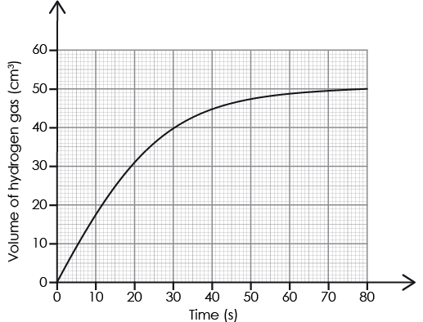
Describe the change in the rate of reaction over time.
__________________________________________________________________________________
__________________________________________________________________________________
__________________________________________________________________________________

- A learner investigated the rate of reaction when the catalyst manganese(IV) oxide was added to a solution of hydrogen peroxide.

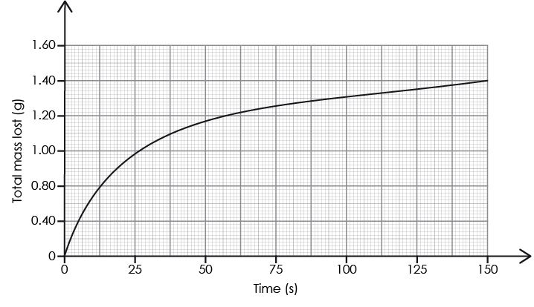
- Describe the change in the rate of reaction over time.

__________________________________________________________________________________
__________________________________________________________________________________
__________________________________________________________________________________
- Explain how manganese(IV) oxide affects the rate of reaction.

__________________________________________________________________________________
__________________________________________________________________________________
__________________________________________________________________________________

- A learner investigated the effect of temperature on the rate of a reaction.
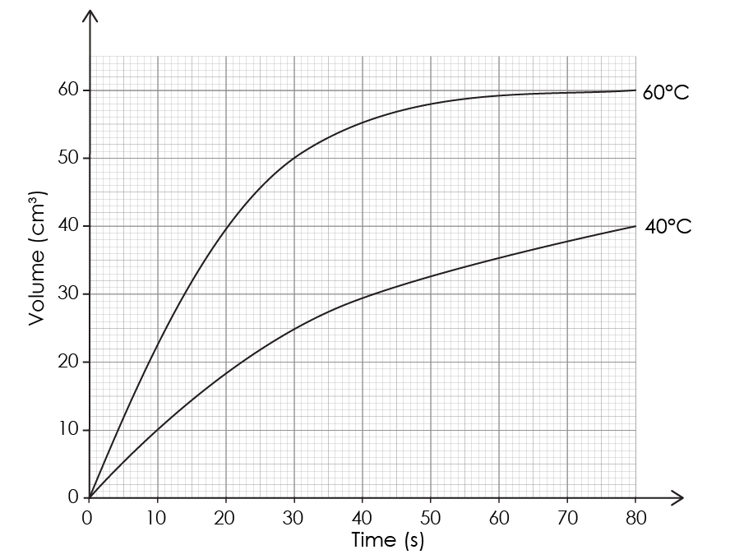
Describe and explain the relationship between temperature and the rate of reaction using information from the graph.
__________________________________________________________________________________
__________________________________________________________________________________
__________________________________________________________________________________

