Interpreting graphs
This presentation forms part of the Maths skills for chemistry resources series, rsc.li/4A41ezG. The series offers flexible, targeted support for maths skills which are fundamental to chemistry teaching:
- Graphs and data, divided into:
  - Creating graphs
  - Interpreting graphs
- Ratio and proportion
- Understanding number, divided into:
  - Unit conversion
  - Significant figures and rounding
- Algebra and equations

Resource series components
The resource series is divided into two stages. Stage 1 (✪) is most suitable for ages 11−14 and stage 2 (✪✪) for ages 14−16. However, older learners with gaps in their fundamental knowledge can use stage 1 as a stepping stone.
Stage 1 ✪ | 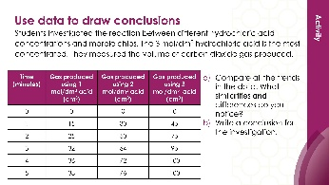 | 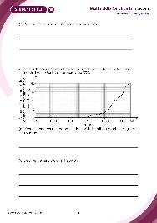
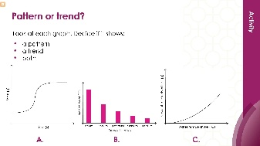
Teacher-led presentation (✪) | Short activities (✪) | Learner worksheet (✪)
Stage 2 ✪✪ |   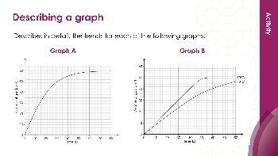 | 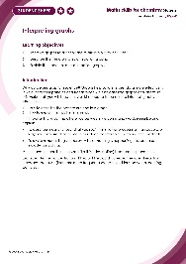
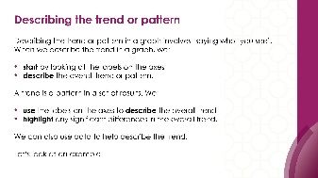
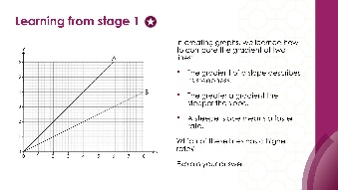

Teacher-led presentation (✪✪): a full lesson including learning objectives, learner-facing instructions and activities. | Short activities (✪✪): learner-facing activities, designed as lesson starters or quick activities to engage prior knowledge. | Learner worksheet (✪✪): activities for learners to independently practice their maths skills. Suitable as classroom activity following the teacher presentation or as a home-learning task.

Key terms support
Key maths vocabulary for each skill area is defined in the key terms support: rsc.li/4wypuqq. You will find the key terms listed by topic area and an accessible glossary slide for each term.

Using the teacher-led presentation
This is a full lesson focused on mastering maths skills in a chemistry context. The aim is for learners to develop key skills and then begin to apply these independently.

Learning objectives
- Interpret graphs to describe the relationship between data.
- Describe the trend on rates of reaction graphs.
- Explain the trend on rates of reaction graphs.
As you move through the presentation, there is a clear progression in skills development. The first slides engage learners’ prior knowledge of the chosen maths skill. These slides link back to their learning from maths lessons as well as prior chemistry knowledge, where applicable.
Following this, the slides move onto some maths−chemistry translation tasks, then learners complete activities within a chemistry context.
The teacher-led presentation is designed to be used:
- prior to teaching a topic which makes explicit use of the maths skill, such as describing patterns and trends in results, identifying information from multiple data sets and writing conclusions from graphs
- after summative assessment as an intervention.

Scaffolding
The presentation is scaffolded, moving from worked examples (‘I do’) to faded examples (‘we do’), before learners go on to answer questions themselves (‘you do’).

Metacognition
This resource supports learners to develop their metacognitive skills in three key areas.
- Planning – prompt learners to draw on their existing mathematical knowledge by asking themselves: ‘Have I seen a similar question before? Have I come across this maths skill before? Have I learned a different method for solving a similar problem?’
- Monitoring – prompt learners to ask themselves: ‘How confident am I feeling with these maths skills? Which parts of the presentation were most helpful to me?’
- Evaluation – prompt learners to ask themselves: ‘What have I learned during the presentation? How will I apply this new knowledge in my learning?’

Teaching sequence
Each teacher-led presentation begins with an introduction, learning objectives, and a chemistry question which uses the target maths skills. During the presentation, the learners acquire the maths skills relevant to the question. At the end of the presentation, learners answer the question posed at the start, using the skills they have just developed.
Avoid giving learners access to this presentation independently. It is designed to be teacher-led.
- Outline the learning objectives (slide 2)
- Review the lesson question (slide 3) without answering it, following the teacher notes (provided in the presentation and copied below).
- Revisit learning interpreting graphs from stage 1 resources (slides 4–5).
- Work through the mathematics modelling slides, making explicit links between maths and science (slides 6–12).
- Learners complete the ‘checking for understanding’ questions. Ask learners to independently complete the lesson question using the knowledge covered during the lesson (slides 13–14)).

Review learning
You can use the linked learner worksheet and short activities as a follow-up to this lesson or later as a review.

Slide notes

Introduction (slides 1–5)

Slide 1: Title slide

Slide 2: Introduction
Explain that we will be covering these key maths skills in a chemistry context.

Slide 3: Lesson question
This slide introduces the challenge question that learners will return to at the end of the lesson. Learners are not expected to attempt it at this point. We will return to complete the question at the end of the session.

Slide 4: Learning from stage 1
In the creating graphs stage 2 resource set, learners describe the gradient of a slope, calculated the gradient of a slope and calculated the gradient of a tangent. If your learners need to revisit any of these skills, the teacher-led presentation can be found here: rsc.li/4gA2Lp7.
Answer: Line A has the higher rate because the gradient is steeper.​ As x increases y increases.​

Slide 5: Describing the trend or pattern
If your learners need to revisit the difference between the trend or pattern or the definitions, this is available in the level 1 teacher led presentation of this set: rsc.li/3l0g6sR

Mathematical modelling (slides 6–12)

Slide 6: Describing the pattern
Explain that when we are talking about bivariate data, we can use the independent and dependent variables to describe the overall trend:
- As the [independent variable] increases the [dependent variable] increases/decreases.
Emphasise that we are using the entire label on each axis to describe the overall trend. Discuss the meaning of linear relationship.

Slide 7: Describing the pattern (answers)
No notes.

Slide 8: Describing the trend – time series graphs
Explain that in a time series graph, time is plotted on the x-axis, and the measured variable is plotted on the y-axis. Activities on how to find the gradient of a slope (with or without a tangent) can be found in creating graphs stage 2 resources: rsc.li/4gA2Lp7. Revisit this with your learners if they need to practice finding the gradient of a slope.
Discuss how the trend statement is different to that of the previous graph:
- The [dependent variable] increases/decreases over time.

Slide 9: Describing the trend – time series graphs (answers)

Slide 10: Graphs with multiple lines of best fit
Explain that some time series graphs in science have multiple lines of best fit – each line represents a change in the variable.
Explain that we can describe each time separately, as we would any time series graph. The important point is to look at the variable of temperature and to work out how temperature affects the rate of reaction. Explicitly describe the link between rate of reaction and the steepness of each line.
Ask learners: how do we know the rate of reaction is faster at the higher temperature?

Slide 11: Graphs with multiple lines of best fit (answer)
Make the link between variables using the sentence structure: as the [independent variable] increases the [dependent variable] increases/decreases.

Slide 12: Explaining the line of best fit
Explain that a good explanation normally consists of [description] [connective] [explanation]. The connectives (because and so) are highlighted in purple for learners.
As temperature increases the rate of reaction increases [description] because [connective] the particles have more kinetic energy [explanation], so [connective] there are more frequent successful collisions.
In this sentence, 'because' is the main connective separating the explanation and the description. ‘So’ is also a connective, separating the sentence clauses (parts of the sentence) indicated by a comma.

Checking for understanding (slides 13–14)

Slide 13: Returning to the original question
Explain that we are going to use the information from the previous slides to describe and explain the graph above.

Slide 14: Finding the gradient using coordinates
Discuss how we know that the rate of reaction has decreased over time. Relate this to the volume of gas being produced. The rate at which the gas is being produced is decreasing over time.

Slide 15: Acknowledgements
No notes.

