Algebra and equations
This presentation forms part of the Maths skills for chemistry resources series which can be viewed at: rsc.li/4A41ezG. The resource series covers maths skills which are fundamental to chemistry teaching. Titles in the series:
- Understanding number, divided into:
  - Unit conversion
  - Significant figures and rounding
- Ratio and proportion
- Graphs and data, divided into:
  - Creating graphs
  - Interpreting graphs
- Algebra and equations

Resource series components
The resource series is divided into two stages. Stage 1 (✪) is most suitable for ages 11−14 and stage 2 (✪✪) for ages 14−16. However, older learners with gaps in their fundamental knowledge can use stage 1 as a stepping stone.
Stage 1 ✪ | 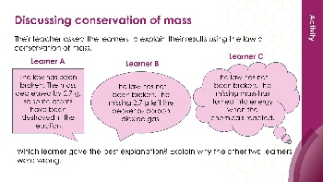  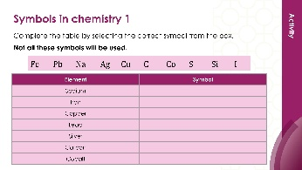 | 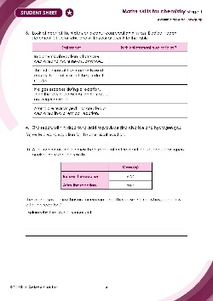
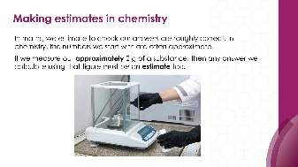
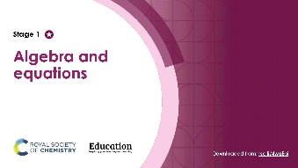
Teacher-led presentation (✪): a full lesson including learning objectives, learner-facing instructions and activities with answers for self-assessment. | Short activities (✪): learner-facing activities, designed as lesson starters or quick activities to engage prior knowledge. | Learner worksheet (✪): activities for learners to independently practice their maths skills. Suitable as a classroom activity following the teacher presentation or as a home-learning task.

Stage 2 ✪✪ | 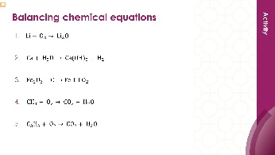  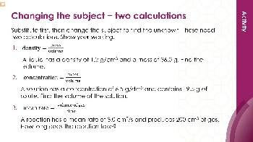 | 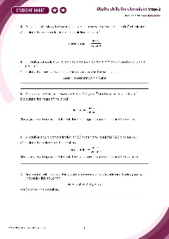
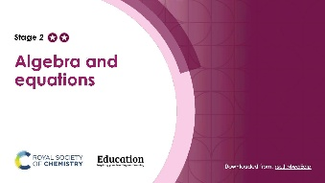
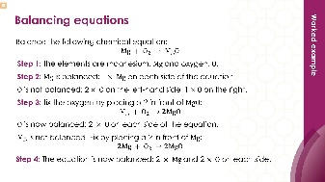

Teacher-led presentation (✪✪) | Short activities (✪✪) | Learner worksheet (✪✪)

Key terms support
Key vocabulary for each skill area is defined in the key terms support: rsc.li/4wypuqq. You will find the key terms listed by topic area and an accessible glossary slide for each term.

Using the teacher-led presentation
This is a full lesson focused on mastering maths skills in a chemistry context. The aim is for learners to develop key skills and then begin to apply these independently.

Learning objectives
- Make estimates of the results of simple calculations.
- Recognise mass is conserved during a chemical reaction.
- Understand some common symbols used in word and symbol equations.
As you move through the presentation, there is a clear progression in skill development. The first slides engage learners’ prior knowledge of the chosen maths skills. These slides link back to their learning from maths lessons as well as prior chemistry knowledge, where applicable.
Following this, the slides move onto some maths−chemistry translation tasks, then learners’ complete activities within a chemistry context.
The teacher-led presentation is designed to be used:
- prior to teaching a topic which makes explicit use of the maths skill, such as conservation of mass or balancing symbol equations
- after summative assessment as an intervention.

Scaffolding
The presentation is scaffolded, moving from worked examples (‘I do’) to faded examples (‘we do’), before learners go on to answer questions themselves (‘you do’).

Metacognition
This resource type supports learners to develop their metacognitive skills in three key areas.
- Planning – prompt learners to draw on their existing mathematical knowledge by asking themselves: ‘Have I seen a similar question before? Have I come across this maths skill before? Have I learned a different method for solving a similar problem?’
- Monitoring – prompt learners to ask themselves: ‘How confident am I feeling with these maths skills? Which parts of the presentation were most helpful to me?’
- Evaluation – prompt learners to ask themselves: ‘What have I learned during the presentation? How will I apply this new knowledge in my learning?’

Teaching sequence
Each teacher-led presentation begins with an introduction, learning objectives, and a chemistry question which uses the target maths skills. During the presentation, the learners acquire the skills relevant to the question. At the end of the presentation, learners answer the question posed at the start, using the maths skills they have developed.
Avoid giving learners access to this presentation independently. It is designed to be teacher-led.
- Outline the learning objectives with learners (slide 2)
- Review the chemistry question (slide 3–4) without answering it, following the teacher notes (provided in the presentation and in the slide notes below).
- Work through the mathematical modelling slides, making explicit links between maths and science (slides 5–20).
- Learners complete the ‘checking for understanding’ questions. Ask learners to independently complete the lesson question using the knowledge covered during the lesson (slides 21–23).

Review learning
You can use the linked learner worksheet and short activities as a follow-up to this lesson or later as a review.

Slide notes
Below is the teacher guidance by slide, giving detailed information to support your teaching of the maths skill. Answers are provided for all questions. When relevant, common mathematical misconceptions are highlighted. These notes are also provided in the notes section of the PowerPoint presentation.

Introduction (slides 1–4)

Slide 1: Title slide

Slide 2: Learning objectives
No notes.

Slide 3: Lesson question
This slide introduces the challenge question that learners will return to at the end of the session. It is not expected that learners attempt it at this point.

Slide 4: Lesson question continued
Briefly talk through the scenario. The question combines three skills from the session:
- writing a word equation
- checking that the law of conservation of mass is upheld
- knowing if an equation is balanced or not.
Check that learners understand the terms ‘relative formula mass’ and ‘relative atomic mass’. If they require support with these terms, revisit our accessible glossary to support this resource series: rsc.li/4wypuqq.

Mathematical modelling (slides 5–21)

Slide 5: Making estimates in maths
Before showing the content of the slide, ask learners if they can recall how to estimate the result of a calculation in maths. Recall what the term rounding to 1 significant figure means to check for understanding, and that 1 significant figure is not the same as 1 decimal place. This is covered in the understanding number stage 1 significant figure and rounding resources: rsc.li/4gbEt3p. You may need to revisit this resource with learners, as well as the accessible glossary which supports this resource: rsc.li/4wypuqq.
Show the content and talk through each step of the worked example.
Ask learners to complete the question $6.7 × 4.2$ as practice.
6.7 is rounded to 7.0 and 4.2 is rounded to 4.0. Therefore, $7 × 4 = 28$.
The actual answer for $6.7 × 4.2$ = $28.14$, so the estimate is close to the true value.

Slide 6: Making estimates in chemistry
Many learners think an estimate means a rough guess. An estimate can be the result of a careful, accurate calculation, it is just that the numbers we put in were not perfectly exact. Learners often think that if they have done the maths calculation correctly, their answer must be exactly right. In chemistry, the answer is only as accurate as the values you started with.

Slide 7: Making estimates in chemistry: example
This example shows that an estimate can be the result of a careful, accurate calculation, it is just that the numbers we put in were not perfectly exact.
In maths, learners round numbers to make calculations easier and then check their answer is roughly right. In chemistry, the periodic table has already done that rounding for us, so every calculation we do using it is technically an estimate which is close enough for the calculations needed at this point.

Slide 8: Which answer is correct?
The focus of this slide is to encourage the habit of estimating before calculating. Learners who estimate first are much less likely to accept a wrong answer from their calculator without questioning it. Check and recap so that learners know how to round to 1 significant figure. Rounding 93 to 90and 31 to 30 are both straightforward examples that most learners will manage confidently.
Ask learners to commit to an answer before revealing the answer (the next slide in this presentation). This is important because if they see the answers first, the estimation step loses its purpose. Ask learners to hold up A, B, C or D on mini whiteboards before discussing as a class.

Slide 9: Which answer is correct? (answer)
A dividing the wrong way round is common, especially when learners are not sure which number is the numerator.
B is the correct answer.
C adding instead of dividing often happens when learners are rushing.
D multiplying instead of dividing is another rushing mistake.
Discuss the wrong answers; each wrong answer represents a very common calculator mistake. It is worth spending time on each one.
Stress that the estimate does not need to be exact, it just needs to be close enough to tell you whether your answer is sensible. An estimate of 3 is enough to rule out 0.33, 124 and 2883 immediately. This directly mirrors what learners do in maths when they round to $1$significant figure to check a calculation. Reminding learners of this connection can help those who are less confident in chemistry but stronger in maths.

Slide 10: Making estimates using a table of results
This slide introduces a different kind of estimation to what learners have seen before. Rather than rounding numbers to check a calculation, learners are now using the pattern in a set of data to suggest a missing value. This is a skill that comes up regularly in upper secondary science when data is incomplete or a reading has been missed.
In maths, estimation usually means rounding to 1 significant figure to simplify a calculation. Here, estimation means using scientific reasoning to suggest a value that fits the data. There is no single correct answer − any reasonable value supported by the pattern in the data would be acceptable. Learners may incorrectly think they are guessing, make sure they realise that they are using the evidence provided. A good estimate will be consistent with the trend shown in the rest of the data.
Work through the following steps while thinking out loud to decode the issue for learners.
Step 1: look at the range. The temperatures go from 90°C down to 70°C. So, our missing value must sit between 85°C and 75°C. It cannot be higher than 85, or lower than 75.
Step 2: look for a pattern. Every 2 minutes the temperature drops by 5°C. This is a very clear and consistent pattern.
Step 3: use the trend to estimate. If the temperature at 2 minutes is 85°C and it is dropping by 5°C every 2 minutes, then at 4 minutes we would expect the temperature to be 80°C.
Step 4: check it makes sense. Does 80°C fit between 85°C and 75°C? Yes. Does it follow the pattern? Yes. So, 80°C is a sensible estimate.
Discuss why is this still an estimate and not an exact answer.
We did not actually measure the temperature at 4 minutes; we are predicting it from the pattern. Once learners are comfortable identifying the trend and using it to fill in a gap, you can introduce messier real-world data where the pattern is less obvious, and the estimate requires more judgement. This skill connects directly to interpolation on a graph, where learners read off a value between two data points. If learners have covered line graphs, make this link explicit.

Slide 11: Conservation of mass
Before revealing the slide content, ask learners where they have heard the word conservation before and discuss what they think it means. Reveal the etymology of the word conservation first as a useful hook. Learners will be familiar with the word from contexts like conservation of wildlife or energy conservation, where the idea of ‘keeping’ something is already present.
Check that learners understand the meaning of the words reactant and product in relation to a chemical reaction. If learners need further support, use our accessible glossary rsc.li/4wypuqq.
This slide introduces one of the most fundamental ideas in chemistry. Everything that follows in chemical calculations depends on learners understanding that mass is always conserved. Spend time making sure this concept is secure before moving on. You can also use the definition of conservation of mass in the accessible glossary.
The bricks analogy is deliberately simple. Use it to make the point that rearranging things does not change how many you have. Extend this by asking learners: ‘If I have 10 red bricks and 5 blue bricks and I build something new with them, how many bricks do I have at the end?’ This reinforces the idea before introducing atoms.
Finally, ask learners what the image is showing: both sides are level, meaning both sides have equal mass.

Slide 12: Conservation of mass in a chemical reaction
This slide moves from the concept of conservation of mass to applying it with real numbers. Learners are asked to verify the law for themselves using experimental data. This is an important step, rather than just being told the law is true, they are checking it.
Draw learners' attention to the word equation on the slide and point out that the arrow separates the reactants from the products; everything to the left of the arrow is what we start with, everything to the right is what we end up with. The arrow in a chemical equation might be verbalised as ‘reacts to make’ or ‘produces’. The arrow shows the direction the reaction travels; everything on the left is what you start with, and everything on the right is what you end up with. The arrow itself represents the moment of change, where the atoms are rearranged into something new. Point out to learners that the arrow is not an equal sign, even though in terms of mass, both sides are equal. An equal sign would suggest the two sides are the same thing, but they are not. The substances have changed. The arrow captures the idea that a transformation has taken place. Get learners to read a word equation out loud, so they become comfortable with what is happening in a chemical reaction.
Use the next slide to model how to find out if mass has been conserved to learners by thinking out loud.

Slide 13: Conservation of mass in a chemical reaction (answers)
Step 1: identify the reactants and their masses. Ask: ‘what are we starting with? Magnesium and oxygen. What are their masses? 2.4 g and 1.6 g.’
Step 2: add the masses of the reactants on the interactive white board or visualiser. ‘Total mass before the reaction = $2.4 + 1.6 = 4.0 g.$’
Step 3: identify the product and its mass. Ask ‘what is produced? Magnesium oxide. What is its mass? 4.0 g.’
Step 4: compare. ‘Mass before = 4.0 g. Mass after = 4.0 g.’
They are equal, so yes, the law of conservation of mass is true here. In a reaction, nothing is lost and nothing is gained. The atoms just get rearranged into new substances, so the mass stays the same. All the atoms we started with are all still there, they have just been rearranged into magnesium oxide.
Some learners will not realise they need to add the mass of both reactants together before comparing them to the mass of the product.
Explicitly say: ‘We need to add up everything on the left–hand side of the arrow and compare it to everything on the right-hand side.’

Slide 14: Conservation of mas when a gas is produced
- Read out the first sentence on the slide. Before revealing anything else on the slide, ask learners to attempt the word equation themselves (answers available on the next slide). If a prompt is needed, then ask learners to identify the reactants and the products first.
- This slide tackles the most common situation where learners think conservation of mass has broken down. The mass appears to decrease, but no atoms have been lost. They have left the system as a gas. Make this critical point explicitly. It is also a deeply held misconception that some learners think gases have no mass.
- This is a higher order question. Guide learners towards the answer (available on the next slide).

Slide 15: Conservation of mas when a gas is produced (answers)
- Learners may struggle to identify all three products. Carbon dioxide is the one most likely to be missed, which makes it a perfect lead into the discussion about why mass appears to decrease.
- Model the mass calculation: ask learners to calculate the difference in mass between the start and end of the experiment and write this in a sentence. Learners should write something like this: The mass has decreased by 2.2 g from the start to the end of the experiment. Then ask: ‘Where did those 2.2 g go?’ This is the key question. Learners need to connect the missing mass to the carbon dioxide that escaped. The mass of carbon dioxide produced was 2.2 g. Some learners may still think that the law of conservation has not been upheld. Stress that the law of conservation of mass is always true and that we must account for all the products even gases. Learners may not think that a gas has mass. In this case, ask learners what the gas is made from. They should recognise that a gas is made up of atoms and atoms have mass.
- Guide learners towards the answer: If no gas could escape, all the products would stay inside the container. The total mass of everything inside would still be 50.0 g. because no atoms have left. Learners may incorrectly believe that conservation of mass only applies in sealed containers. Learners sometimes reason that if the container is open, the rule does not apply. It is worth being clear that the law always holds; what changes is whether we can easily measure all the products.

Slide 16: From words to symbols
This slide bridges the gap between word equations, which learners have already used, and symbol equations, which are new. The key point is that symbols are a universal language and mean the same thing everywhere, which is why scientists use them.
If we translate the name of the element silver into French, it is argent. In Polish, silver is srebro. In Romanian it is argint and in Punjabi silver is ਚਾਂਦੀ [chandi]. To illustrate this point further, ask your class if anyone is multilingual. Invite them to share the translation for silver (or other elements) in their home language.
Show the table but do not reveal the answers yet (available on the next slide). Learners sometimes think the symbol is just an abbreviation of the English name. Point out that some symbols come from Latin, for example iron is Fe from ferrum and sodium is Na from natrium. This shows why we cannot always guess the symbol from the English name. However, there are several elements that do have single letter symbols that could cause confusion with two letter symbols starting with the same letter.

Slide 17: From words to symbols (answers)
Answers: $C$ is carbon, $Ca$ is calcium, $Cl$is chlorine and $Co$ is cobalt. There are also $Cu,$which is copper, and$Cr,$which is chromium.
Extension
Expand the discussion: $H$ is hydrogen, $He$is helium and $Hg$ is mercury, $N$is nitrogen, $Na$ is sodium and $Ni$ is nickel. The capital and lower-case rule is important. When learners write chemical formulas, they must always write the first letter as a capital and the second letter, if there is one, as lower case.
We know $Co$ means cobalt (one element). However, $CO$ means carbon monoxide (two elements, carbon and oxygen). We can tell this because there are two capital letters. If a learner writes the symbol for cobalt as $CO$ (with both letters in capital) it is carbon monoxide, which completely changes the meaning and the reaction! Make this point explicitly to learners early on, as it is a very common source of confusion and can lead to errors in formulas and equations that are difficult to spot later.
Ask learners where they can go to find the names and symbols for elements if they are not sure. Learners can use a periodic table to help: e.g. periodic-table.rsc.org.

Slide 18: From symbols to formulas
This slide introduces chemical formulas and the meaning of subscript numbers. Start by asking learners to define the term ‘element’ as an opportunity for recall. Then ask what the prefix ‘sub’ means. Think about a submarine − a vessel which goes below the surface of the sea. Sub means below. So, a subscript is writing below the line.
It is important that learners understand a formula contains information about how many atoms or ions of each element are present.

Slide 19: Reading a symbol equation
This slide uses the magnesium example learners have already seen to introduce the idea of counting atoms/ions on each side of an equation. The question at the end is deliberately left open to create curiosity and lead into the next slide. Learners have already seen this word equation in the conservation of mass slides. Using a familiar example here aims to reduce the cognitive load and lets learners focus on the new skill of counting atoms (and ions).
Work through the table by thinking out loud with learners. Point to each symbol and count explicitly. For example: on the left I have $Mg$, that is 1 magnesium. I have $O_{2}$, that is 2 oxygen. On the right I have $MgO$, that is 1 magnesium and 1 oxygen.
Where has the other oxygen atom gone?
This is the hook for the next slide. Do not answer it yet. Give students a moment to think and discuss before moving on. Some may suggest the equation is wrong. Others may suggest we need more $MgO$ on the right. Both responses are useful starting points. A common misconception is that learners think $O_{2}$ means 2 separate oxygen atoms rather than 2 oxygen atoms joined together. Clarify this but keep it simple at this stage, as the focus is on counting rather than bonding. Explain that not all elements form diatomic pairs.

Slide 20: Balancing a symbol equation
This slide introduces balancing as a direct consequence of conservation of mass. Ask learners to recall the law of conservation of mass (slide 11) and ask them what they would expect if it was upheld. Learners already know that atoms cannot be created or destroyed, so it should feel logical that both sides of the equation must have the same number of atoms.
Emphasise that we can only add coefficients (the big number) in front of formulas. We must never change the subscript numbers inside a formula. Changing a subscript changes the substance itself. For example, changing $MgO$ to $MgO₂$would turn magnesium oxide into a completely different substance. This is a rule learners must learn early and apply consistently.
Highlight the coefficients which have been added. The next slide asks learners to use the table method to show that the number of atoms/ions on each side are now balanced. Learners often incorrectly try to balance equations by changing subscripts rather than adding coefficients. This is the single most common error in this topic so address it directly before learners start practising independently. Balancing equations is one of the focal points of the stage 2 teacher-led presentation.

Checking for understanding (slides 21–23)

Slide 21: Is it balanced?
Ask learners to check the final equation themselves by counting both sides before revealing the completed table.
Link the table and equation back to conservation of mass. Once the equation is balanced ask learners: does this equation show conservation of mass? How do you know? A good answer would refer to the equal number of each type of atom/ion on both sides of the arrow.

Slide 22: Returning to the lesson question
Return to the challenge question from the start of the session. Allow learners time to attempt the question independently before discussing as a class. The answers are on the next slide.

Slide 23: Returning to the lesson question (answer)
No notes.

Slide 24: Acknowledgements
No notes.

