Elements, compounds and mixtures

Introduction

These questions are designed to help you to develop your mental models (pictures in your head) of symbols and formulae. Use the icon in the margin to find out which level of understanding the question is developing.
 | Macroscopic: what we can see. Think about the properties that we can observe, measure and record.
 | Sub-microscopic: smaller than we can see. Think about the particle or atomic level.
 | Symbolic: representations. Think about how we represent chemical ideas including symbols and diagrams.


Questions
- The images below show an element in the gas state and another element in the solid state.

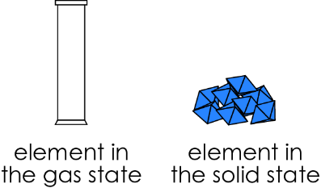
- Diagram X, Y and Z represent how the atoms are arranged in elements in the gas and solid state. Each diagram represents the huge number of particles that make up an element but only a few are drawn.

State which diagram or diagrams show an element in each state.

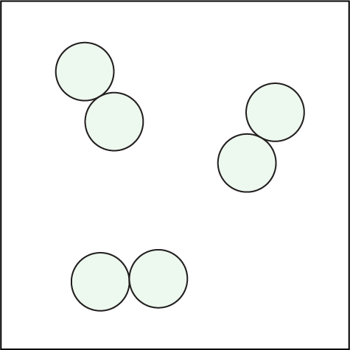  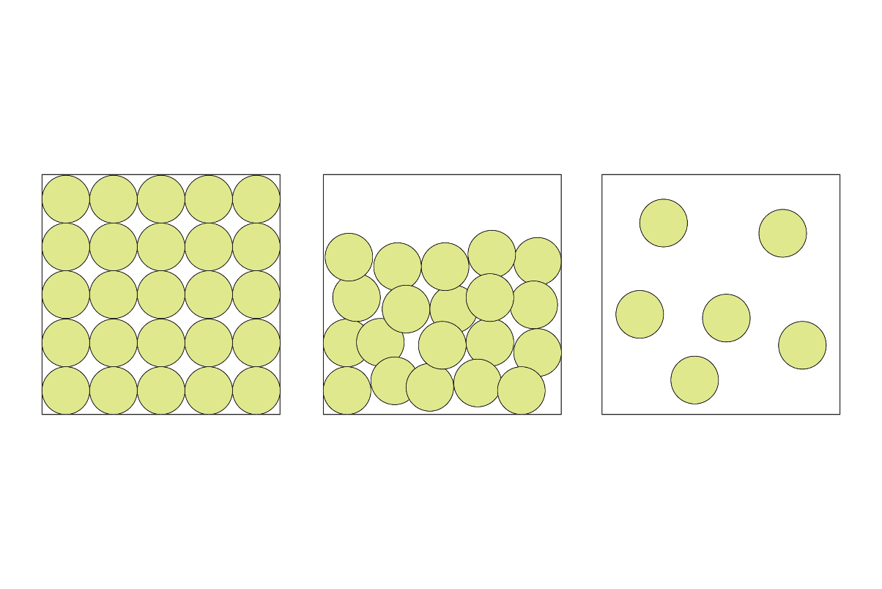 |  | 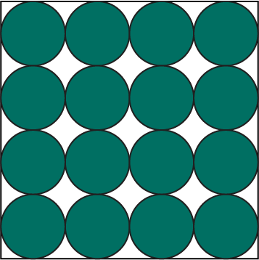
X | Y | Z
- gas state ______________
- solid state ______________
- Select the sentence that best describes what is represented by:

- diagram X _____
- diagram Z _____

A | six atoms of an element
B | 25 atoms of an element
C | 4000 atoms of an element
D | more than a million atoms of an element

- Write a sentence to describe what diagram Y represents.

__________________________________________________________________________________

__________________________________________________________________________________

- A compound is made up of atoms of more than one element that are chemically combined.
- Draw lines to match each description to the correct meaning. The first line is drawn for you.

Diagram | Description |  | Meaning
 | 1 circle |  | 2 atoms of an element
 | 2 touching circles with the same colour |  | 1 molecule of a compound
 | 2 separate circles with the same colour |  | 2 atoms of different elements
 | 2 separate circles with different colours |  | 1 atom of an element
 | 2 touching circles with different colours |  | 1 molecule of an element

- Give the letter of the diagram that matches each description.
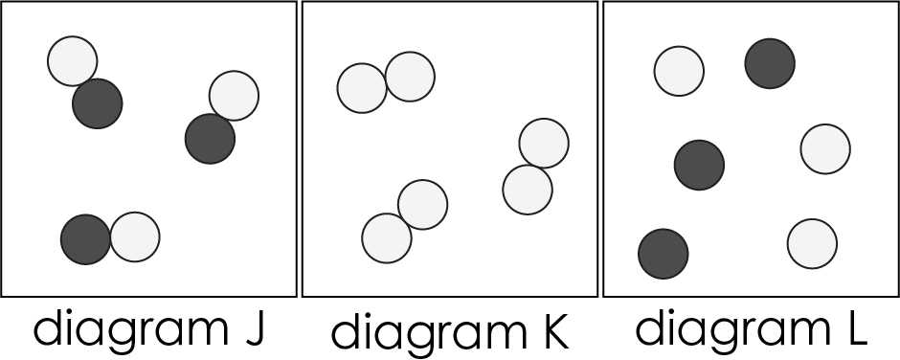

- This diagram does not represent a compound. Each molecule is made up of the same type of atom. _____
- This diagram does not represent a compound. There are two types of atom but the atoms are not combined. _____
- This diagram does represent a compound. The molecules are made up of two types of atom. _____

- Identify which diagram represents:
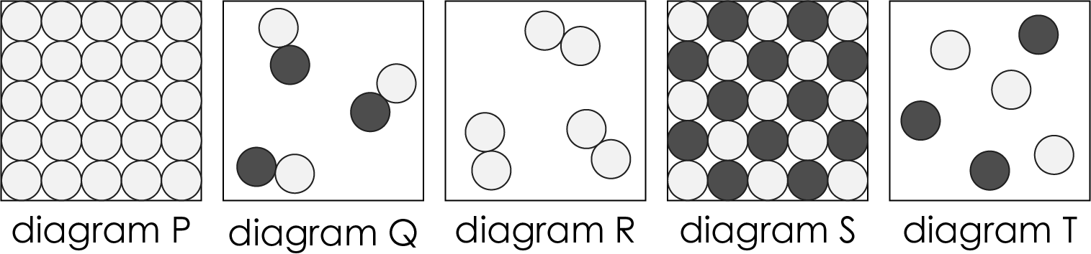

- an element in the gas state _____
- an element in the solid state _____
- a compound in the gas state _____
- a compound in the solid state _____

- Look at the particle diagrams in the table on the next page.
- For each particle diagram state how many elements or compounds are shown, record this in the table.

- Describe how you worked this out. Use the words atom, molecule, element and compound in your answers. The first two rows are completed for you.

 | Particle diagram | Number of elements | Number of compounds | Explanation
 | 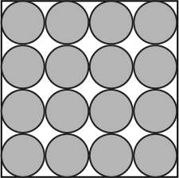 | 1 | 0 | because the circles are the same colour and represent one type of atom.
ii. | 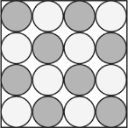 | 0 | 1 | because there are two types of circles (touching) which represent two types of atoms that are joined.
iii. | 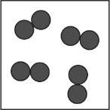 |  |  | because
iv. | 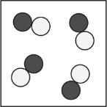 |  |  | because
v. | 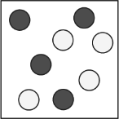 |  |  | because
vi. | 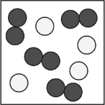 |  |  | because
vii. | 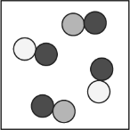 |  |  | because
viii. | 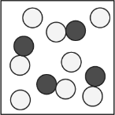 |  |  | because

- List the particle diagrams which show a mixture.

__________________________________________________________________________________

__________________________________________________________________________________

- Carbon dioxide has the formula $CO_{2}$. A molecule of carbon dioxide is made up of one atom of carbon and two atoms of oxygen.

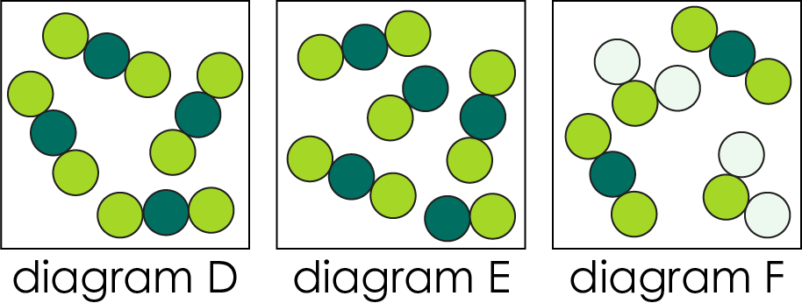

Identify the diagram or diagrams that show:
- a pure sample of carbon dioxide. ______________
- a mixture of carbon dioxide and another compound. ______________

