Elements, compounds and mixtures

This resource is from the Johnstone’s triangle series which can be viewed at: rsc.li/4jI4bfW. In this series you will also find our Elements, compounds and mixtures: Johnstone’s triangle worksheet which introduces the triangle in the context of gases in the air and can be viewed at: rsc.li/4vWehQn.

Learning objectives
LO | Objective | Where assessed
1 | Interpret particle diagrams of an element in the gas and solid states. | Q1
2 | Distinguish particle diagrams of elements and compounds in the gas and solid states. | Q2
3 | Interpret particle diagrams of elements, compounds and mixtures of elements or compounds. | Q3

How to use this resource
When to use? |   Introduce |   Develop |   Revise |   Assess
When to use? | Use after initial teaching or discussion of this topic to develop ideas further. You can also use as a revision activity.
Group size? |   Independent |   Small group |   Whole class |   Homework
Group size? | Suitable for independent work either in class or at home. Or use the questions for group or class discussions.
How long? |  |  | 15–30 mins

This resource aims to develop learners’ understanding of particle diagram representations of elements and compounds. The questions encourage learners to think carefully about the actual diagrams and what the different colour and arrangement of the circles signify. As a result, learners should develop more secure mental models to support their thinking about this topic.

Johnstone’s triangle

Johnstone’s triangle is a model of the three different conceptual levels in chemistry: macroscopic, sub-microscopic and symbolic. You can use Johnstone’s triangle to build a secure understanding of chemical ideas for your learners.

Find further reading about Johnstone’s triangle and how to use it in your teaching at rsc.li/4fnaFSr.

Johnstone’s triangle and this resource

The icons in the margin indicate which level of understanding each question is developing to help prompt learners in their thinking.

 | Macroscopic: what we can see. Think about the properties that we can observe, measure and record.
 | Sub-microscopic: smaller than we can see. Think about the particle or atomic level.
 | Symbolic: representations. Think about how we represent chemical ideas including symbols and diagrams.

The levels are interrelated, for example, learners need visual representation of the sub-microscopic to develop mental models of the particle or atomic level. Our approach has been to apply icons to questions based on what the learners should be thinking about.

Questions may be marked with two or all three icons, indicating that learners will be thinking at more than one level. However, individual parts of the question may require learners to think about only one or two specific levels at a time.

Support

This worksheet is ramped so that the earlier questions are more accessible. The activity becomes more challenging in the later questions. You can give extra explanations for the more challenging questions. If completing as an in-class activity it is best to pause and check understanding at intervals, as often one question builds on the previous one.

To help learners understand the macroscopic model give them physical models to use and manipulate, such as counters or marbles.


Answers
- Guidance note: This question develops learners’ understanding of the representation (symbolic understanding) of the arrangement of atoms and molecules (sub-microscopic understanding) in substances that are in the solid or gas state (macroscopic understanding). This question aims to extend understanding from the basic particle model representation, where all particles are represented by a single circle, to the representation of individual atoms and molecules. It is impossible to draw all the particle in a sample of a substance. A particle model diagram represents a tiny section of the arrangement of particles (atoms or molecules) across the whole substance. Therefore, diagrams X and Y do not represent the number of atoms shown, they represent more than a million atoms of each element.

- X and Y
- Z

- D
- D
- Diagram Y represents over a million molecules of an element.

- Guidance note: This question develops learners’ understanding of how colour and the arrangement of circles are used in particle diagrams (symbolic understanding) to represent atoms in elements and compounds (sub-microscopic understanding).
- See bold lines.

Diagram | Description |  | Meaning
 | 1 circle |  | 2 atoms of an element
 | 2 touching circles with the same colour |  | 1 molecule of a compound
 | 2 separate circles with the same colour |  | 2 atoms of different elements
 | 2 separate circles with different colours |  | 1 atom of an element
 | 2 touching circles with different colours |  | 1 molecule of an element

- K
- L
- J

- R
- P
- Q
- S

- Guidance note: This question develops learners’ understanding of how to use the colour and arrangement of circles in a particle diagram (sub-microscopic understanding) to identify the number of elements and compounds represented as well as if the diagram shows a mixture. By giving an explanation students are required to explicitly connect the diagram to the types of atoms and molecules (sub-microscopic understanding) being represented and how this justifies the number of elements or compounds identified.

- and (b) see table on next page

(c) v, vi, vii and viii

- and (b) see table
 | Particle diagram | Number of elements | Number of compounds | Explanation
i. | 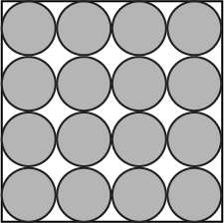 | 1 | 0 | because the circles are the same colour and represent one type of atom.
ii. | 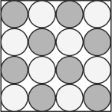 | 0 | 1 | because there are two types of circles (touching) which represent two types of atoms that are joined.
iii. | 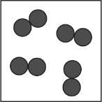 | 1 | 0 | because the circles that are touching (in pairs) are the same colour and represent molecules made up of the same type of atom.
iv. | 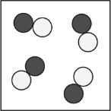 | 0 | 1 | because the circles that are different colours are touching (in pairs) represent two different types of atoms that are joined to form molecules of a compound.
v. | 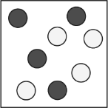 | 2 | 0 | because there are circles (not touching) of two different colours which represent atoms of two different elements.
vi. | 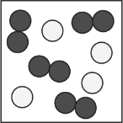 | 2 | 0 | because there are circles of one colour (representing atoms of one element) and joining circles of another colour representing molecules of another element.
vii. | 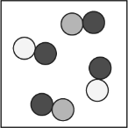 | 0 | 2 | because there are white and black circles touching that represent molecules of one compound and black and grey circles touching which represent molecules of a different compound that is made up of a different combination of atoms.
viii. | 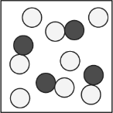 | 1 | 1 | because there are separate circles in one colour that represent atoms of one element and there are also white circles touching black circles which represent the two types of atoms that are joined to make molecules of a compound.

- Guidance note: This question develops learners’ understanding of particle diagrams (sub-microscopic understanding) that show molecules of substances. The question is designed to require students to connect colour, arrangement and number of circles to find the diagrams that match two descriptions. Learners should be encouraged to connect their thinking with the meaning of the chemical formula of carbon dioxide (symbolic understanding).
- D
- E and F

