Evaporation and distillation

Introduction

These questions are designed to help you to develop your mental models (pictures in your head) of symbols and formulae. Use the icon in the margin to find out which level of understanding the question is developing.
 | Macroscopic: what we can see. Think about the properties that we can observe, measure and record.
 | Sub-microscopic: smaller than we can see. Think about the particle or atomic level.
 | Symbolic: representations. Think about how we represent chemical ideas including symbols and diagrams.


Questions
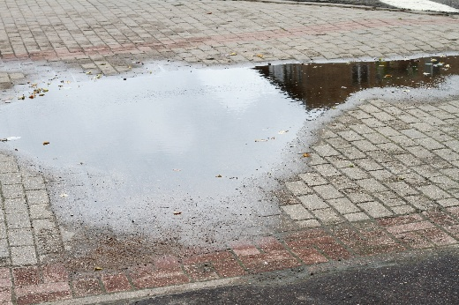
- On a rainy day a puddle forms on a pavement.

Image ©: Shutterstock/Totokzww

Over time the puddle gets smaller until it eventually disappears.

Complete the sentences to explain the process by choosing from the words from below.

air evaporation condensation water

Particles of ________________________ leave the puddle and mix with particles that make up the ________________________. This process is called ________________________.

- If water is left in an open container, it will gradually evaporate.
- Figure 1 shows a shallow dish containing water.

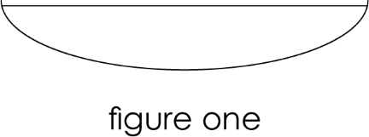
- Complete the diagrams to show what happens to water in the shallow dish after 12 hours and after 2 days.

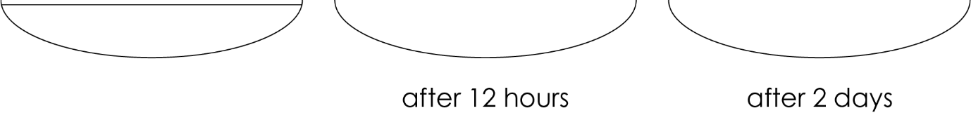

- Explain why this happens in terms of particles.

__________________________________________________________________________________

__________________________________________________________________________________

__________________________________________________________________________________
- The same volume of water is added to a beaker. The beaker is left for several days.

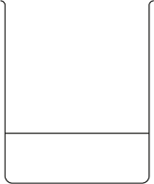

- Describe how observations of the water level over time would be different to the shallow dish shown in figure 1.

__________________________________________________________________________________

__________________________________________________________________________________
- Explain why this happens in terms of particles.

__________________________________________________________________________________

__________________________________________________________________________________

__________________________________________________________________________________

- A traditional way of producing salt from seawater is to use salt pans.

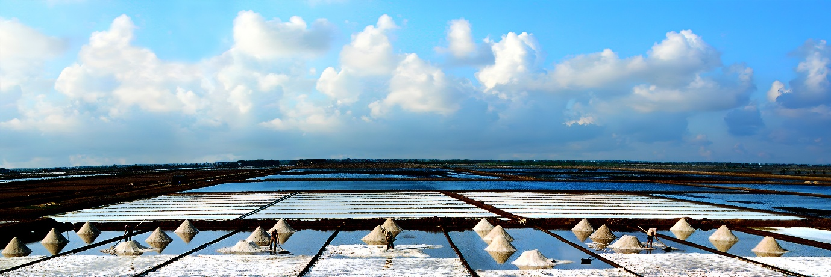
Image ©: Shutterstock/Jahid Kiron

Suggest why the salt pans are wide and shallow.

__________________________________________________________________________________

__________________________________________________________________________________

__________________________________________________________________________________
- Blue copper sulfate solution was poured into a shallow dish.

The diagrams show the change in the volume of solution over time.

- Draw what will be observed in the dish after 4 days when all the water has evaporated.

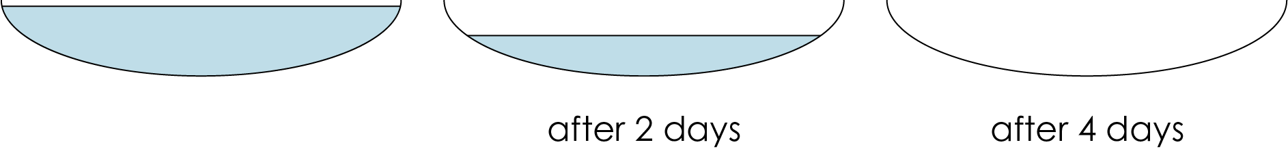

- Explain what has happened in terms of particles.

__________________________________________________________________________________

__________________________________________________________________________________

__________________________________________________________________________________


- Some simple distillation apparatus is set up. Tap water is added to the flask.

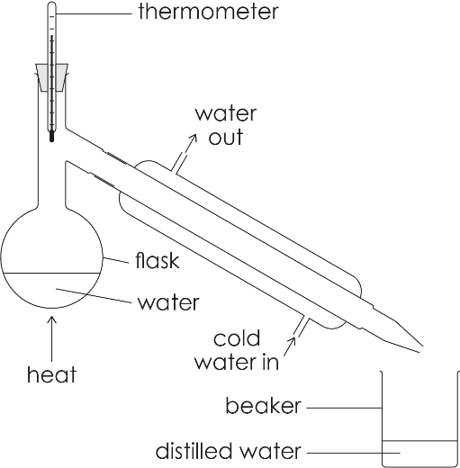

- Complete the sentences to describe the change in state that occurs at different points in the apparatus. Choose from the words provided. You may use words more than once.

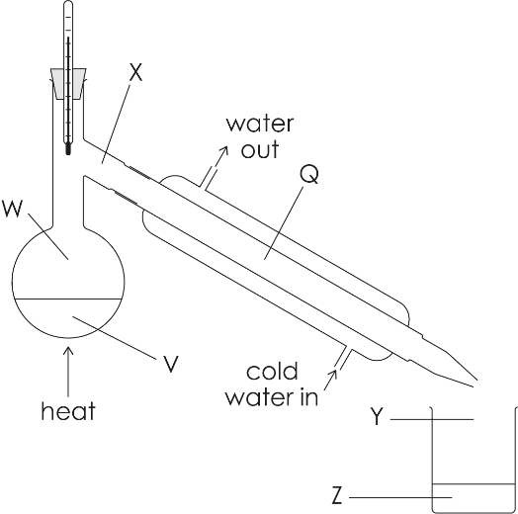

gas liquid heated cooled evaporation condensation

- At V water changes from the ________________________ state to the ________________________ state because it is being ________________________. This process is called ________________________.
- At Q water changes from the ________________________ state to the ________________________ state because it is being ________________________. This process is called ________________________.
- Give the state of the water at each location in the apparatus.

V: ________________________ W: ________________________ X: ________________________ Q: ________________________ Y: ________________________ Z: ________________________
- State the name given to the liquid collected at Z. ____________________

- Compare the temperature at which water can change into the gas state through:
- evaporation
- boiling

__________________________________________________________________________________

__________________________________________________________________________________
- A solution of blue ink and water is added to the round bottomed flask of a distillation apparatus.

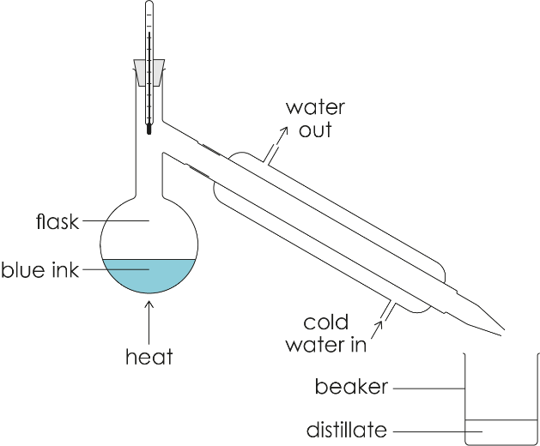

- Explain why the volume of solution in the flask decreases. Refer to change of state in your answer.

__________________________________________________________________________________

__________________________________________________________________________________

__________________________________________________________________________________
- Explain why volume of distillate in the beaker increases. Refer to change of state in your answer.

__________________________________________________________________________________

__________________________________________________________________________________

__________________________________________________________________________________
- Explain why the liquid in the beaker remains colourless.

__________________________________________________________________________________

__________________________________________________________________________________

__________________________________________________________________________________

__________________________________________________________________________________

