Atoms, molecules and elements

This resource is from the Johnstone’s triangle series which can be viewed at: rsc.li/4jI4bfW. In this series you will also find our Atoms, molecules and elements: Johnstone’s triangle worksheet which introduces the triangle in the context of hydrogen, helium and lithium and can be viewed at: rsc.li/4wp8qUy.

Learning objectives
LO | Objective | Where assessed
1 | Recognise that the arrangements of atoms that make up an element that is in the solid state at room temperature can be shown in a diagram similar to the particle model. | Q1
2 | Recognise that a diagram of atoms represents the element and not the shape of an object made of that element. | Q2
3 | Give an advantage of a 3D version of the particle model. | Q2
4 | Draw labelled diagrams of elements that are in the gas or liquid state at room temperature and made up of separate atoms or, for the gas state (only), made up of separate molecules. | Q3

How to use this resource
When to use? |   Introduce |   Develop |   Revise |   Assess
When to use? | Use after initial teaching or discussion of this topic to develop ideas further. You can also use as a revision activity.
Group size? |   Independent |   Small group |   Whole class |   Homework
Group size? | Suitable for independent work either in class or at home. Or use the questions for group or class discussions.
How long? |  |  | 15–30 mins

This resource aims to develop learners’ understanding of the basic particle model by extending it to represent elements that are made up of individual atoms and those that are made up of separate molecules. As a result, learners should develop more secure mental models to support their thinking about this topic.

Johnstone’s triangle

Johnstone’s triangle is a model of the three different conceptual levels in chemistry: macroscopic, sub-microscopic and symbolic. You can use Johnstone’s triangle to build a secure understanding of chemical ideas for your learners.

Find further reading about Johnstone’s triangle and how to use it in your teaching at rsc.li/3TCOjUo.

Johnstone’s triangle and this resource

The icons in the margin indicate which level of understanding each question is developing to help prompt learners in their thinking.

 | Macroscopic: what we can see. Think about the properties that we can observe, measure and record.
 | Sub-microscopic: smaller than we can see. Think about the particle or atomic level.
 | Symbolic: representations. Think about how we represent chemical ideas including symbols and diagrams.

The levels are interrelated, for example, learners need visual representation of the sub-microscopic to develop mental models of the particle or atomic level. Our approach has been to apply icons to questions based on what the learners should be thinking about.

Questions may be marked with two or all three icons, indicating that learners will be thinking at more than one level. However, individual parts of the question may require learners to think about only one or two specific levels at a time.

Support

This worksheet is ramped so that the earlier questions are more accessible. The activity becomes more challenging in the later questions. You can give extra explanations for the more challenging questions. If completing as an in-class activity it is best to pause and check understanding at intervals, as often one question builds on the previous one.

It is useful for learners to observe macroscopic properties first-hand. You could circulate examples of substances in the classroom, run a class practical of a chemical reaction, show a teacher demonstration of properties, or give learners physical models such as counters or marbles to use and manipulate.

Additional support may be needed for any learners still lacking in confidence in the required symbolic representation, for example by sharing and explaining a diagram or a simulation that can show movement of the particles.


Answers
- Guidance note: This question develops learners’ understanding of the basic particle model to include the concept of the ‘particles’ in different substances being different types of atom (sub-microscopic understanding).

- aluminium
- copper
- A standard diagram showing the particle arrangement of the liquid state (random arrangement, circles touching) with circles to match the diagram of aluminium in part (a). Learners may choose to label an atom of aluminium.
For example:

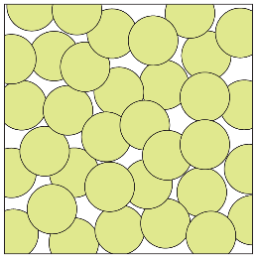
- Both diagrams are correct.

Additional guidance note: A learner who thinks that A is correct but not B may hold the misconception that the colour of the atoms in the diagram is linked to the colour of the bulk substance. The definition of an atom as ‘the smallest part of an element’ may inadvertently reinforce this misconception.
- Both diagrams are correct as they show the correct arrangement of atoms of carbon in the solid state (in terms of the particle model) and in each a circle is clearly labelled as a carbon atom.

- Guidance note: This question develops learners’ understanding of a typical 2D diagram and how it represents the 3D arrangement of atoms (symbolic understanding) forming any shaped sample of the bulk material (macroscopic understanding).
- All three should be selected.
- The 3D particle model makes it clearer how the arrangement of particles can form a 3D object.
- Guidance note: This question supports learners to develop their understanding to include the idea that some substances are made up of separate molecules (sub-microscopic understanding). This question also requires learners to connect the symbol or formula of a gaseous element to whether it is made up of separate atoms or molecules (symbolic understanding).

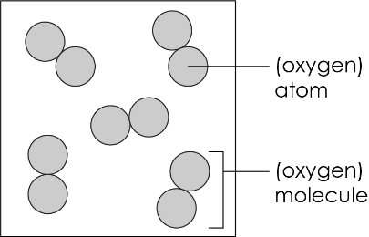

- Answers in table.

Element | Symbol or formula | Separate atoms or molecules?
helium | $$He$$ | atoms
oxygen | $$O_{2}$$ | molecules
hydrogen | $$H_{2}$$ | molecules
neon | $$Ne$$ | atoms
argon | $$Ar$$ | atoms
nitrogen | $$N_{2}$$ | molecules

- A diagram showing separate molecules with a pair of atoms labelled as ‘hydrogen molecule’. Learners may also label an individual circle as a ‘hydrogen atom’.
e.g.

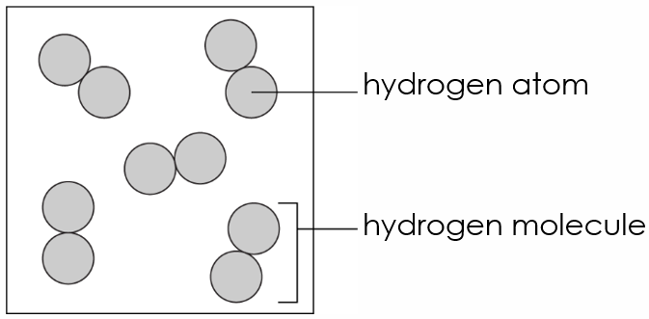

- A diagram showing separate atoms with an atom labelled as ‘neon atom’.

e.g.

