Solubility

This resource is from the Johnstone’s triangle series, which can be viewed at: rsc.li/43jMfSn.

Learning objectives
LO | Objective | Where assessed
1 | Recognise that a substance may be soluble in one solvent but insoluble in another. | Q1
2 | Identify whether a substance is soluble or insoluble from macroscopic observations. | Q2
3 | Use solubility to explain macroscopic observations. | Q3
4 | Recognise that the solubility of a substance can change with temperature. | Q4
5 | Interpret different points on a temperature–solubility graph. | Q4
6 | Connect points on a temperature-solubility graph with macroscopic observations. | Q5

How to use this resource

This resource aims to develop learners’ understanding of solubility. The questions encourage learners to think about how graphical representations of solubility link to macroscopic observations and symbolic understanding. As a result, learners should develop more secure mental models to support their thinking about this topic.
When to use? |   Introduce |   Develop |   Revise |   Assess
When to use? | Use after initial teaching or discussion of this topic to develop ideas further. You can also use as a revision activity.
Group size? |   Independent |   Small group |   Whole class |   Homework
Group size? | Suitable for independent work either in class or at home. Or use the questions for group or class discussions.
How long? |  |  | 15–30 mins

Johnstone’s triangle

Johnstone’s triangle is a model of the three different conceptual levels in chemistry: macroscopic, symbolic and sub-microscopic. You can use Johnstone’s triangle to build a secure understanding of chemical ideas for your learners.

Find further reading about Johnstone’s triangle and how to use it in your teaching at rsc.li/4x3n6so.

Johnstone’s triangle and this resource

The icons in the margin indicate which level of understanding each question is developing to help prompt learners in their thinking.

 | Macroscopic: what we can see. Think about the properties that we can observe, measure and record.
 | Sub-microscopic: smaller than we can see. Think about the particle or atomic level.
 | Symbolic: representations. Think about how we represent chemical ideas including symbols and diagrams.

The levels are interrelated, for example, learners need visual representation of the sub-microscopic in order to develop mental models of the particle or atomic level. Our approach has been to apply icons to questions based on what the learners should be thinking about.

Questions may be marked with two or all three icons, indicating that learners will be thinking at more than one level. However, individual parts of the question may require learners to think about only one or two specific levels at a time.

Support

This worksheet is ramped so that the earlier questions are more accessible. The activity becomes more challenging in the later questions. You can give extra explanations for the more challenging questions. If completing as an in-class activity it is best to pause and check understanding at intervals, as often one question builds on the previous one.

It is useful for learners to observe macroscopic properties first-hand. You could circulate examples of substances in the classroom, run a class practical of a chemical reaction or show a teacher demonstration of properties.

Additional support may be needed for any learners still lacking in confidence in the required symbolic representation, for example by sharing and explaining a diagram or a simulation that can show movement of the particles.

Answers
- Guidance note: This question supports learners to recognise that a solvent does not have to be water and that a substance may be insoluble in one liquid but soluble in another (macroscopic understanding). This question assumes that learners are already familiar with the terms soluble and insoluble.

- salt
- water

- nail varnish
- propanone

- In order to remove nail varnish, the nail varnish must dissolve. Water cannot dissolve nail varnish because nail varnish is insoluble in water. Nail varnish is dissolved by propanone so that is why it is used as nail varnish remover.

- Guidance note: This question supports learners to recognise observations (macroscopic understanding) that show that a substance is soluble (formation of a clear solution) or insoluble (either a lump of undissolved solid or a cloudy mixture formed by a powder that does not dissolve).

If learners need support explain that:
- If the substance is soluble in the solvent then it will seem to disappear and the solution will remain clear i.e. you can see through it. The solution may be colourless or coloured.
- If the substance is insoluble, then it will either sink to the bottom or make the solution cloudy when first added.

[See completed table on the next page of the document for answers to question 2.]
Observations | Soluble or insoluble | Reason
Substance A  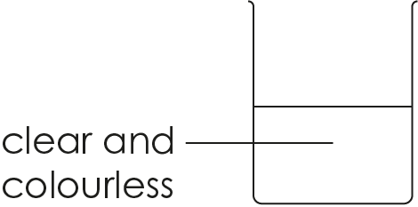 | soluble | mixture is clear
Substance B  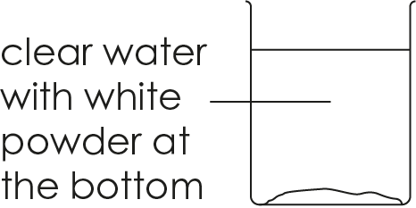 | insoluble | undissolved solid is visible at the bottom
Substance C  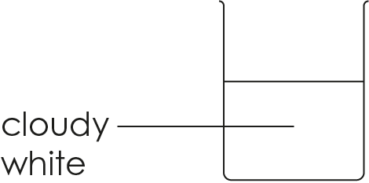 | insoluble | mixture is cloudy because small pieces of the undissolved substance are spread throughout the mixture (a suspension)
Substance D  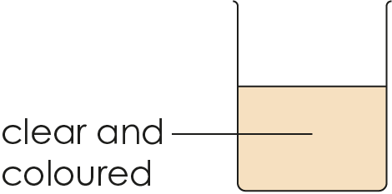 | soluble | mixture is clear
- Guidance note: This question supports learners explain observations (macroscopic understanding) in terms of the solubility of a compound.

- less
- greater
- unsaturated
- saturated

- Only 30 g of sodium chloride can dissolve. If 40 g is added, then 10 g cannot dissolve. If 50 g is added, then 20 g cannot dissolve. More undissolved solid will therefore be visible at the bottom of the beaker.

- Guidance note: This question supports further understanding of the graphical representation (a form of symbolic understanding) of solubility of a compound at different temperatures. It then develops learners’ ability to connect this with observations (macroscopic understanding).

- less
- less
- more
- more

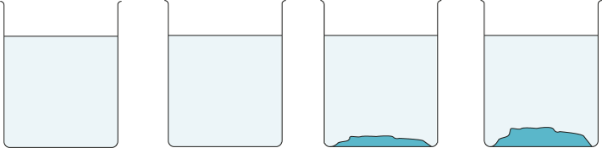
i | ii | iii | iv

- less
- less
- more
- more

i | ii | iii | iv
- Guidance note: The first part of this question supports learners to explain observations (macroscopic understanding) in terms of the change in solubility of a compound at different temperatures. The second part of the question supports learners to interpret the meaning of a graphical representation (a form of symbolic understanding) of solubility of a compound at different temperatures. This question assumes some familiarity with the interpretation of a graph. Learners lacking confidence with this may require additional scaffolding and support.
- Undissolved potassium nitrate is observed because the mass added is greater than the solubility of potassium nitrate in 100 cm³ of water.

- The solubility of potassium nitrate has increased with temperature.

- B
- B
- C
- D
- B
- A and C
- D and E

- The solubility of sodium chloride changes very little with temperature.

