Solubility

Introduction

These questions are designed to help you to develop your understanding of solubility graphs and how these connect to real-life observations. Use the icon in the margin to find out which level of understanding the question is developing.
 | Macroscopic: what we can see. Think about the properties that we can observe, measure and record.
 | Sub-microscopic: smaller than we can see. Think about the particle or atomic level.
 | Symbolic: representations. Think about how we represent chemical ideas including symbols and diagrams.

Questions
- A solute is the substance that is dissolved and is soluble. A solvent is the substance that dissolves the solute. Together they form a solution.

- Salt is soluble in water.
- Name the solute. __________
- Name the solvent. __________

- Nail varnish is soluble in a liquid called propanone.
- Name the solute. ________________________
- Name the solvent. ________________________

- Nail varnish is insoluble in water.

Explain why nail varnish remover is made of propanone and not water.

__________________________________________________________________________________

__________________________________________________________________________________

__________________________________________________________________________________

__________________________________________________________________________________
- Water is added to four beakers. A different substance is added to each beaker and stirred. The observations are shown in the table.

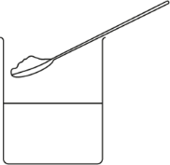

Complete the table to show whether each substance is soluble or insoluble in water. Give reasons for your answers.

Observations | Soluble or insoluble | Reason
Substance A

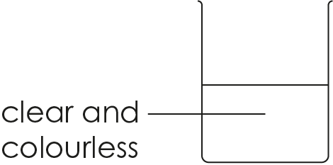
Substance B

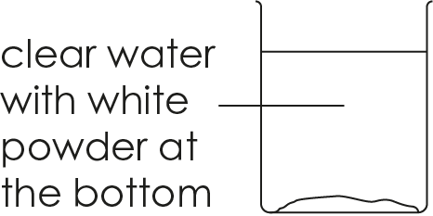
Substance C

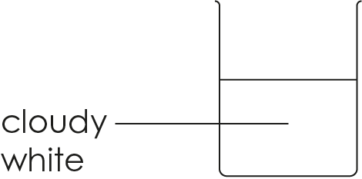
Substance D

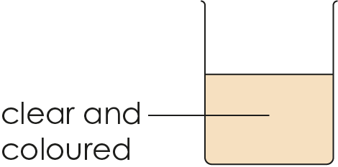

- The maximum mass of sodium chloride that can dissolve in 100 cm³ of water is 36 g at 20°C. This is called the solubility of sodium chloride (at 20°C).

When no more solute will dissolve then the solution is called saturated. If more solute can dissolve, then the solution is called unsaturated.

Each beaker shown contains 100 cm³ of water (at 20°C).

Different masses of sodium chloride are added to each beaker.

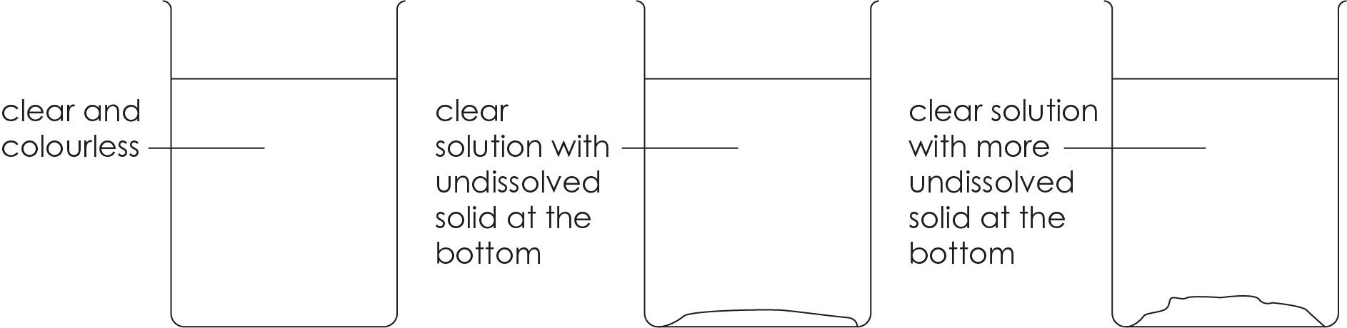

30 g sodium chloride | 40 g sodium chloride | 50 g sodium chloride

- Select the correct word to complete the sentences:
- 30 g of sodium chloride completely dissolves because this is greater/less than its solubility.
- 40 g of sodium chloride does not fully dissolve because this is greater/less than its solubility.
- The solution made with 30 g of sodium chloride is saturated/unsaturated because more sodium chloride could dissolve in it.
- The solution made with 40 g of sodium chloride is saturated/unsaturated because no more sodium chloride can dissolve in it.

- Explain why there is more undissolved solid in the beaker containing 50 g of sodium chloride.

__________________________________________________________________________________

__________________________________________________________________________________

__________________________________________________________________________________

__________________________________________________________________________________


- The solubility of copper sulfate is the maximum mass in grams that will dissolve in 100 cm³ water at a given temperature.
- The graph shows how the solubility of copper sulfate changes with temperature. The dashed lines show whether different masses of copper sulfate are less than or more than the solubility of copper sulfate at 30°C.

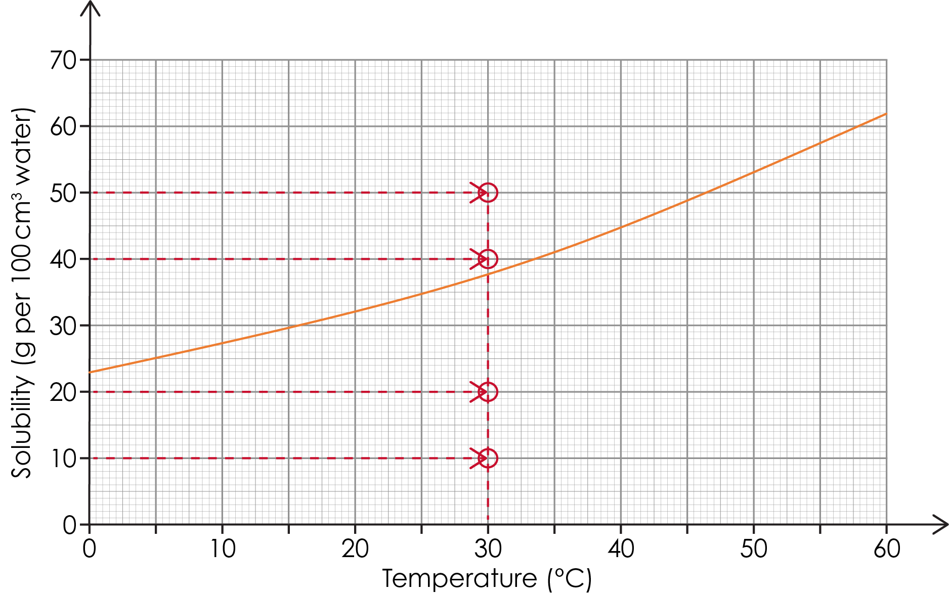

State whether each mass of copper sulfate is less than or more than the solubility of copper sulfate at 30°C. Use the graph to help you.
- 10 g __________________
- 20 g __________________
- 40 g __________________
- 50 g __________________

- Each beaker contains 100 cm³ of water and a different mass of copper sulfate. Draw what would be observed in each beaker at 30°C.


i. 10 g | ii. 20 g | iii. 40 g | iv. 50 g

- The dashed lines on the graph show whether 35 g of copper sulfate is less than or greater than the solubility of copper sulfate at different temperatures.

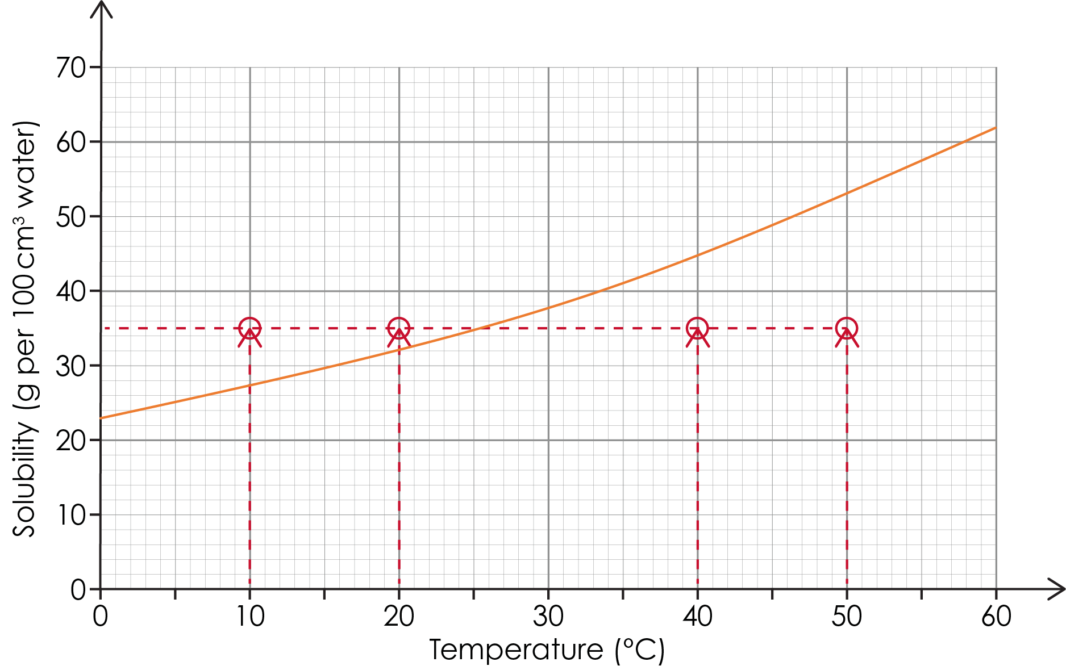

35 g of copper sulfate is mixed with 100 cm³ water that is 50°C. The solution is then cooled.

State whether 35 g of copper sulfate is less or more than the solubility of copper sulfate at each temperature.
- 50°C __________________
- 40°C __________________
- 20°C __________________
- 10°C __________________

- Draw what would be observed at each temperature.

i. 50°C | ii. 40°C | iii. 20°C | iv. 10°C

- The solubility of potassium nitrate is not fixed. It can change with temperature.

- 50 g of potassium nitrate is added to a beaker containing 100 cm³ of water at 20°C. The solubility of potassium nitrate at this temperature is 32 g per 100 cm³ water.

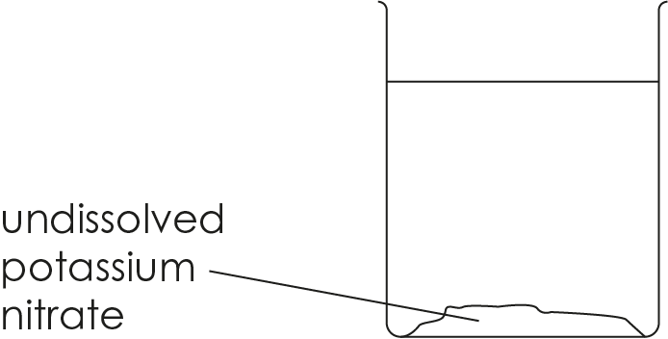

Explain why undissolved potassium nitrate is observed.

__________________________________________________________________________________

__________________________________________________________________________________

__________________________________________________________________________________
- The beaker is heated until the solution reaches 40°C.

All the potassium nitrate is now dissolved.

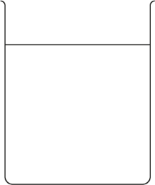

Describe how the solubility of potassium nitrate has changed with the increase in temperature.

__________________________________________________________________________________

__________________________________________________________________________________

- The solubility of potassium nitrate at different temperatures can be drawn as a graph.

Five different points are marked on the graph labelled A–E.

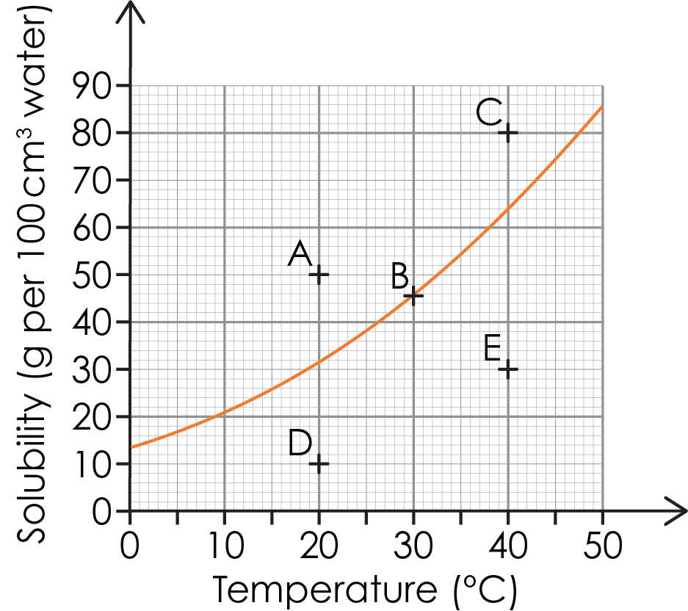

Give the letter of each point described by the following sentences.
- The solubility of potassium nitrate at 30°C. _____
- The maximum mass of potassium nitrate that will dissolve at 30°C. ____
- The mass of potassium nitrate that is greater than its solubility at 40°C. ______
- The mass of potassium nitrate that is less than its solubility at 20°C. _____
- A saturated solution with no undissolved solid. ____
- Saturated solution with undissolved solids. ____ and ____
- Unsaturated solutions. ____ and _____
- The graph shows how the solubility of sodium chloride changes with temperature.

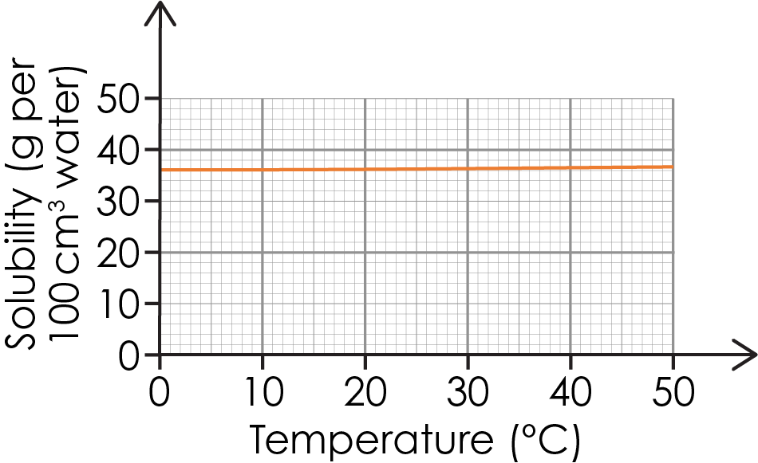

Explain why heating a solution of sodium chloride has little effect on how much sodium chloride dissolves.

__________________________________________________________________________________

__________________________________________________________________________________

