Alkenes

Introduction

These questions are designed to help you to develop mental models (pictures in your head) of the representations of covalent bonding and alkene structure and formulae. Use the icon in the margin to find out which level of understanding the question is developing.
 | Macroscopic: what we can see. Think about the properties that we can observe, measure and record.
 | Sub-microscopic: smaller than we can see. Think about the particle or atomic level.
 | Symbolic: representations. Think about how we represent chemical ideas including symbols and diagrams.


Questions
- Hydrocarbon molecules can be represented in different ways.
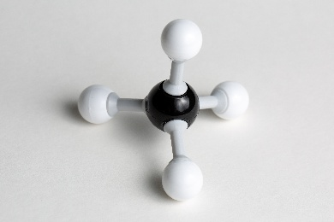
- Look at the picture of a molecule model.
- State what represents atoms in this model.

_________________________________________________________
- State what represents covalent bonds.

_________________________________________________________
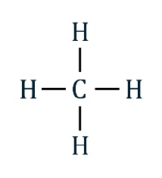
- Look at the displayed formula of a molecule.
- State what represents atoms in this displayed formula.

_________________________________________________________
- State what represents covalent bonds.

_________________________________________________________

- The alkenes are a family of hydrocarbons that have double bonds. Circle the alkene molecules shown.

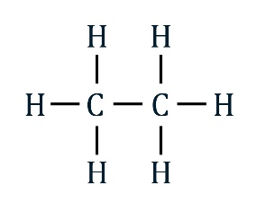 | 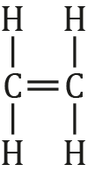 | 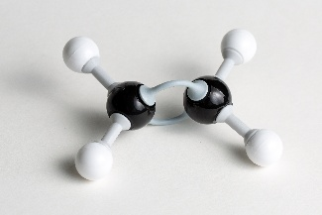 | 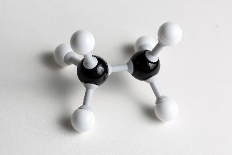

- Describe how you identified the alkenes.

_________________________________________________________________________________

_________________________________________________________________________________
- A covalent bond is made up of two shared electrons. A connecting stick or line therefore represents these two shared electrons.

An ethene molecule has a double covalent bond between the two carbon atoms.

- Complete the dot and cross diagram of an ethene molecule to show the electrons in the double bond.

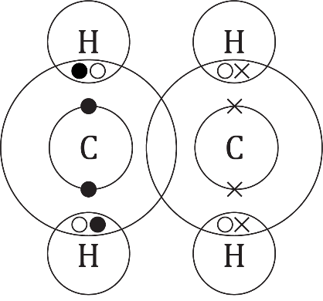
- Give the total number of shared electrons that make up a double bond. _______
- Give the number of electrons from each carbon atom in the double bond. _____
- Explain why a carbon atom can make four single bonds.

_________________________________________________________________________________

_________________________________________________________________________________
- Explain why a carbon atom with a double bond can only make two more single bonds.

_________________________________________________________________________________

_________________________________________________________________________________
- The formula for the alkane propane is $C_{3}H_{8}$. The formula for the alkene propene is $C_{3}H_{6}$. Propene is said to be unsaturated because it has fewer hydrogen atoms.

- Complete the diagram to show the displayed formula of $C_{3}H_{8}$.

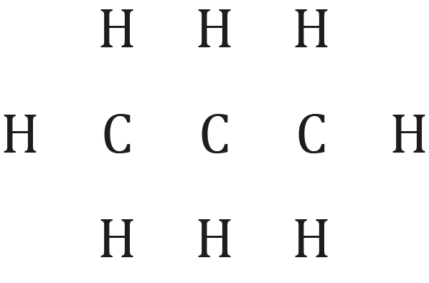
- Complete the diagram to show the displayed formula of $C_{3}H_{6}$

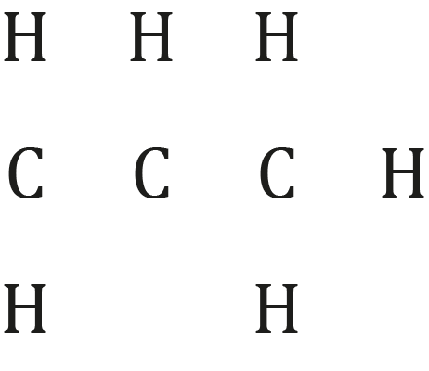

- Give the chemical formula of the molecule that is an alkene.

C____H____
- Explain why the alkene has fewer hydrogen (H) atoms.

_________________________________________________________________________________

_________________________________________________________________________________

_________________________________________________________________________________
- A general formula allows the formula of an alkane or alkene to be worked from the number of carbon atoms without having to draw out the molecule.

The general formula of an alkene is $C_{n}H_{2n}$ where n is the number of carbon atoms. For example, propene has 3 carbon atoms so n = 3. 2n = 6. Therefore, the formula for propane is $C_{3}H_{6}.$

- Write the formula of the following alkenes.
- ethene C____H____

- butene C____H____

- The general formula of an alkane is $C_{n}H_{2n+2}.$

For example, propene has three carbon atoms so n=3.

$2n+2 = 2x3+2 = 8$

Therefore, the formula for propane is $C_{3}H_{8}$.

Write the formula of the following alkanes.
- ethane C____H____

- butane C____H____

- A hydrocarbon has the formula $C_{5}H_{10}$.
- Name the alkane or alkene.

__________________________________________________________________________________
- Explain how you worked out whether it was an alkane or an alkene.

__________________________________________________________________________________

__________________________________________________________________________________

__________________________________________________________________________________

