Alkenes

This resource is from the Johnstone’s triangle series, which can be viewed at: rsc.li/43jMfSn. In this series you will also find our Johnstone’s triangle worksheet which introduces the triangle in the context of propene and the bromine test for alkenes: rsc.li/3Rclr4N.

Learning objectives
LO | Objective | Where assessed
1 | Identify alkene molecules from a displayed formula or a molecular model. | Q1
2 | State and explain the number of additional single bonds that a double bonded carbon atom can make. | Q2
3 | Explain why an alkene has fewer hydrogen atoms than an alkane with the same number of carbon atoms. | Q3
4 | Write the formula of an alkene or alkane using the general formula. | Q4

How to use this resource

This resource aims to develop learners’ understanding of the idea of alkenes.
When to use? |   Introduce |   Develop |   Revise |   Assess
When to use? | Use after initial teaching or discussion of this topic to develop ideas further. You can also use as a revision activity.
Group size? |   Independent |   Small group |   Whole class |   Homework
Group size? | Suitable for independent work either in class or at home. Or use the questions for group or class discussions.
How long? | 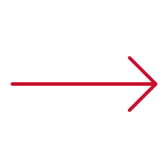 |  | 15–30 mins

The questions encourage learners to think at the sub-microscopic and symbolic levels about the structure and formula of alkenes. As a result, learners should develop more secure mental models to support their thinking about this topic.

Johnstone’s triangle

Johnstone’s triangle is a model of the three different conceptual levels in chemistry: macroscopic, sub-microscopic and symbolic. You can use Johnstone’s triangle to build a secure understanding of chemical ideas for your learners.

Find further reading about Johnstone’s triangle and how to use it in your teaching at rsc.li/3TmcA0S.

Johnstone’s triangle and this resource

The icons in the margin indicate which level of understanding each question is developing to help prompt learners in their thinking.

 | Macroscopic: what we can see. Think about the properties that we can observe, measure and record.
 | Sub-microscopic: smaller than we can see. Think about the particle or atomic level.
 | Symbolic: representations. Think about how we represent chemical ideas including symbols and diagrams.

The levels are interrelated, for example, learners need visual representation of the sub-microscopic in order to develop mental models of the particle or atomic level. Our approach has been to apply icons to questions based on what the learners should be thinking about.

Questions may be marked with two or all three icons, indicating that learners will be thinking at more than one level. However, individual parts of the question may require learners to think about only one or two specific levels at a time.

Support

This worksheet is ramped so that the earlier questions are more accessible. The activity becomes more challenging in the later questions. You can give extra explanations for the more challenging questions. If completing as an in-class activity it is best to pause and check understanding at intervals, as often one question builds on the previous one.

Give learners physical models to use and manipulate, such as a Molymod kits or other physical molecule models.


Answers
- Guidance note: This question develops learners’ understanding of how a hydrocarbon molecule can be represented by a molecule model or a displayed formula (symbolic understanding) including the representation of atoms and bonds (sub-microscopic understanding).

- black and white balls
- connecting sticks

- element symbols (letters)
- lines
- The second and third molecule should be circled.
- The alkenes are the molecules with a double bond shown by two connecting sticks or two lines.
- Guidance note: This question develops learners’ understanding of the carbon-carbon double bond using a dot and cross diagram (sub-microscopic understanding)

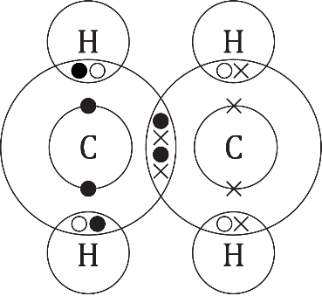
- four electrons
- two electrons
- A carbon atom can make four single bonds because it has four outer electrons to share.
- A carbon atom that has formed a double bond has already shared two of its electrons, so it only has two outer electrons left. It can therefore only make two more single bonds.
- Guidance note: This question develops learners’ understanding of the structure of the alkane propane and the alkene propene (sub-microscopic understanding) using displayed formulae (symbolic understanding).

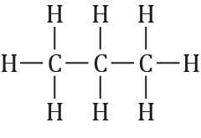

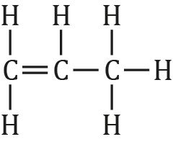
- $C_{3}H_{6}$
- The alkene has fewer hydrogen atoms because the two double bonded carbon atoms can bond to one fewer hydrogen than in the alkane.

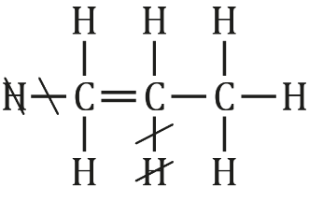
- Guidance note: This question develops learners’ understanding of the general formulae for alkenes and alkanes (symbolic understanding) and what they represent in terms of the number of carbon and hydrogen atoms (sub-microscopic understanding).

- $C_{2}H_{4}$
- $C_{4}H_{8}$

- $C_{2}H_{6}$
- $C_{4}H_{10}$

- pentene
- The number of hydrogen atoms is two times the number of carbon atoms.

