Sulfur dioxide: Johnstone’s triangle

Learning objectives
- Give two ways in which sulfur dioxide is released into the atmosphere.
- Use the particle model to explain why sulfur doxide molecules mix with molecules of other gases in the air.
- Connect the particle model representation to the arrangement of sulfur dioxide molecules.

Introduction

The particle model can be extended to explain why molecules of sulfur dioxide mix with the air in the atmosphere.

Johnstone’s triangle

In chemistry we make sense of the things that we can see by representing what we can’t see using formulas, equations, diagrams and models.

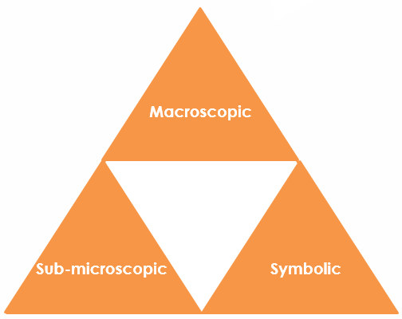
Johnstone’s triangle is a way of thinking about these different concepts as different corners of a triangle:
- Macroscopic – what we can see. Think about the properties we can observe, measure and record.
- Sub-microscopic – smaller than we can see. Think about the particle or atomic level.
- Symbolic – representations. Think about how we represent chemical ideas, including symbols and diagrams.

Being able to connect and move between these three different levels is important for scientific understanding.

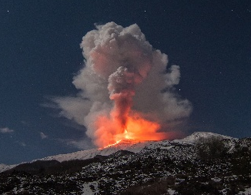
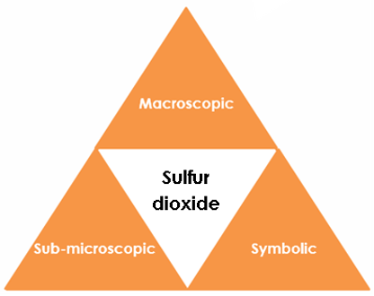

Symbolic – representations

For every atom of sulfur in sulfur dioxide there are two oxygen atoms. Write the formula for sulfur dioxide. _________________

Complete the particle model diagram to show the arrangement of molecules in sulfur dioxide.



Macroscopic – what we can see

Sulfur dioxide is an invisible gas that can cause acid rain.

Give one example in nature where sulfur dioxide is released into the atmosphere.

______________________________________________________

How can humans cause the production of sulfur dioxide?

_______________________________________________________

_______________________________________________________

Sub-microscopic – smaller than we can see

The diagram shows a molecule of sulfur dioxide.

Add the labels: molecule, sulfur atom, oxygen atom



The particle model can describe the arrangement and movement of particles of a substance in the gas state. State what a particle of sulfur dioxide is.

_____________________________________________________________

Use the particle model to explain why sulfur dioxide molecules mix with molecules of other gases in the air.

_____________________________________________________________

_____________________________________________________________

_____________________________________________________________
Image ©: Shutterstock/Wead

