Sulfur dioxide: Johnstone’s triangle

This resource is from the Johnstone’s triangle series which can be viewed at: rsc.li/43jMfSn. It will help learners to understand the different ways you need to think in chemistry, and to build their mental models and understanding.

Learning objectives
- Give two ways in which sulfur dioxide is released into the atmosphere.
- Use the particle model to explain why sulfur doxide molecules mix with the molecules of other gases in the air.
- Connect the particle model representation to the arrangement of sulfur dioxide molecules.

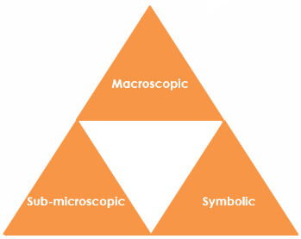
How to use Johnstone’s triangle

Use Johnstone’s triangle to develop learners’ thinking about scientific concepts at three different conceptual levels:
- Macroscopic – what we can see. Think about the properties you can observe, measure and record.
- Sub-microscopic – smaller than we can see. Think about the particle or atomic level.

- Symbolic – representations. Think about how we represent chemical ideas including symbols and diagrams.

For learners to gain a deeper awareness of a topic, they need to understand it at all three levels.

When introducing a topic, don't try to introduce all three levels of thinking at once. This will overload working memory. Instead complete the triangle over a series of lessons, beginning with the macroscopic level, then symbolic and then sub-microscopic.

The levels are interrelated. For example, learners need visual representation of the sub-microscopic in order to develop mental models of the particle or atomic level.

Find further reading about Johnstone’s triangle and how to use it in your teaching at rsc.li/4vSykPx.

Scaffolding

Share the structure of the triangle with learners prior to use. Tell them why you are using it and how it will help them to develop their understanding. Use an ‘I try, we try, you try’ approach when introducing Johnstone’s triangle for the first time.

More resources

To further develop learner’s thinking in all areas of Johnstone’s triangle, try our Developing understanding of representing compounds worksheets (rsc.li/44MmBHh). These include icons in the margin referring to the conceptual level of thinking needed to answer the question.

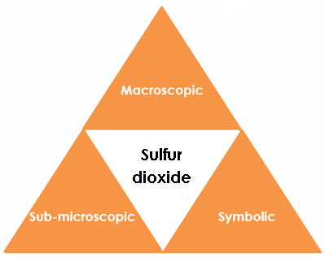
Image ©: Shutterstock/Wead

Symbolic – representations

For every atom of sulfur in sulfur dioxide there are two oxygen atoms. Write the formula for sulfur dioxide. SO₂

Complete the diagram to show the arrangement of molecules in sulfur dioxide.

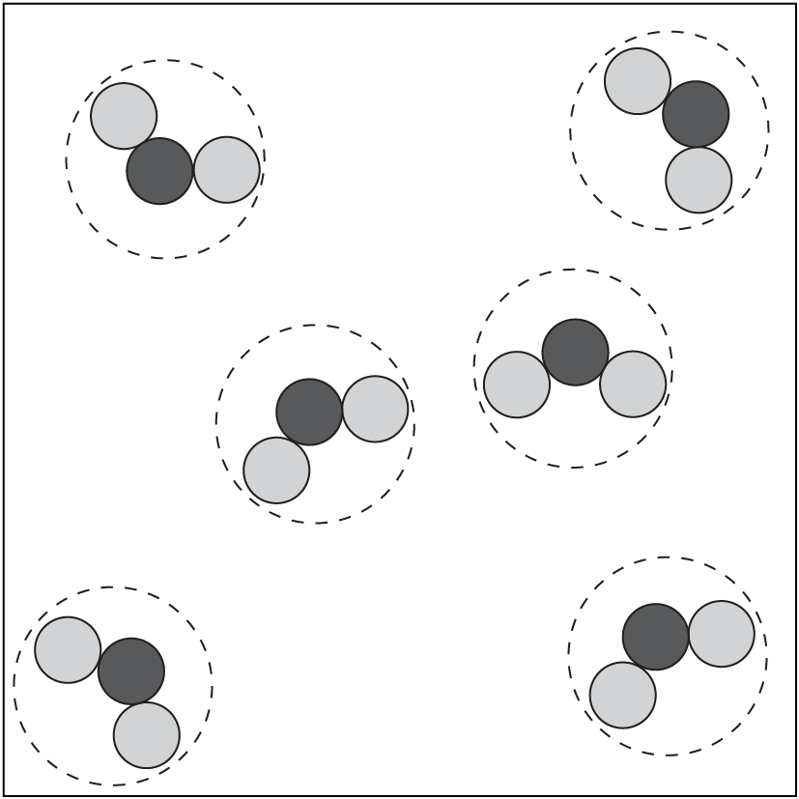

Sub-microscopic – smaller than we can see

The diagram shows a molecule of sulfur dioxide.

Add the labels: molecule, sulfur atom, oxygen atom



The particle model can show the arrangement and movement of particles of a substance in the gas state. State what a particle of sulfur dioxide is. sulfur dioxide molecule

Use the particle model to explain why sulfur dioxide molecules mix with molecules of other gases in the air.

The sulfur dioxide molecules are free to move and this enables them to mix with molecules of other types of gas in the air.

Macroscopic – what we can see

Sulfur dioxide is an invisible gas that can cause acid rain.

Give one example in nature where sulfur dioxide is released into the atmosphere.

Sulfur dioxide can be released by volcanoes.

How can humans cause the production of sulfur dioxide?

Sulfur dioxide can be produced by the burning of fossil fuels.

