Reactions of alkenes

Introduction

These questions are designed to help you to develop mental models (pictures in your head) of alkene structures, representations of covalent bonding and alkene reactions. Use the icon in the margin to find out which level of understanding the question is developing.
 | Macroscopic: what we can see. Think about the properties that we can observe, measure and record.
 | Sub-microscopic: smaller than we can see. Think about the particle or atomic level.
 | Symbolic: representations. Think about how we represent chemical ideas including symbols and diagrams.


Questions
- During a chemical reaction a new substance or substances are formed. Reactions can be of different general types. Some chemical reactions result in a colour change.
- Complete the table to show the reactants and products of each type of reactions.
Type of reactions | General equation | Reactant(s) | Product(s)
decomposition | $$AB→A+B$$ | $$AB$$
substitution | $$AB+CD→AC+BD$$ | $AB$ and $CD$
addition | $$A+B→AB$$ | $A$ and B

- Name the following types of reaction.
- one new substance (product) is formed from two reactants

__________________________________________________________________________________
- only one substance (reactant) is present at the start

__________________________________________________________________________________
- two starting substances (reactants) form two new substances (products)

__________________________________________________________________________________
- Explain why it is not possible to predict the colour of a product of a reaction from the colours of the reactant or reactants.

__________________________________________________________________________________

__________________________________________________________________________________
- Bromine water is used to test for alkenes. The colour change if an alkene is present is from orange to colourless.

The balanced chemical equation for the reaction is

$$C_{2}H_{4} + {Br}_{2}→C_{2}H_{4}{Br}_{2}$$
- Give the number of
- reactants ______
- products _______
- Name the type of chemical reaction that is taking place.

__________________________________________________________________________________
- Give the formula of the reactant that is orange. ______
- Explain why the product $C_{2}H_{4}{Br}_{2}$ is not orange.

_________________________________________________________________________________

_________________________________________________________________________________

The image below shows the reaction of ethene with bromine using displayed structural formulas.

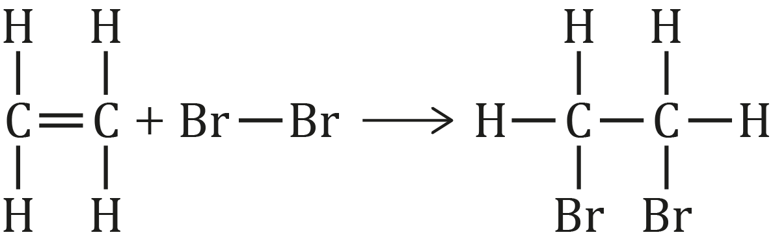

Alkenes can also react with other group 7 elements (chlorine and iodine).
- Draw displayed formulas to show the reaction of chlorine $({Cl}_{2})$ with ethene.

- Alkenes can undergo other addition reactions.
- Hydrogen can also be added to an alkene.

Draw the displayed formula to show the product of the reaction between propene and hydrogen.

- Alkenes can undergo addition reactions to form an alcohol.
- Look at the displayed formula reaction below. Circle the atoms that have been added to ethene.

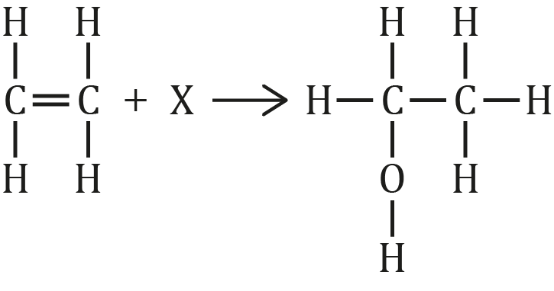
- Give the formula of chemical X __________
- The reaction between ethene and bromine can be shown using the displayed formulas of the reactants and products. These show simply the atoms and covalent bonds that make up the molecules.
- The dot and cross diagram below shows the arrangement of electrons in the outer shells of the atoms that make up ethene.

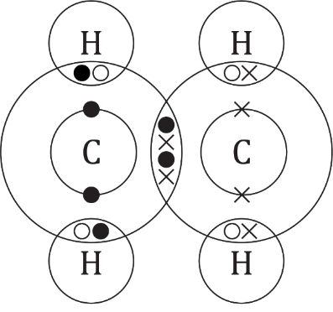
- Give the number of electrons shared between the two carbon atoms. _______
- Name the type of bond between that carbon atoms that is formed by the sharing of four electrons in ethene. ____________
- The dot and cross diagram below shows the arrangement of electrons after a bromine molecule has been added.

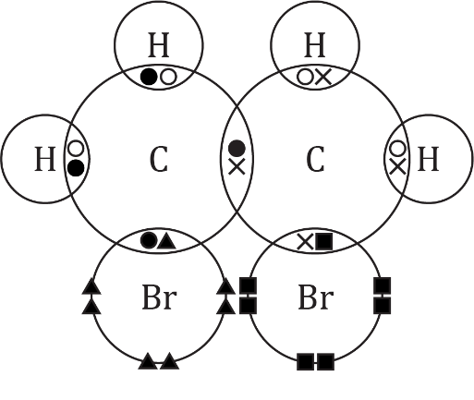
- Give the number of electrons that are now shared by the carbon atoms. ____
- Name the type of bond that now exists between the carbon atoms.

__________________________________________________________________________________
- Describe where the two additional electrons from the double bond are now located.

__________________________________________________________________________________

__________________________________________________________________________________
- Explain why the product of the addition reaction is always a type of alkane.

__________________________________________________________________________________

__________________________________________________________________________________

- Explain why alkenes are able to add atoms from another molecule like bromine. You should refer to electrons in your answer.

__________________________________________________________________________________

__________________________________________________________________________________

__________________________________________________________________________________

