Reaction of alkenes

This resource is from the Johnstone’s triangle series, which can be viewed at: rsc.li/43jMfSn. In this series you will also find our Johnstone’s triangle worksheet which introduces the triangle in the context of propene and the bromine test for alkenes: rsc.li/3Rclr4N.

Learning objectives
LO | Objective | Where assessed
1 | Recognise that different types of reaction have different numbers of reactants and products. | Q1
2 | Explain the observed colour change of the bromine water test for an alkene. | Q2
3 | Explain why an alkene can undergo addition reactions using the dot-and-cross diagram model. | Q3
4 | Complete displayed formulas to show further addition reactions of ethene. | Q4

How to use this resource

This resource aims to develop learners’ understanding of the reactions of alkenes.
When to use? |   Introduce |   Develop |   Revise |   Assess
When to use? | Use after initial teaching or discussion of this topic to develop ideas further. You can also use as a revision activity.
Group size? |   Independent |   Small group |   Whole class |   Homework
Group size? | Suitable for independent work either in class or at home. Or use the questions for group or class discussions.
How long? |  |  | 15–30 mins

The questions encourage learners to think at the macroscopic, sub-microscopic and symbolic levels about the bromine test for alkenes and why alkenes undergo certain reactions. As a result, learners should develop more secure mental models to support their thinking about this topic.

Johnstone’s triangle

Johnstone’s triangle is a model of the three different conceptual levels in chemistry: macroscopic, sub-microscopic and symbolic. You can use Johnstone’s triangle to build a secure understanding of chemical ideas for your learners.

Find further reading about Johnstone’s triangle and how to use it in your teaching at rsc.li/4fuS85l.

Johnstone’s triangle and this resource

The icons in the margin indicate which level of understanding each question is developing to help prompt learners in their thinking.

 | Macroscopic: what we can see. Think about the properties that we can observe, measure and record.
 | Sub-microscopic: smaller than we can see. Think about the particle or atomic level.
 | Symbolic: representations. Think about how we represent chemical ideas including symbols and diagrams.

The levels are interrelated, for example, learners need visual representation of the sub-microscopic in order to develop mental models of the particle or atomic level. Our approach has been to apply icons to questions based on what the learners should be thinking about.

Questions may be marked with two or all three icons, indicating that learners will be thinking at more than one level. However, individual parts of the question may require learners to think about only one or two specific levels at a time.

Support

This worksheet is ramped so that the earlier questions are more accessible. The activity becomes more challenging in the later questions. You can give extra explanations for the more challenging questions. If completing as an in-class activity it is best to pause and check understanding at intervals, as often one question builds on the previous one.

It is useful for learners to observe macroscopic properties first-hand. You could, run a class practical of a chemical reaction or show a teacher demonstration.


Answers
- Guidance note: This question develops learners’ understanding of different types of chemical reactions in terms of the number of reactants and products (macroscopic understanding) and generalised equations (symbolic understanding).

(a)
Product(s)
$A$ and $B$
$$AC + BD$$
$$AB$$

(b)
- addition
- decomposition
- substitution

(c) The product of a reaction is a new substance. The colour of the new substance is not connected to the colour of the reactants.
- Guidance note: This question develops learners’ understanding of how the reaction between bromine and an alkene (ethene) can be represented (symbolic understanding) and how this connects with observed colour changes (macroscopic understanding).

- 2
- 1
- addition
- ${Br}_{2}$
- It is not orange because it is a different substance to bromine and has different properties.

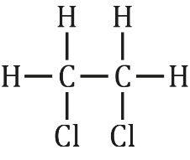
- Guidance note: This question develops learners’ understanding of other addition reactions of alkenes using displayed formulas (symbolic understanding).

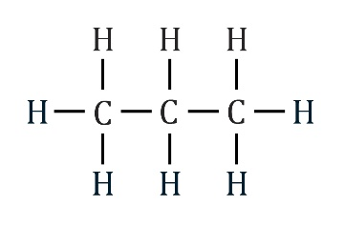

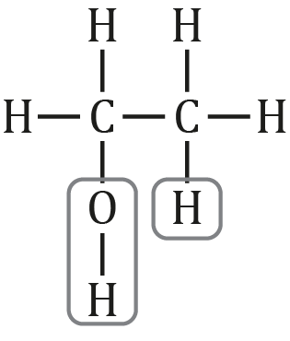
- $H_{2}O$
- Guidance note: This question supports learners to understand how a displayed formula connects to a dot and cross representation (symbolic understanding). It then develops learners’ understanding of how alkenes are able to undergo addition reactions in terms of the breaking of the double bond and the formation of new single bonds (sub-microscopic understanding).

- 4
- double bond

- 2
- single bond
- The two electrons are now part of single bonds with two bromine atoms.
- The product is always an alkane because the double bond becomes a single bond.
- Alkenes are able to add other atoms because they have a second pair of electrons in their double bond that can create new single bonds.

