Alkane boiling points

Introduction

These questions are designed to help you to develop mental models (pictures in your head) of the trend in boiling point for different alkanes. Use the icon in the margin to find out which level of understanding the question is developing.
 | Macroscopic: what we can see. Think about the properties that we can observe, measure and record.
 | Sub-microscopic: smaller than we can see. Think about the particle or atomic level.
 | Symbolic: representations. Think about how we represent chemical ideas using symbols and diagrams.


Questions
- The alkanes are hydrocarbons. They are made up of carbon and hydrogen atoms only. Complete the table to show the name, formula and displayed formula of the first four alkanes.

Alkane name | Formula | Displayed formula
methane | $${CH}_{4}$$ | 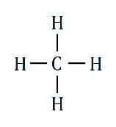
ethane | $$C_{2}H_{6}$$
propane |  | 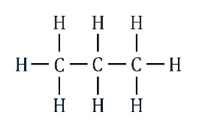
butane
- This diagram of a thermometer shows the melting point and boiling point of butane.

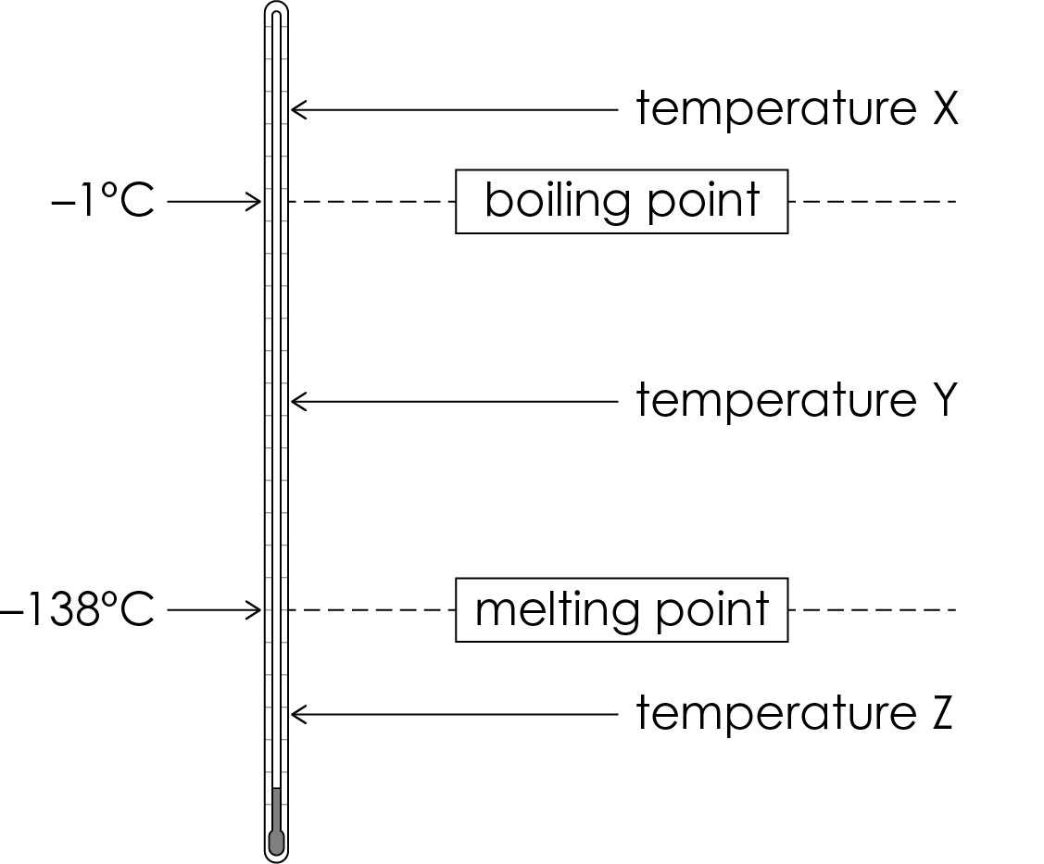

- Give the state of butane at
- temperature X ______
- temperature Y ______
- temperature Z ______
- When butane in the liquid state is heated to −0.5°C it changes into the gas state. Name this process.

__________________________________________________________________________________
- When butane in the gas state is cooled to −0.5°C it changes back to the liquid state. Name this process.

__________________________________________________________________________________
- Complete the sentence to describe what the boiling point of butane represents.

The boiling point of butane is the temperatures at which it ___________________ and ____________________.

- Methane is the gas used in a Bunsen burner. Hexane is a colourless liquid.

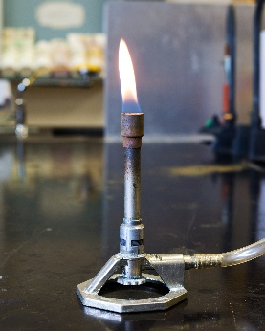 | 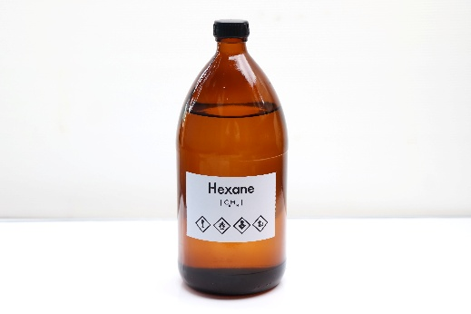
Image ©: Shutterstock/ggw | Image ©: Shutterstock/chemical industry

- At the temperature of a school lab (20°C), methane and hexane are in different states. Complete the sentences using the words below.

above below liquid gas

The temperature of the lab is ____________ the boiling point of hexane so hexane is in the ____________ state. The temperature is ____________ the boiling point of methane so methane is in the ____________ state.
- The diagram below represents what happens to the molecules when methane changes from the liquid to the gas state.

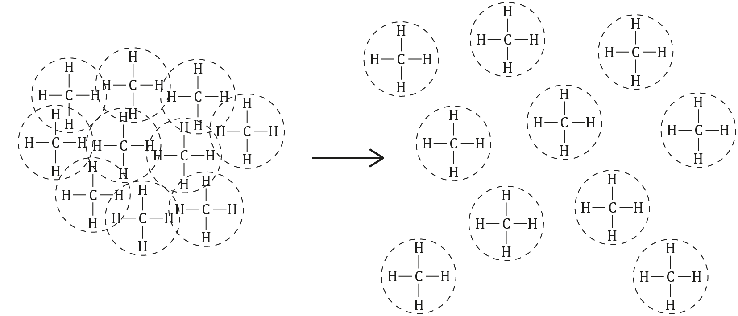

Choose whether each statement below is true or false. Circle your answer.

When methane changes to the gas state…
- the molecules move apart. true/false
- the covalent bonds break. true/false
- the force of attraction between the methane molecules is overcome. true/false
- State which of the statements above will affect the boiling point of methane.

_________________________________________________________________________________
- The boiling point of methane is −164°C and the boiling point of hexane is 69°C.

Explain why hexane has a higher boiling point than methane.

_________________________________________________________________________________

_________________________________________________________________________________

_________________________________________________________________________________
- The table shows the boiling points of the first six alkanes.

Alkane name | Formula | Boiling point  (°C)
methane | $${CH}_{4}$$ | -164
ethane | $$C_{2}H_{6}$$ | -89
propane | $$C_{4}H_{8}$$ | -42
butane | $$C_{4}H_{10}$$ | -0.5
pentane | $C_{5}H_{12}$ | 36
hexane | $$C_{6}H_{14}$$ | 69

- Describe the trend in boiling points.

________________________________________________________________________________

- Explain the trend in the boiling points of the alkanes.

_________________________________________________________________________________

_________________________________________________________________________________

_________________________________________________________________________________

