Fractional distillation

Introduction

These questions are designed to help you to develop mental models (pictures in your head) of how the fractional distillation process separates crude oil. Use the icon in the margin to find out which level of understanding the question is developing.
 | Macroscopic: what we can see. Think about the properties that we can observe, measure and record.
 | Sub-microscopic: smaller than we can see. Think about the particle or atomic level.
 | Symbolic: representations. Think about how we represent chemical ideas using symbols and diagrams.

Questions
- Diesel is a fuel used by lorries, vans and other road vehicles. It is made of a mixture of different hydrocarbons.

- Define the term hydrocarbon.

_________________________________________________________________________________

_________________________________________________________________________________

The table shows suggested boiling point ranges of each fuel.
Fuel | Boiling point range (°C)
petrol | 20–70
diesel | 220–250
- Explain why diesel does not have a single boiling point.

_________________________________________________________________________________

_________________________________________________________________________________
- Petrol is another fuel made up of a mixture of hydrocarbons that is different from diesel. Suggest why the boiling point range of petrol is lower.

_________________________________________________________________________________

_________________________________________________________________________________
- Crude oil is a mixture of many types of hydrocarbon molecules which can be grouped into a range of different fractions (parts). Diesel and petrol are two examples of fractions of crude oil.
- Crude oil is separated using a fractionating column. Before entering the column, the crude oil is heated. Almost all of the different molecules that make up the crude oil escape from the liquid and enter the gas state. Name this process.

_________________________________________________________________________________
- Explain why the molecules that make up both diesel and petrol move up the column.

_________________________________________________________________________________

_________________________________________________________________________________

The image below shows a simplified diagram of a fractionating column. The column is hotter at the bottom than at the top. When a fraction of crude oil condenses in a section, the liquid is collected and is drained off through a pipe on the side.

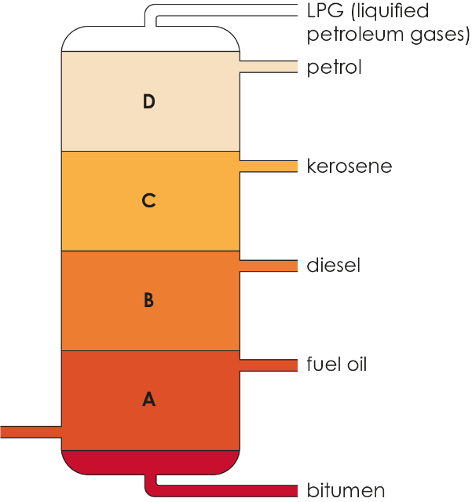

Fractionating column
- Give the section in which diesel condenses. ____
- Explain why molecules from the diesel fraction are not present in section C or D.

_________________________________________________________________________________

_________________________________________________________________________________
- Explain why petrol condenses in a section higher up the fractionating column than diesel.

_________________________________________________________________________________

_________________________________________________________________________________

- The diagram below shows four temperatures (W, X, Y and Z) at different heights of a fractionating column.

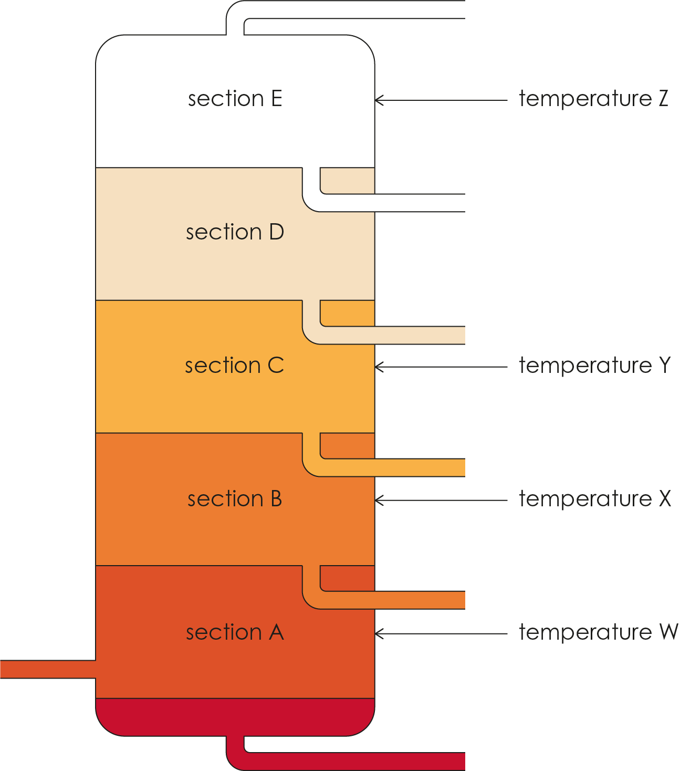

- State whether temperature W is hotter or cooler than temperature Z. ____________

- Crude oils enter the fractionating column at temperature W. Explain why bitumen is removed at the bottom of the column.

_________________________________________________________________________________

_________________________________________________________________________________
- Explain why butane is one of the substances that leaves the fractionating column in the gas state at temperature Z.

_________________________________________________________________________________

_________________________________________________________________________________

- The table shows the number of carbon atoms in molecules of each fraction.
Fraction | Number of carbon atoms in each molecule
kerosene | 12-16
fuel oil | 15-18
petrol | 5-12

- List the fractions in order of molecule size, from smallest to largest.
________________ | ________________ | ________________
- List the fractions in the order in which they will condense and be collected from the fractionating column (starting with the lowest).
________________ | ________________ | ________________
- Explain the order in which fractions are collected from a fractionating column.

_________________________________________________________________________________

_________________________________________________________________________________

_________________________________________________________________________________

_________________________________________________________________________________

