Addition polymerisation

Introduction

These questions are designed to help you to develop mental models (pictures in your head) of different representations of monomers and polymers and how to use these to understand why ethene molecules can join to make a polymer. Use the icon in the margin to find out which level of understanding the question is developing.
 | Macroscopic: what we can see. Think about the properties that we can observe, measure and record.
 | Sub-microscopic: smaller than we can see. Think about the particle or atomic level.
 | Symbolic: representations. Think about how we represent chemical ideas using symbols and diagrams.


Questions
- Plastic bags are often made of the polymer called polyethene (or ‘polythene’ for short). Polyethene is made from lots of ethene molecules.

Below are four different ways in which ethene can be represented.

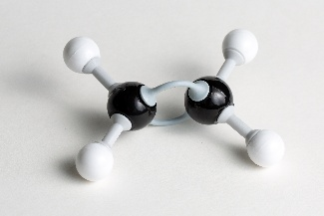 | 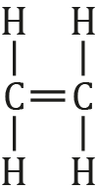
molecule model | displayed formula
$$C_{2}H_{4}$$ | 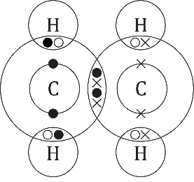
chemical formula | dot-and-cross diagram

Complete the table to show what each model does show () or does not show ().
 | Molecule model | Displayed formula | Chemical formula | Dot-and-cross diagram
The number of carbon and hydrogen atoms
A double bond between carbon atoms
Single bonds between the carbon and hydrogen atoms
The arrangement of electrons
- Ethene is an example of a monomer. Many monomers can join to make a polymer. The diagram below shows four monomers forming a polymer. In real life a very large number of monomers combine forming a very long polymer.

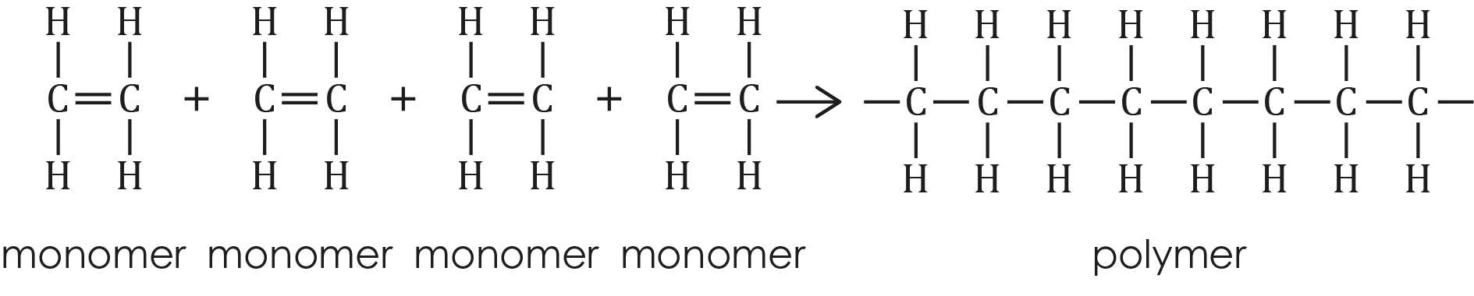

Brackets can be used to show a repeating unit in a longer polymer chain.

The polymer above can be shown as

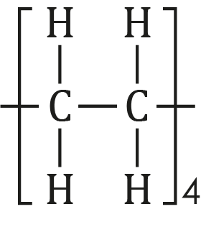
- Draw the displayed formula of the molecule represented by:
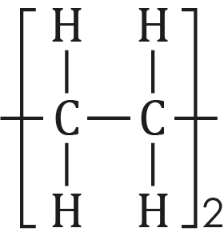

- Give the number of ethene molecules that would be needed to make this polymer. ______

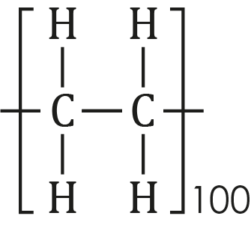
- Polymers are usually represented by using n to represent a large number.

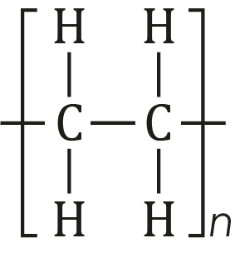

Explain why n is used and not a very large number.

_________________________________________________________________________________

_________________________________________________________________________________
- Different monomers combine to produce different polymers.
- Draw the structure of the polymer formed from each monomer. You should draw one repeating unit of the polymer and brackets to present your answer.
 | monomer | polymer
i. | 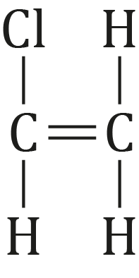
ii. | 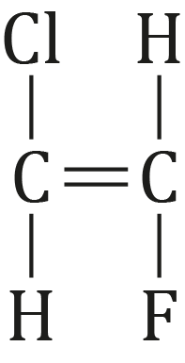
- Draw the monomer that forms each polymer

 | polymer | monomer
i. | 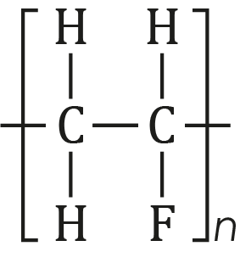
ii. | 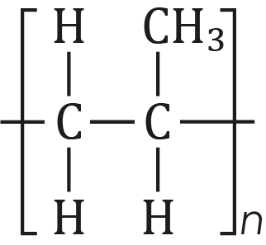
- The diagram below shows two ethene molecules connecting to make one, longer molecule. This is not a real-life reaction.

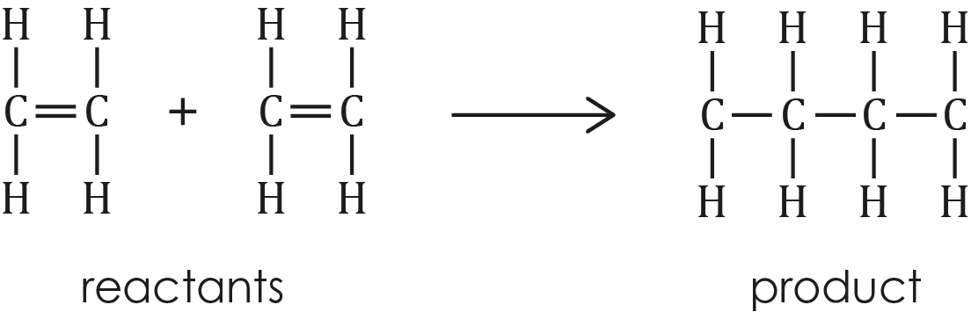
- Explain why the structure of the product molecule above is not correct.

_________________________________________________________________________________

_________________________________________________________________________________
- Explain why the end carbon can create one more bond.

_________________________________________________________________________________

_________________________________________________________________________________
- Suggest why ethene molecules are able to join to make a long chain.

_________________________________________________________________________________

_________________________________________________________________________________

