Addition polymerisation

This resource is from the Johnstone’s triangle series, which can be viewed at: rsc.li/43jMfSn. In this series you will also find our Johnstone’s triangle worksheet which introduces the triangle in the context of polypropene: rsc.li/4fy9GNY.

Learning objectives
LO | Objective | Where assessed
1 | Compare different representations of ethene | Q1
2 | Understand how polymers can be represented by a repeating unit | Q2
3 | Represent a range of polymers and identify the monomer needed to make a given polymer | Q3
4 | Explain in terms of bonds why ethene molecules can join to make a long chain | Q4

How to use this resource

This resource aims to develop learners’ understanding of addition polymerisation.
When to use? |   Introduce |   Develop | 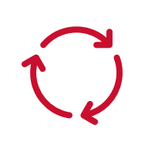  Revise |   Assess
When to use? | Use after initial teaching or discussion of this topic to develop ideas further. You can also use it as a revision activity.
Group size? |   Independent |   Small group |   Whole class |   Homework
Group size? | Suitable for independent work either in class or at home. Or you can use the questions for group or class discussions.
How long? | 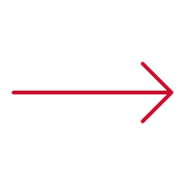 |  | 15–30 mins

The questions encourage learners to think at the sub-microscopic and symbolic levels about how polymers are represented and to understand that they are made from repeating units of monomers. As a result, learners should develop more secure mental models to support their thinking about this topic.

Johnstone’s triangle

Johnstone’s triangle is a model of the three different conceptual levels in chemistry: macroscopic, sub-microscopic and symbolic. You can use Johnstone’s triangle to build a secure understanding of chemical ideas for your learners.

Find further reading about Johnstone’s triangle and how to use it in your teaching at rsc.li/4bXQic8.

Johnstone’s triangle and this resource

The icons in the margin indicate which level of understanding each question is developing so as to help prompt learners in their thinking.

 | Macroscopic: what we can see. Think about the properties that we can observe, measure and record.
 | Sub-microscopic: smaller than we can see. Think about the particle or atomic level.
 | Symbolic: representations. Think about how we represent chemical ideas using symbols and diagrams.

The levels are interrelated; for example, learners need visual representation of the sub-microscopic in order to develop mental models of the particle or atomic level. Our approach has been to apply icons to questions based on what the learners should be thinking about.

Questions may be marked with two or all three icons, indicating that learners will be thinking at more than one level. However, individual parts of the question may require learners to think about only one or two specific levels at a time.

Support

This worksheet is ramped so that the earlier questions are more accessible. The activity becomes more challenging in the later questions, so you may want to give extra explanations for these. If completing the worksheet as an in-class activity, it is best to pause and check understanding at intervals, as often one question builds on the previous one.

Give learners physical models to use and manipulate, such as a Molymod kits.


Answers
- Guidance note: This question develops learners’ understanding of the different representations of the monomer ethene (symbolic understanding) and what they do and do not show in terms of atoms, bonds and electrons (sub-microscopic understanding).
 | Molecule model | Displayed formula | Chemical formula | Dot-and-cross diagram
The number of carbon and hydrogen atoms
A double bond between carbon atoms
Single bonds between the carbon and hydrogen atoms
The arrangement of electrons

- Guidance note: This question develops learners’ understanding of the repeating unit representation of a polymer (symbolic understanding) and how this connects to the monomer and polymer chain (sub-microscopic understanding).

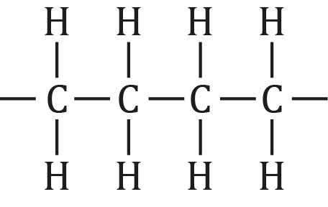
- 100
- Polymer chains are not an exact length.
- Guidance note: This question develops learners’ understanding of how to derive the repeating unit notation from the displayed formula of a given monomer and vice versa (symbolic understanding).

i. | 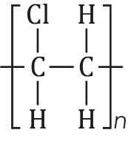 | ii. | 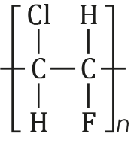

i. | 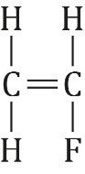 | ii. | 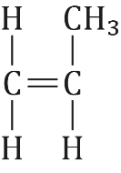
- Guidance note: This question develops learners’ understanding of why alkene monomer molecules connect to form long polymer chains (sub-microscopic understanding.
- The carbon atoms at each end have made only three bonds and not four.
- The carbon atoms at each end have made only three bonds so each atom can make one more bond.
The double bond in each ethene molecule can break, which allows the carbons of the double bond to form one more bond each with another molecule. This enables a chain to form.

