Polypropene: Johnstone’s triangle

Learning objectives
- Connect the properties of propene to its uses.
- Explain why propene monomers can join to form a polymer.
- Identify and draw a repeating unit of polypropene.

Introduction

Propene monomers can join together to form the polymer polypropene. The process is called addition polymerisation.

Johnstone’s triangle

In chemistry, we make sense of the things that we can see by representing what we can’t see using formulas, equations, diagrams and models.

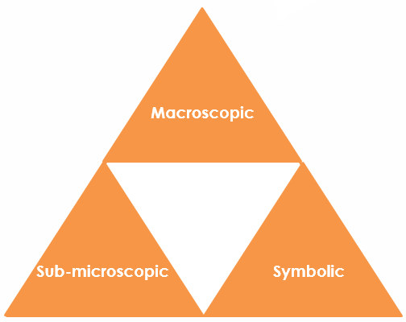
Johnstone’s triangle is a way of thinking about these different concepts as different corners of a triangle:
- Macroscopic – what we can see. Think about the properties we can observe, measure and record.
- Sub-microscopic – smaller than we can see. Think about the particle or atomic level.
- Symbolic – representations. Think about how we represent chemical ideas using symbols and diagrams.

Being able to connect and move between these three different levels is important for scientific understanding.

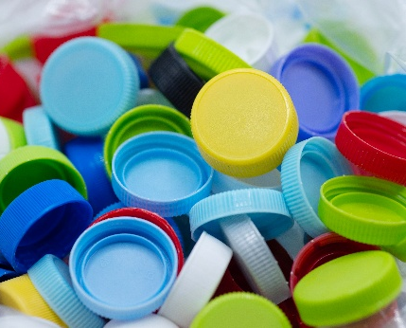
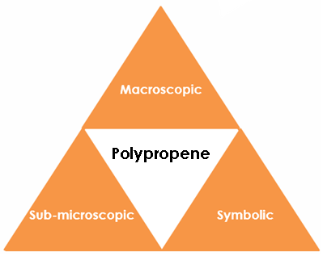

Macroscopic – what we can see

Polypropene is very resistant to many types of chemicals. It is strong and durable. It has a high melting point

Suggest why polypropene is used to make the following:
- microwavable bowl _____________________________
__________________________________________________
- bottle lids ________________________________________

__________________________________________________
- bottles for household cleaners ____________________
__________________________________________________

Image ©: Shutterstock/ Runglawan Khrutjaikla

Symbolic – representations

This displayed formula represents a very short polymer molecule. A polymer molecule is usually a lot longer.

Draw a box around the repeating unit.

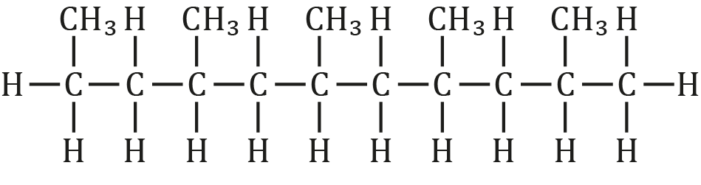

Draw the repeating unit.

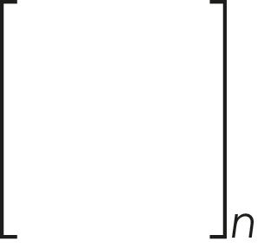

What does the letter n mean?

___________________________________________________________

Sub-microscopic – smaller than we can see

Draw the displayed formula for a propene monomer.

Give the number of outer electrons that a carbon atom has to form covalent bonds?

How many electrons from a carbon atom are involved in the double bond?

Explain why a propene monomer is able to form a new covalent bond with the carbon in another monomer.

_____________________________________________________________

_____________________________________________________________

_____________________________________________________________

