Polypropene: Johnstone’s triangle

This resource is from the Johnstone’s triangle series which can be viewed at: rsc.li/43jMfSn. It will help learners to understand the different ways in which you need to think in chemistry, building their mental models and understanding.

Learning objectives
- Connect the properties of polypropene to its uses.
- Explain why propene monomers can join to form a polymer.
- Identify and draw a repeating unit of polypropene.

How to use Johnstone’s triangle

Use Johnstone’s triangle to develop learners’ thinking about scientific concepts at three different conceptual levels:
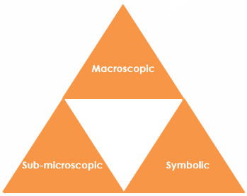
- Macroscopic – what we can see. Think about the properties you can observe, measure and record.
- Sub-microscopic – smaller than we can see. Think about the particle or atomic level.
- Symbolic – representations. Think about how we represent chemical ideas using symbols and diagrams.

For learners to gain a deeper awareness of a topic, they need to understand it at all three levels.

When introducing a topic, do not try to introduce all of the levels of thinking at once. This will overload working memory. Instead complete the triangle over a series of lessons, beginning with the macroscopic level. Introduce the other levels, in turn, once learners are secure.

All of the levels are interrelated; for example, learners need visual representation of the sub-microscopic in order to develop mental models of the particle or atomic level.

Find further reading about Johnstone’s triangle and how to use it in your teaching at rsc.li/4fy9GNY.

Scaffolding

Share the structure of the triangle with learners prior to use. Tell them why you are using it and how it will help them to develop their understanding. Use an ‘I try, we try, you try’ approach when introducing Johnstone’s triangle for the first time.

More resources


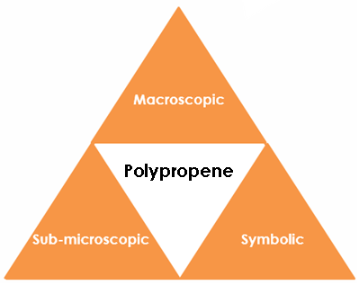
To further develop learner’s thinking in all areas of Johnstone’s triangle, try our Developing understanding of addition polymerisation worksheets (rsc.li/4bXQic8). These include icons in the margin referring to the conceptual level of thinking needed to answer the question.

Macroscopic – what we can see

Polypropene is very resistant to many types of chemicals. It is strong and durable. It has a high melting point

Suggest why polypropene is used to make the following:

microwavable bowl high melting point

bottle lids strong and durable

bottles for household cleaners resistant to chemicals

Sub-microscopic – smaller than we can see

Draw the displayed formula for a propene monomer.

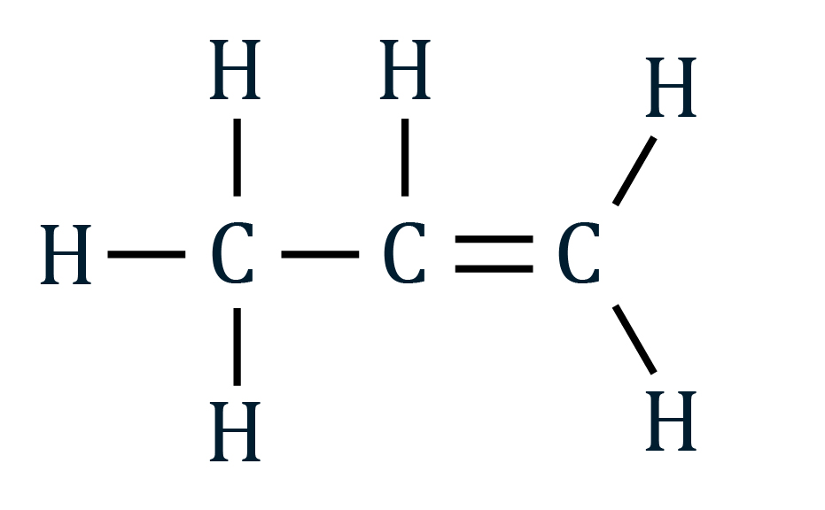

Give the number of outer electrons that a carbon atom has to form covalent bonds? 4

How many electrons of a carbon atom are involved in the double bond? 2

Explain why a propene monomer is able to form a new covalent bond with the carbon in another monomer.

One of the electrons from the double bond can be used to form a new covalent bond.

Symbolic – representations

This displayed formula represents a very short polymer molecule. A polymer molecule is usually a lot longer.

Draw a box around the repeating unit

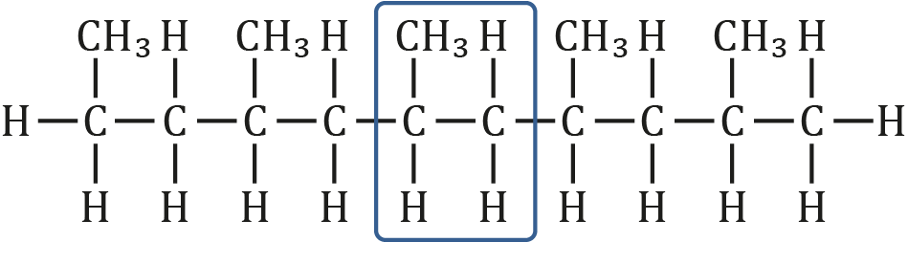

Draw the repeating unit.

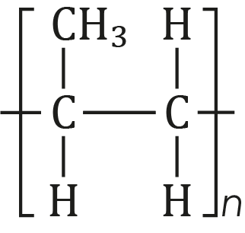

What does the letter $n$ mean?

That it is repeated many times.
Image ©: Shutterstock/ Runglawan Khrutjaikla

