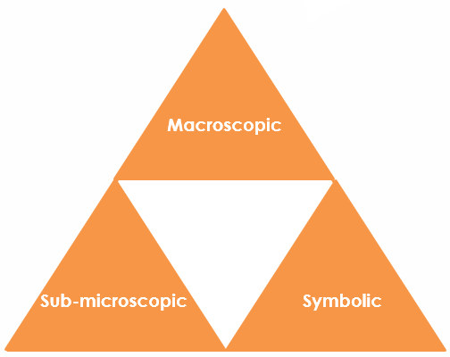
Cracking alkanes: Johnstone’s triangle

Learning objectives
- Explain the equipment used for cracking alkanes in the laboratory.
- Deduce a hydrocarbon product of cracking.
- Use general formulas to identify the products of cracking.

Introduction

Longer chain alkanes can be cracked to form shorter chain alkanes and alkenes.

Johnstone’s triangle

In chemistry. we make sense of the things that we can see by representing what we can’t see using formulas, equations, diagrams and models.

Johnstone’s triangle is a way of thinking about these different concepts as different corners of a triangle:

- Macroscopic – what we can see. Think about the properties we can observe, measure and record.
- Sub-microscopic – smaller than we can see. Think about the particle or atomic level.
- Symbolic – representations. Think about how we represent chemical ideas using symbols and diagrams.

Being able to connect and move between these three different levels is important for scientific understanding.

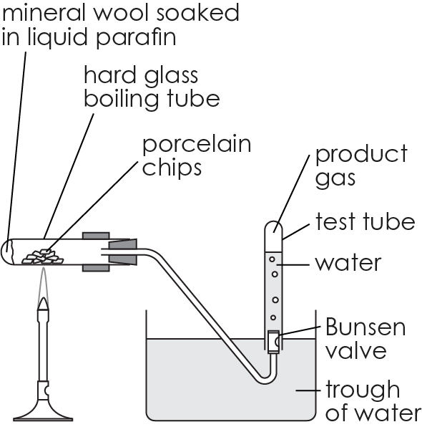
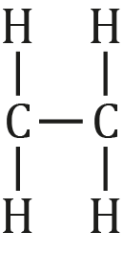
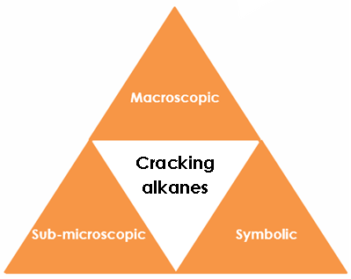

Sub-microscopic – smaller than we can see

The alkane decane can be cracked to produce octane plus another hydrocarbon. Complete the table to show the number of hydrogen atoms in decane and in octane.
Alkane | Number of C atoms | Number of H atoms
decane | 10
octane | 8

Deduce the number of carbon and hydrogen atoms in the other hydrocarbon product.

_________________________________________________________

_________________________________________________________

Explain why the displayed formula of the other hydrocarbon product is not correct.
___________________________________________
Change the formula to make it correct.

Macroscopic – what we can see

Paraffin is made up of long chain alkanes. Paraffin can be cracked in the laboratory.

Name the equipment used to provide:
- high temperature ___________________________________
- catalyst _____________________________________________

Explain why the products are collected over water.

_______________________________________________________________

Symbolic – representations

The alkane dodecane has 12 carbon atoms. Dodecane can be cracked to form three different products.

The equation for the reaction is:

$C_{12}H_{26}$ → $C_{7}H_{16}$+ $C_{2}H_{4}$ + $C_{3}H_{6}$

The general formula for an alkane is $C_{n}H_{2n+2}$.

Give the value of $n$ for dodecane. ______

Show that the number of hydrogen atoms in the formula is correct.

________________________________________________________________

Use the general formula to identify the formula of the product which is also an alkane. ________________________________________________

Give the general formula for $C_{2}H_{4}$ and $C_{3}H_{6}$.

______________________________________________________________________________________________________________

Name the type of hydrocarbon that the formula represents.

________________________________________________________________

