Cracking alkanes: Johnstone’s triangle

This resource is from the Johnstone’s triangle series which can be viewed at: rsc.li/43jMfSn. It will help learners to understand the different ways you need to think in chemistry, and to build their mental models and understanding.

Learning objectives
- Explain the equipment used for cracking alkanes in the laboratory.
- Deduce a hydrocarbon product of cracking.
- Use general formulas to identify the products of cracking.

How to use Johnstone’s triangle

Use Johnstone’s triangle to develop learners’ thinking about scientific concepts at three different conceptual levels:
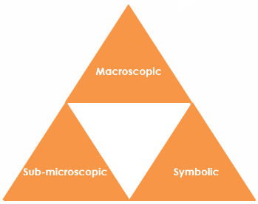
- Macroscopic – what we can see. Think about the properties you can observe, measure and record.
- Sub-microscopic – smaller than we can see. Think about the particle or atomic level.
- Symbolic – representations. Think about how we represent chemical ideas using symbols and diagrams.

For learners to gain a deeper awareness of a topic, they need to understand it at all three levels.

When introducing a topic, do not try to introduce all of the levels of thinking at once. This will overload working memory. Instead complete the triangle over a series of lessons, beginning with the macroscopic level. Introduce the other levels, in turn, once learners are secure.

All of the levels are interrelated; for example, learners need visual representation of the sub-microscopic in order to develop mental models of the particle or atomic level.

Find further reading about Johnstone’s triangle and how to use it in your teaching at rsc.li/4fwKdEJ.

Scaffolding

It is important to share the structure of the triangle with learners prior to use. Tell them why you want them to use the triangle and how it will help them to develop their understanding. Use an ‘I try, we try, you try’ approach when you are introducing Johnstone’s triangle for the first time.

More resources

To further develop learner’s thinking in all areas of Johnstone’s triangle, try our Developing understanding worksheets (rsc.li/43jMfSn). These include icons in the margin referring to the conceptual level of thinking needed to answer the question.
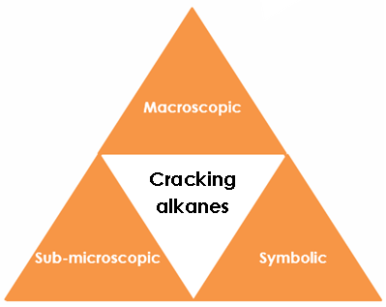
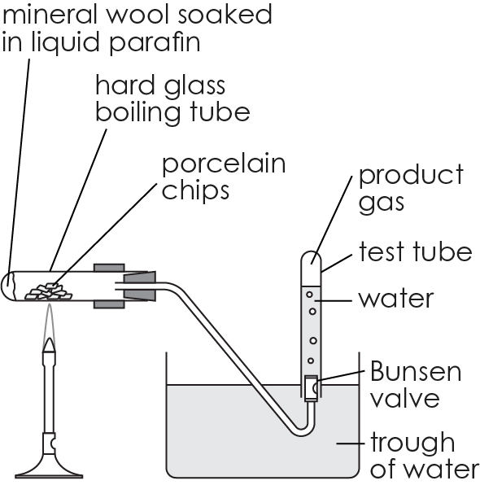
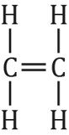

Symbolic – representations

The alkane dodecane has 12 carbon atoms. Dodecane can be cracked to form three different products.

The equation for the reaction is

$C_{12}H_{26}$ → $C_{7}H_{16}$+ $C_{2}H_{4}$ + $C_{3}H_{6}$

The general formula for an alkane is $C_{n}H_{2n+2}$.

Give the value of $n$ for dodecane. 12

Show that the number of hydrogen atoms in the formula is correct. 2x12+2 = 26

Use the general formula to identify the formula of the product which is also an alkane. C₇H₁₆

Give the general formula for $C_{2}H_{4}$ and $C_{3}H_{6}$. C_{n}H_{2n}

Name the type of hydrocarbon that the formula represents.

alkenes

Sub-microscopic – smaller than we can see

The alkane decane can be cracked to produce octane plus another hydrocarbon. Complete the table to show the number of hydrogen atoms in decane and octane.
Alkane | Number of C atoms | Number of H atoms
decane | 10 | 22
octane | 8 | 18

Deduce the number of carbon and hydrogen atoms in the other hydrocarbon product.

10-8 = 2 carbon atoms 22-18= 4 H atoms

Explain why the displayed formula of the other

hydrocarbon product is not correct.

Each carbon must have 4 bonds.

Change the formula to make it correct.

Macroscopic – what we can see

Paraffin is made up of long chain alkanes. Paraffin can be cracked in the laboratory.

Name the equipment used to provide

high temperature Bunsen burner

catalyst broken porcelain

Explain why the products are collected over water.

This is because the products are in the gas state.

