Polyester: Johnstone’s triangle

This resource is from the Johnstone’s triangle series which can be viewed at: rsc.li/43jMfSn. It will help learners to understand the different ways you need to think in chemistry, and to build their mental models and understanding.

Learning objectives
- Give ways to mitigate the environmental impact of the polyester PET.
- Describe how a polyester is formed.
- Interpret representations of monomer molecules.

How to use Johnstone’s triangle

Use Johnstone’s triangle to develop learners’ thinking about scientific concepts at three different conceptual levels:
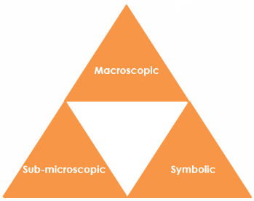
- Macroscopic – what we can see. Think about the properties you can observe, measure and record.
- Sub-microscopic – smaller than we can see. Think about the particle or atomic level.
- Symbolic – representations. Think about how we represent chemical ideas using symbols and diagrams.

For learners to gain a deeper awareness of a topic, they need to understand it at all three levels.

When introducing a topic, do not try to introduce all of the levels of thinking at once. This will overload working memory. Instead complete the triangle over a series of lessons, beginning with the macroscopic level. Introduce the other levels, in turn, once learners are secure.

All of the levels are interrelated; for example, learners need visual representation of the sub-microscopic in order to develop mental models of the particle or atomic level.

Find further reading about Johnstone’s triangle and how to use it in your teaching at rsc.li/4vRRtRR.

Scaffolding

Share the structure of the triangle with learners prior to use. Tell them why you are using it and how it will help them to develop their understanding. Use an ‘I try, we try, you try’ approach when introducing Johnstone’s triangle for the first time.

More resources

To further develop learner’s thinking in all areas of Johnstone’s triangle, try our Developing understanding worksheets (rsc.li/43jMfSn). These include icons in the margin referring to the conceptual level of thinking needed to answer the question.
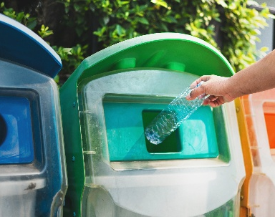
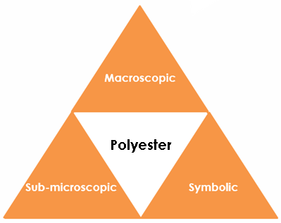

Macroscopic – what we can see

The polyester PET can be spun into fibres. Name one

everyday item that is made from PET.

Clothing or other fabric product

PET can also be used to make bottles. Give one

environmental disadvantage of PET. not biodegradable.

Give two ways in which PET waste can be reduced.

reusing or recycling

Symbolic – representations

A polyester is made from two different monomers.

1. A diol which has two alcohol functional groups ($-OH$)

2. A dicarboxylic acid which has two carboxylic acid functional groups ($-CO_{2}$)

Circle the two functional groups in each displayed formula.
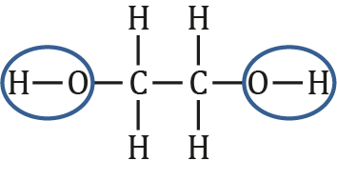 | 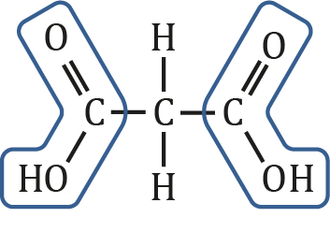

The monomers are sometime represented using a rectangle. The rectangle represents the carbon chain. 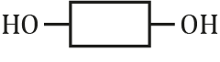

Draw a displayed formula to show the carbon chain in the diol monomer.

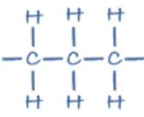

If you need to use diagrams please provide an example and we will redraw these in-house.>

Sub-microscopic – smaller than we can see

Circle the atoms that are eliminated (lost) when the two monomers react.

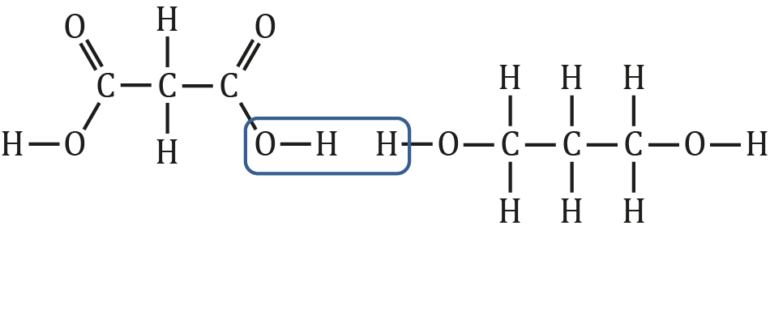

Give the formula of the molecule that is eliminated. H₂O

What special feature of the monomers allows a chain to form?

They have the same functional group at each end.

Complete the displayed formula for the repeating unit of the polymer.

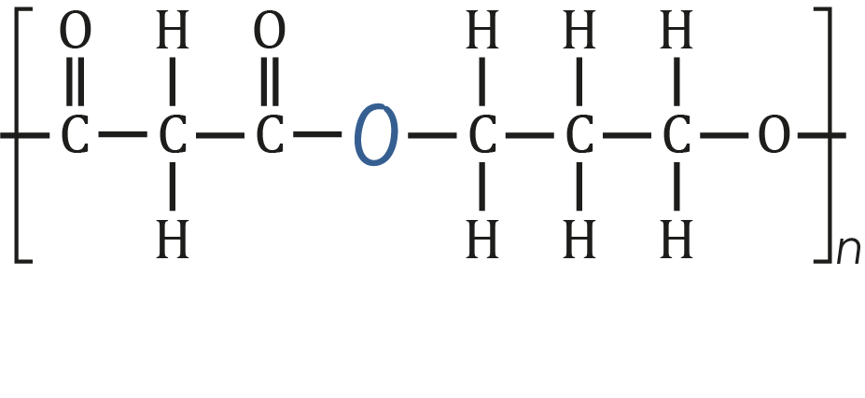

Image ©: Shutterstock/lovelyday12

