Microscale simple cracking
These teacher and technician notes are part of a collection of microscale chemistry resources at: rsc.li/4iiIjbl. This resource combines an experiment from the Nuffield practical collection with a method from CLEAPSS Microscale cracking of liquid paraffin (bit.ly/4yRRK9n). To explore the full Nuffield collection, which includes over 200 step-by-step practicals, go to rsc.li/43bjGql.

Integrated instructions for this experiment, a copy of the learning objectives and the discussion questions are available in the accompanying slides, rsc.li/3Utdw4q.

Introduction

Small and microscale chemistry practicals provide plenty of variety and opportunity for learners to refine their observation skills.

In this activity, learners crack liquid paraffin to illustrate the conversion of long-chain saturated hydrocarbons into shorter-chain unsaturated hydrocarbons.

Learning objectives
- Observe the colour change associated with the bromine water test for unsaturated hydrocarbons.
- Explain the purpose of cracking, as used in the petrochemical industry.

Equipment (per group)
- Integrated instruction sheet
- Sealed glass Pasteur pipette (see note below for instructions on how to prepare)
- Miniature spirit burner (see note below for a link to the instructions)
- Small test tube
- Delivery tube connected to a short (~5 cm³) length of flexible tubing
- Retort stand, boss and clamp
- Mineral wool
- Liquid paraffin, 0.5 cm³
- Aluminium oxide powder or granules
- Bromine water (0.002 mol dm⁻³), 1 cm³
- Optional: potassium manganate(VII) solution (0.002 mol dm⁻³) as a substitute for bromine water

Safety equipment
- Eye protection: safety glasses to EN ISO16321 C

Preparation

To prepare the glass Pasteur pipette for this practical:
- Hold the tip of a clean, dry Pasteur pipette in the outer blue cone of a Bunsen burner, rotating the pipette continuously to ensure it is heated evenly.
- As the glass softens and glows orange/red the tip will melt and close shut.
- Remove from the flame and leave the pipette on a heat-proof surface to cool slowly.

CLEAPSS have developed a guide to producing small-scale spirit burners using miniature jars (as shown in the image on page 4), see bit.ly/4zBLuTk for full instructions.

Safety
- Read our standard health and safety guidance (rsc.li/3zyJLkx) and carry out a risk assessment before running any live practical.
- The main hazards are ethanol, the glass tubing and bromine water. Due to the nature of the hazards, eye protection should be worn at all times during this experiment, including set up and dismantling.
- Students should be warned about the dangers of the ethanol in the spirit burners. They should keep the burner upright and should not take off the lid. Ethanol produces highly flammable vapour and can catch fire very easily. To minimise any risk, ensure that the burners are filled prior to the lesson. Students need to light their burners, and the easiest way to do this is with matches - take a flame to the burner, not the burner to a flame. It is advisable to have a box of matches per bench, to know how many boxes you have and to count them out at the start and in at the end of the session. As an alternative, have a lit Bunsen or two in the laboratory and have students use splints to light their burners. However, they can be tricky to light this way.
- Refer to SSERC/CLEAPSS Hazcards and recipe sheets or contact your local safety advisory body. Hazard classification may vary depending on supplier.
Chemical supplied for the practical | Preparation
Liquid or medicinal paraffin  Not currently classified as hazardous.  Refer to CLEAPSS Hazcard 045b, SSERC or contact your local safety advisory body. | Wear eye protection.  Avoid inhaling fumes.  Ensure laboratory is well ventilated.
Aluminium oxide solid  Not currently classified as hazardous.  Refer to CLEAPSS Hazcard 002b, SSERC or contact your local safety advisory body. | No additional preparation required.
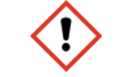  Bromine solution, 0.002 mol dm⁻³  WARNING: Irritant.  Refer to CLEAPSS Hazcard 015b, SSERC or contact your local safety advisory body. | 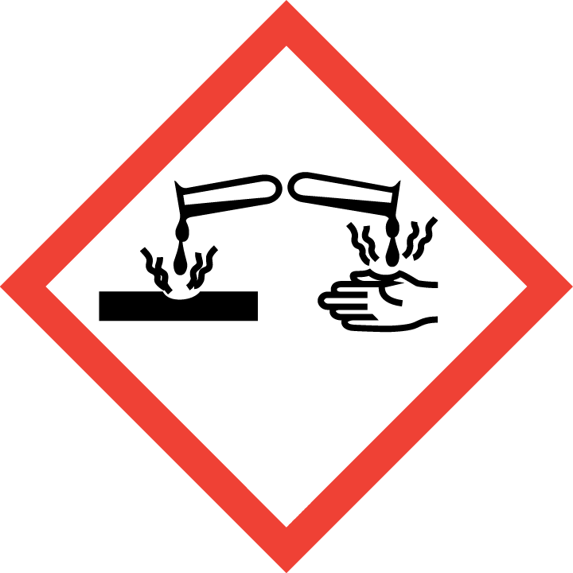  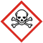  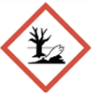  Bromine, bromine water and opening bromine ampules  DANGER: Fatal if inhaled. Causes severe skin burns and eye damage. Very toxic to aquatic organisms  Refer to CLEAPSS Hazcard 015b, SSERC or contact your local safety advisory body.  Prepare solution using CLEAPSS recipe sheet RB017 and refer to this guidance on handling liquid bromine and preparing bromine water, rsc.li/4zwfekn.
Potassium manganate(VII) solution, 0.002 mol dm⁻³  Not currently classified as hazardous. | Potassium manganate(VII), solid  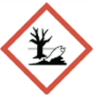  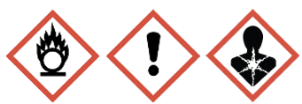  DANGER: May intensify fire, oxidiser. Harmful if swallowed. Suspected of damaging the unborn child. Very toxic to aquatic life with long lasting effects. Causes severe skin burns and eye damage.  Refer to CLEAPSS Hazcard 081, SSERC or contact your local safety advisory body.  Prepare solution using CLEAPSS recipe sheet RB073, refer to SSERC or contact your local safety advisory body.
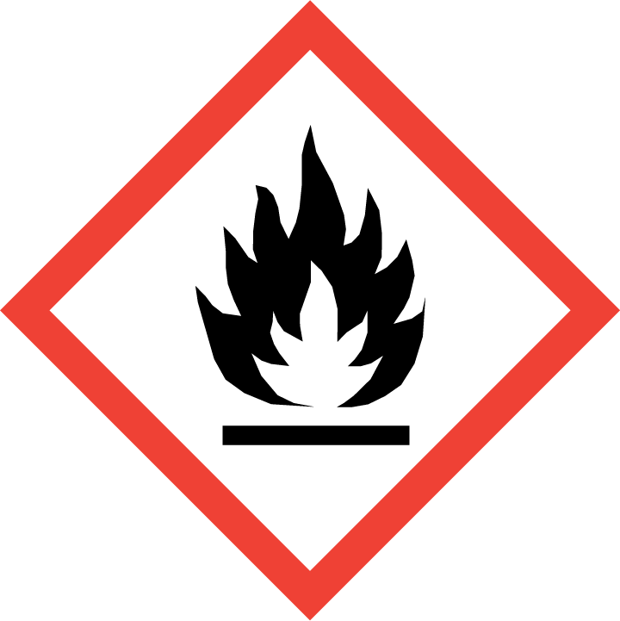  Industrial denatured alcohol (IDA)  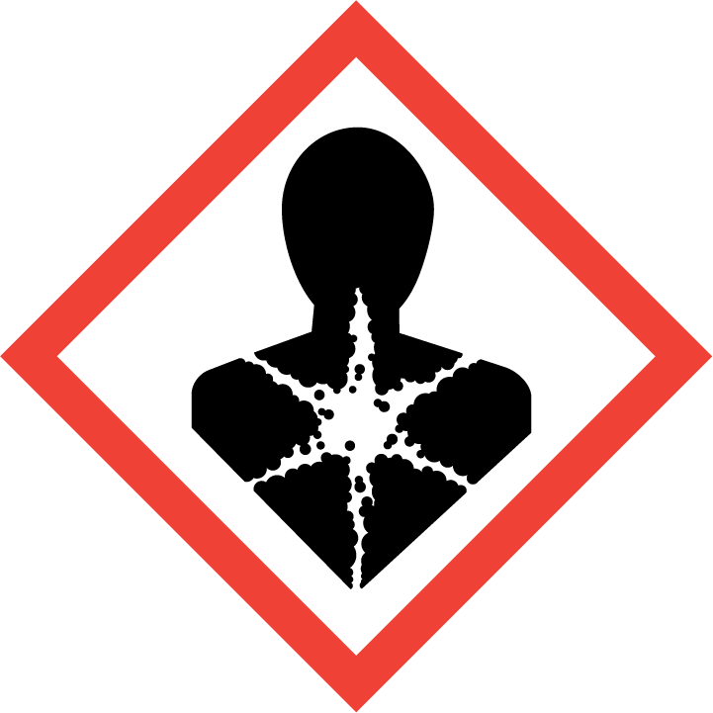    DANGER: Highly flammable. Harmful by ingestion. May cause damage to organs.  Or  Ethanol, $C_{2}H_{6}O(l)$  DANGER: Highly flammable.  Refer to CLEAPSS Hazcard HC040a, SSERC or contact your local safety advisory body. | N/A

Disposal
- Dispose of the Pasteur pipette directly into the glass waste.
- Flush solutions down a foul water drain.

Method
- Add approximately 0.5 cm³ of liquid paraffin to a sealed Pasteur pipette, followed by mineral wool so that all the liquid is absorbed.
- Place the aluminium oxide in the pipette above the mineral wool.
- Add 0.5–1 cm³ of bromine water (or potassium manganate(VII) solution) to the test tube.
- Set up the pipette and delivery tube as shown in the diagram on the integrated instructions worksheet or see the image below.
- Support the pipette by gently clamping it around the rubber tubing.
- Light the spirit burner and place it so that the flame heats the pipette at the junction of the wool and the powder.

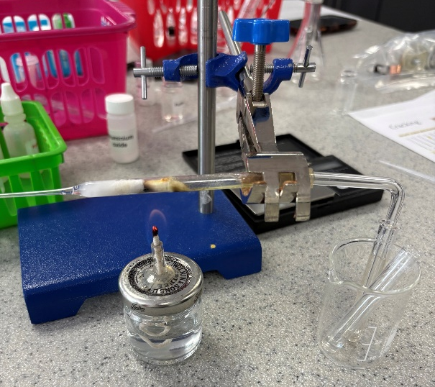

Expected results
- The reaction produces a mixture of small chain alkanes, alkenes and hydrogen gas.
- The alkenes produced will turn the bromine water from yellow−orange to colourless.
- A liquid may be observed (which is often yellowish in colour) near to the end of the glass pipette. This is likely to be the shorter-chain alkane produced in this reaction.
- During the reaction, carbon may form on the catalyst, turning it black.

Discussion questions with answers
- Liquid paraffin is a mixture of hydrocarbons. There will be no visible change when bromine water is added to liquid paraffin. What does this suggest about the composition of the paraffin mixture?

Paraffin is a mixture of alkanes/saturated hydrocarbons and does not contain any alkenes/unsaturated hydrocarbons.
- Mineral wool is inert and does not participate in this reaction. Suggest why it is added to the pipette.

Mineral wool is highly porous. It absorbs the liquid paraffin and keeps it in place, while allowing the vapours that are produced to easily escape.
- What do the results of the bromine water test indicate has occurred during the reaction?

The longer hydrocarbon chains in the paraffin mixture have been ‘cracked’ to produce a mixture of shorter-chain alkenes and alkanes. Br₂ (bromine) molecules react with the carbon−carbon double bond in unsaturated hydrocarbons such as alkenes, decolourising the orange bromine water.
- Suggest the benefits of using an aluminium oxide based catalyst, such as a zeolite, in industry.

Because the catalyst lowers the activation energy of the reaction, a lower temperature can be used. This means that less energy is required for heating, conserving energy resources. Catalysts increase the rate of a chemical reaction, meaning more product can be produced per unit time.
- Cracking reactions produce a mixture of alkanes and alkenes of different chain lengths. Suggest how this mixture could be separated.

Fractional distillation can be used to separate the mixture of hydrocarbons based on their different boiling points.

